AWP’s Tenth Tweet Chat: #AWP16BFPrep
Janury 7 from 3:00-4:00 p.m. ET
AWP ‏@awpwriter
Whether you've read through your exhibitor kit yet or not, join us today at 3 p.m. ET for a live #AWP16BFPrep chat!
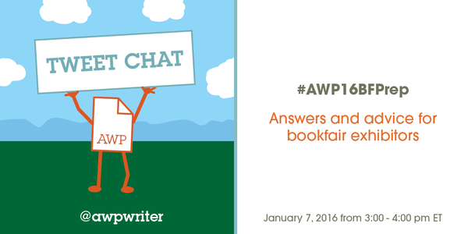
AWP ‏@awpwriter
Welcome to our #AWP16BFPrep chat! For the next hour, we'll share tips & answer questions about exhibiting at the bookfair.
AWP ‏@awpwriter
With us today is @cshermanva, Director of Exhibits. #AWP16BFPrep
AWP ‏@awpwriter
If you have a question about the bookfair, ask it using #AWP16BFPrep.
AWP ‏@awpwriter
If you are a returning exhibitor and have advice to share with fellow exhibitors, jump in any time using #AWP16BFPrep.
cshermava ‏@cshermava
Thank you for taking the time to learn new tips and information for success at #AWP16 #AWP16BFPrep
Cynthia Sherman ‏@cshermanva
Start with a Pre-show Planning Checklist, you will save $$$ by coming up with a detailed budget #AWP16BFPrep
Editions du Cygne ‏@EditionsDuCygne
#AWP16BFPrep Do you have some foreign exhibitors?
Cynthia Sherman ‏@cshermanva
@EditionsDuCygne We do, and in a few minutes I will list a few of them for you! #AWP16BFPrep
cshermava ‏@cshermava
@EditionsDuCygne Great question! There are 11 orgs from Canada, 1 from Ireland, and 4 from the UK #AWP16BFPrep
cshermava ‏@cshermava
@EditionsDuCygne Many of our publishers do publish works by international authors #AWP16BFPrep
cshermava ‏@cshermava
@EditionsDuCygne We also have the American Literary Translators Association in attendance #AWP16BFPrep

Ashley Strosnider ‏@bravenewlady
@awpwriter @cshermanva Any good advice on booth/display designs? How to make best use of space, plan areas to foster engagement w attendees?
AWP ‏@awpwriter
@bravenewlady @cshermanva Good booths are eye-catching! Give-aways, sales, games, contests, & friendly staff go a long way #AWP16BFPrep

cshermava ‏@cshermava
@bravenewlady @awpwriter Hi Ashley! First look at traffic flow, your message and branding, and ease of access #AWP16BFPrep
cshermava ‏@cshermava
@bravenewlady @awpwriter Open engagement areas, mix of low and high tech, and methods of capturing data #AWP16BFPrep

AWP ‏@awpwriter
Some eye-catching bookfair spaces #AWP16BFPrep
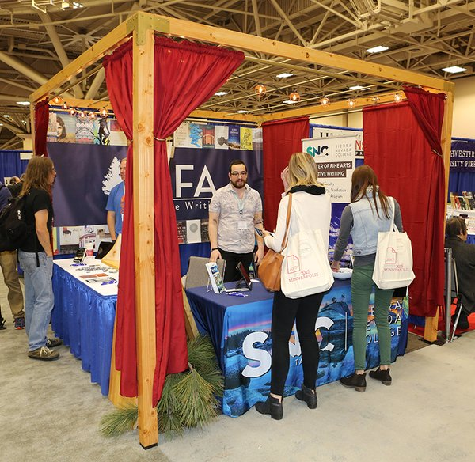
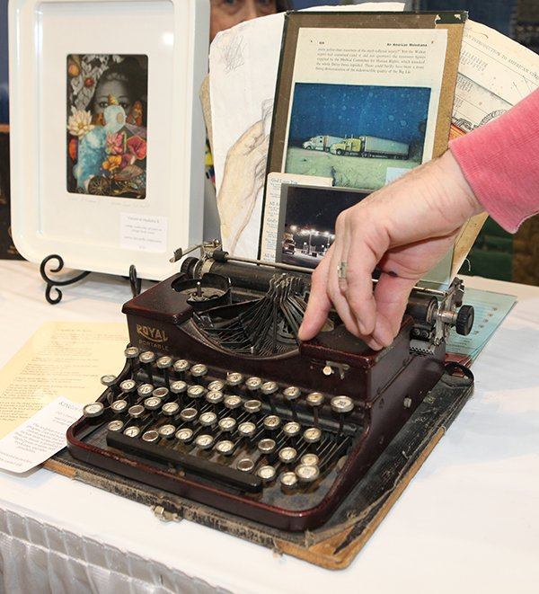
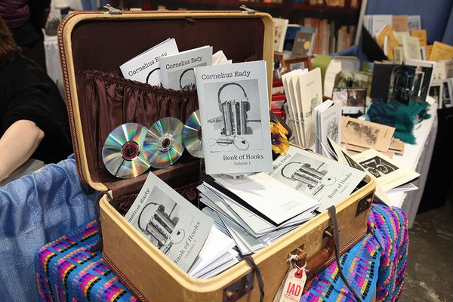
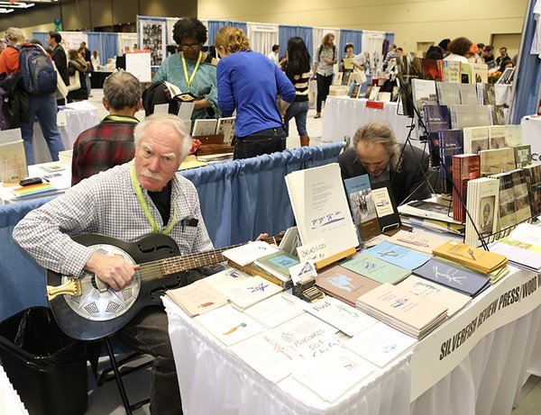

AWP ‏@awpwriter
Don't forget to engage & interact with attendees! #AWP16BFPrep
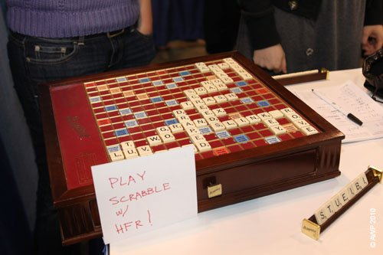
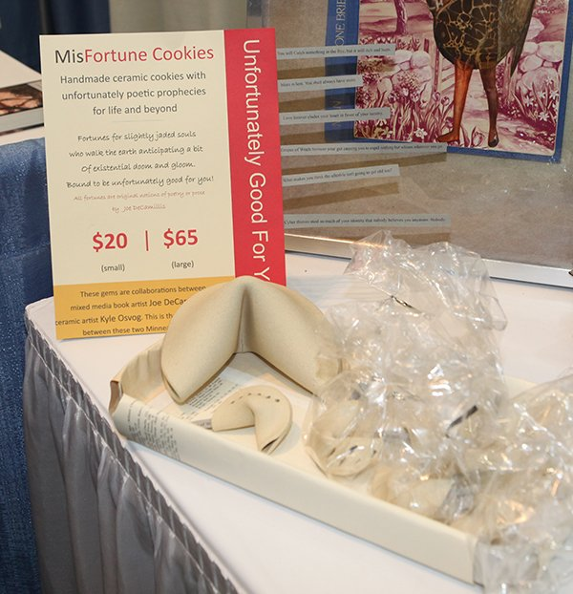
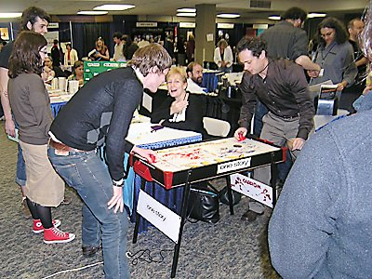
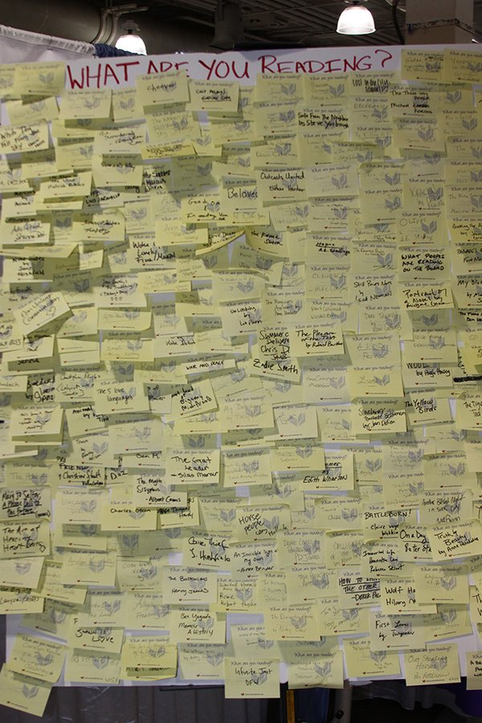

AWP ‏@awpwriter
Exhibitors, have you entered your twitter name on your bookfair management page? AWP will use those to create a Twitter list. #AWP16BFPrep

AWP ‏@awpwriter
Creative costumes would fit right in in LA! #AWP16BFPrep
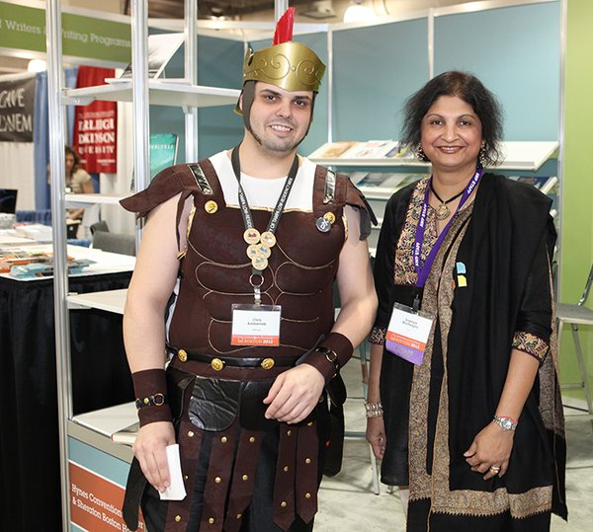
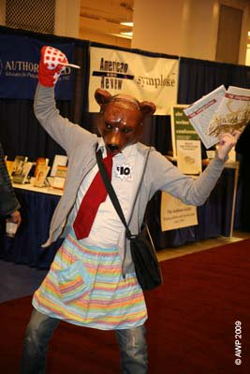
cshermava ‏@cshermava
• The budget includes transportation, hotel, registration, exhibit décor, shipping, & material handling #AWP16BFPrep
AWP ‏@awpwriter
Create an exhibit that speaks to your brand and message #AWP16BFPrep
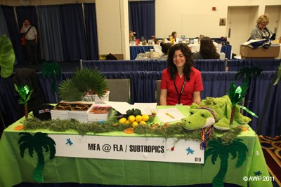
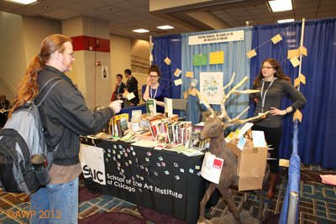
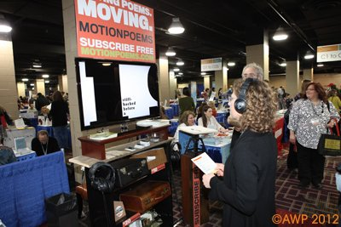

JT ‏@passtheteapot
#AWP16BFPrep I have a line of perfumes called Dead Writers all based on, famous writers Kerouac, Poe etc. Do you accept this sort of booth?
cshermava ‏@cshermava
@passtheteapot Hi JT, sounds like a good fit! Here are the specifics on exhibiting https://www.awpwriter.org/application/public/pdf/conference/2016/2016ExhibitorProspectus.pdf … #AWP16BFPrep
JT ‏@passtheteapot
@cshermava Ok, I'm excited to vend at AWP! I went to the bookfair when it was in Seattle and love the atmosphere and people. Thanks again!

cshermava ‏@cshermava
@passtheteapot Please let me know if you have any questions by phone or email at bookfair(at)http://awpwriter.org #AWPBFPrep
JT ‏@passtheteapot
@cshermava Thank you! I'll check it out and hopefully secure a space :)
cshermava ‏@cshermava
@passtheteapot That's great! I love the bookfair, too and look forward to meeting you and checking out your fragrances! #AWP16BFPrep
davidbishop ‏@davidbishop
@passtheteapot @awpwriter hmm Whiff of Whitman
JT ‏@passtheteapot
@davidbishop @awpwriter That's a good one! My latest is called Death in the Afternoon ;)

cshermava ‏@cshermava
Post-show Follow up on your leads ASAP. Have a plan in place before you go to the show on how you will follow-up. #AWP16BFPrep
cshermava ‏@cshermava
If you are following up via email, personalize it to the conversation you had at the show #AWP16BFPrep
cshermava ‏@cshermava
It's time for your friendly tax reminder! https://www.awpwriter.org/awp_conference/bookfair_tax_info … #AWP16BFPrep
AWP ‏@awpwriter
Let attendees meet your authors and/or faculty. #AWP16BFPrep
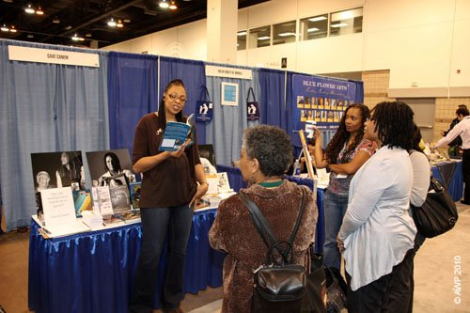
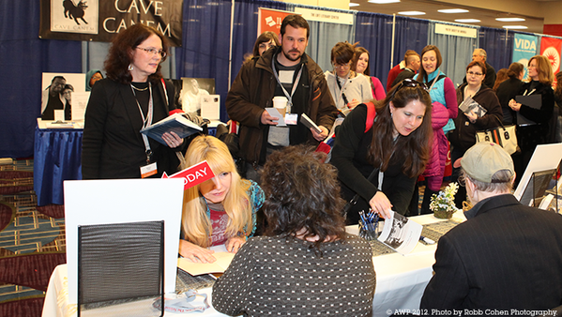
AWP ‏@awpwriter
Promote your sales/signings via social media during #AWP16 and you might show up on our Twitter Wall at the conference #AWP16BFPrep
cshermava ‏@cshermava
Exhibitor Service Kit will be available early next week. You will receive an email from Brede with online order code #AWP16BFPrep
cshermava ‏@cshermava
Assign EABs on your exhibit management page. EABs include full conference registration https://www.awpwriter.org/awp_conference/faqs#BookfairFAQ … #AWP16BFPrep
cshermava ‏@cshermava
AWP is promoting awareness of the need for full access to the conference and bookfair for everyone #AWP16BFPrep
cshermava ‏@cshermava
Bookfair updates and Spotlights are posted to the BF FB page https://www.facebook.com/AWP-Bookfair-536254749775315/ … #AWP16BFPrep
Evan Morgan Williams ‏@EvMoWi
#SarabandeBooks had exceptionally good books for sale and whiskey for free. #AWP16BPrep
cshermava ‏@cshermava
Got general bookfair questions? Check out the FAQs https://www.awpwriter.org/awp_conference/faqs#BookfairFAQ … #AWP16BFPrep
cshermava ‏@cshermava
Thank you for taking the time to prep for the bookfair. I am only a tweet, call or email away if you have questions! #AWP16BFPrep
AWP ‏@awpwriter
We hope you will all have a good and successful #AWP16 bookfair! See you in March in sunny LA! #AWP16BFPrep
AWP ‏@awpwriter
Thank you for joining us today for #AWP16BFPrep. Our February chat will be about #AWP16 registration, using #AWP16Reg.

