AWP’s Twenty-first Tweet Chat: #AWP17
October 13, 2016 from 3:00-4:00 p.m. ET

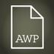AWP ‏@awpwriter
In one hour, AWP's conference staff will be here to chat about #AWP17.
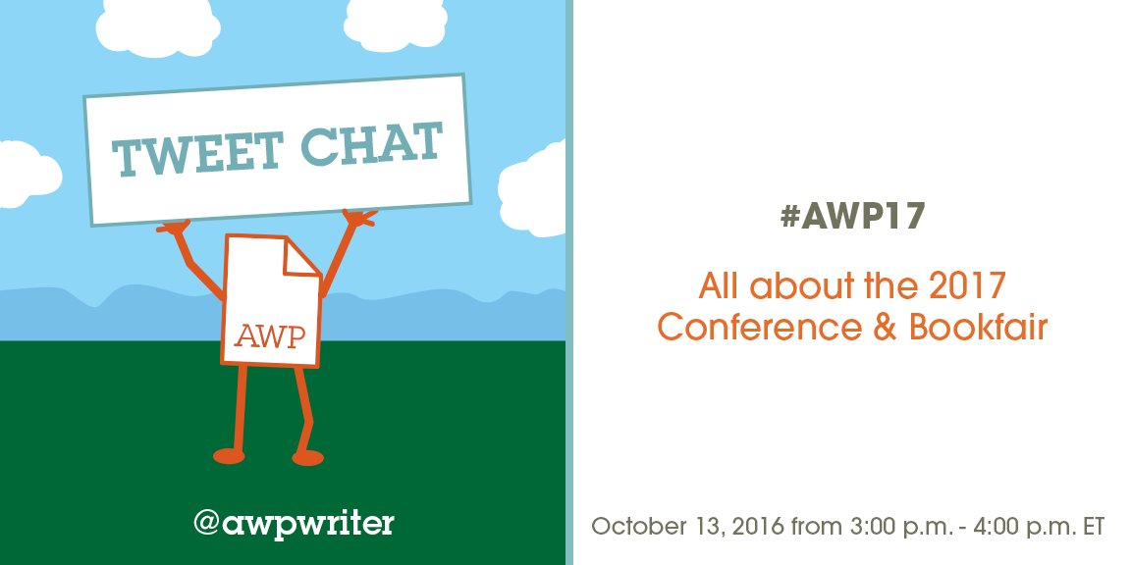
AWP ‏@awpwriter
Thank you for joining us for our #AWP17 chat!
AWP ‏@awpwriter
With us is AWP's Director of Conferences, Christian Teresi @ChristianTeresi, and Director of Exhibits, Cynthia Sherman @cshermanva #AWP17
AWP ‏@awpwriter
Joining us for the first time is our new Conference Registration Coordinator, Tiffany Robinson @AWPsTiffany #AWP17
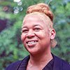
AWP ‏@awpwriter
...and our new Conference Registration Coordinator, Colleen Cable @colleen_cable. Please welcome them both to AWP! #AWP17
AWP ‏@awpwriter
To ask a question about the AWP Conference & Bookfair at any time, just tweet using #AWP17 and our conference department staff will see it.
Christian Teresi ‏@ChristianTeresi
I'm looking forward to seeing these outstanding #AWP17 featured authors in DC next February. https://www.awpwriter.org/awp_conference/presenters_featured_presenters_overview …
Christine Gosnay ‏@dagny
Will Bob Dylan be at #AWP17
Christian Teresi ‏@ChristianTeresi
@dagny Not that I'm aware of, but no one knew he would win the Nobel, so I guess you never know.
Cynthia Sherman ‏@cshermanva
#AWP17 I would love to see him!!!

Christian Teresi ‏@ChristianTeresi
#AWP17 early-bird registration ends tomorrow. Questions about registration? Contact us at registration@awpwriter.org https://www.awpwriter.org/awp_conference/registration_overview …
Cynthia Sherman ‏@cshermanva
#awp17 Bookfair exhibitor spotlights kicked off on Monday! You can see them on the BF FB page and the Events FB page.

Aleesha Nash ‏@Aleesha_Nash
So excited to hear guest speaker @tanehisicoates at #AWP17 @awpwriter Do you know what topic he'll speak on?
Christian Teresi ‏@ChristianTeresi
.@tanehisicoates is giving a reading & conversation with Chimamanda Ngozi Adichie. The event will be moderated by @Ethelbertpoet. #AWP16
Christian Teresi ‏@ChristianTeresi
@Aleesha_Nash I'm really looking forward to seeing @tanehisicoates too. It should make for a great #AWP17 event. @awpwriter
Aleesha Nash ‏@Aleesha_Nash
@ChristianTeresi @tanehisicoates @awpwriter IKR! SIGN ME UP! :)

Cynthia Sherman ‏@cshermanva
#AWP17 Deadline to list Author Signings for the print planner is Nov 1. Signings are entered on the Exhibit Space Management Page.

Christian Teresi ‏@ChristianTeresi
Claudia Rankine's amazing #AWP16 keynote is now in print. Can't wait to hear @azarnafisi give the keynote at #AWP17. https://www.awpwriter.org/magazine_media/writers_chronicle_view/4120/in_our_way_racism_in_creative_writing …
Azar Nafisi ‏@azarnafisi
Great honor. Big Challenge.
Tiffany ‏@AWPsTiffany
Only one day left to purchase your early bird registration. Join us in our nation's capital for #AWP17! https://www.awpwriter.org/store/conference_overview …
Glenda Burgess ‏@GlendaBurgess
@AWPsTiffany @awpwriter Not this year. See you next!
Tiffany ‏@AWPsTiffany
@GlendaBurgess Sunny Tampa Florida! GREAT choice!!

Glenda Burgess ‏@GlendaBurgess
@AWPsTiffany Indeed, I peeked ahead ;)
Aleesha Nash ‏@Aleesha_Nash
Should student registration for #AWP17 have to come through our college? @goddardcollege
Christian Teresi ‏@ChristianTeresi
@goddardcollege is a sponsor. A #AWP17 registration might be available through the English Dept.. Inquire with you CW chair. @Aleesha_Nash
Aleesha Nash ‏@Aleesha_Nash
@ChristianTeresi @goddardcollege Thank you! I will reach out right away!
AWP ‏@awpwriter
@Aleesha_Nash If you don't get a #AWP17 reg. through your school (def. check first!), you can purchase a student reg. from our website ½
AWP ‏@awpwriter
@Aleesha_Nash You'd just need to bring a student ID to #AWP17 to the onsite kiosks to print your badge. 2/2
Aleesha Nash ‏@Aleesha_Nash
@awpwriter Excellent! Thank you! :)
Tiffany ‏@AWPsTiffany
#awp17 Hotels are selling out FAST! Visit https://www.awpwriter.org/awp_conference/hotel_travel_overview … For a listing of our overflow hotels!
AWP ‏@awpwriter
Will #AWP17 be your first conference? Read #AWPTip and #AWPTips for advice!
AWP ‏@awpwriter
AWP's entire conference department is here for another half an hour to answer your #AWP17 questions! Just tweet using #AWP17.
Cynthia Sherman ‏@cshermanva
#AWP17 Check out the over 650 organizations in the bookfair at https://www.awpwriter.org/awp_conference/bookfair_exhibitors_list …
Sarah K. Stephens ‏@skstephenswrite
@cshermanva this will be my first #AWP17--is the book fair only for publishers & programs, or can authors book tables as well?

Cynthia Sherman ‏@cshermanva
@skstephenswrite You are going to love #AWP17! Anyone can exhibit https://www.awpwriter.org/awp_conference/bookfair_overview … more??? bookfair(at)http://awpwriter.org
Sarah K. Stephens ‏@skstephenswrite
@cshermanva Thanks Cynthia--really appreciate your time!
Cynthia Sherman ‏@cshermanva
@skstephenswrite I hope to meet you at #AWP17!
Sarah K. Stephens ‏@skstephenswrite
@cshermanva Me too! :)
AWP ‏@awpwriter
#AWP17 sponsorship closes on the 15th: https://www.awpwriter.org/awp_conference/sponsorship …
AWP ‏@awpwriter
And don't forget about our first ever gala to celebrate AWP's 50th anniversary at #AWP17 https://www.awpwriter.org/awp_conference/gala … Tickets are on sale now!
Tiffany ‏@AWPsTiffany
Calling All Students & Adjuncts! AWP is accepting volunteer applications for #AWP17 visit https://www.awpwriter.org/awp_conference/registration_volunteer …
Aleesha Nash ‏@Aleesha_Nash
@AWPsTiffany Sweet! I just submitted my application for that opportunity! :)
Tiffany ‏@AWPsTiffany
@Aleesha_Nash Whooo Hooo! Thanks Aleesha! See you in D.C.

Aleesha Nash ‏@Aleesha_Nash
@AWPsTiffany Can't wait! :)
Great Writers Steal ‏@GreatWritersSte
@AWPsTiffany @awpwriter Students and adjuncts are on the same level?

Cynthia Sherman ‏@cshermanva
#AWP17 Exhibitor Service Kit will be avail around 10/31. Contains shipping info, ordering elec & other services. Brede will send by email.
Cynthia Sherman ‏@cshermanva
#AWP17 Do you know what an Exhibitor Access Badge (EAB) is? Full conf regist & access for setup/tear down--BF FAQs https://www.awpwriter.org/awp_conference/faqs#BookfairFAQ …
AWP ‏@awpwriter
Got #AWP17 questions? We've got answers! Now's your last chance to tweet during the chat.
AWP ‏@awpwriter
Planning an #AWP17 offsite event? The listing will be available Nov 1. Be sure to choose an accessible location! https://awpdisabilitycaucus.wordpress.com/awp-events/
Great Writers Steal ‏@GreatWritersSte
@awpwriter Why split teachers into classes, particularly in the midst of such unhealthy hiring trends? #awp17
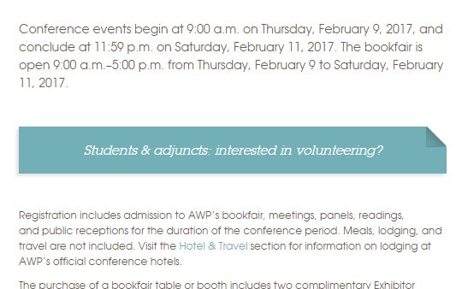
Christian Teresi ‏@ChristianTeresi
@GreatWritersSte Part of the point of the #AWP17 volunteer positions is to help two underserved groups, ie adjuncts & students. @awpwriter
AWP ‏@awpwriter
If you missed the #AWP17 chat, you might find the answer to your question on our FAQ page: https://www.awpwriter.org/awp_conference/faqs …
AWP ‏@awpwriter
Thank you for joining our #AWP17 chat. You can check out our archive of previous tweet chats: https://www.awpwriter.org/community_calendar/tweet_chats …

