AWP’s Twenty-sixth Tweet Chat: #AWPMentorship
November 27, 2018 from 2:00-3:00 p.m. ET

AWP‏ @awpwriter
Don’t forget! This Tuesday, November 27, we are celebrating #GivingTuesday with our annual tweet chat at 2:00 p.m. EST, hosted by @DianeZinna, Director of Membership Services. Learn more about our Writer to Writer program, and chat with past and current mentors and mentees! #W2W

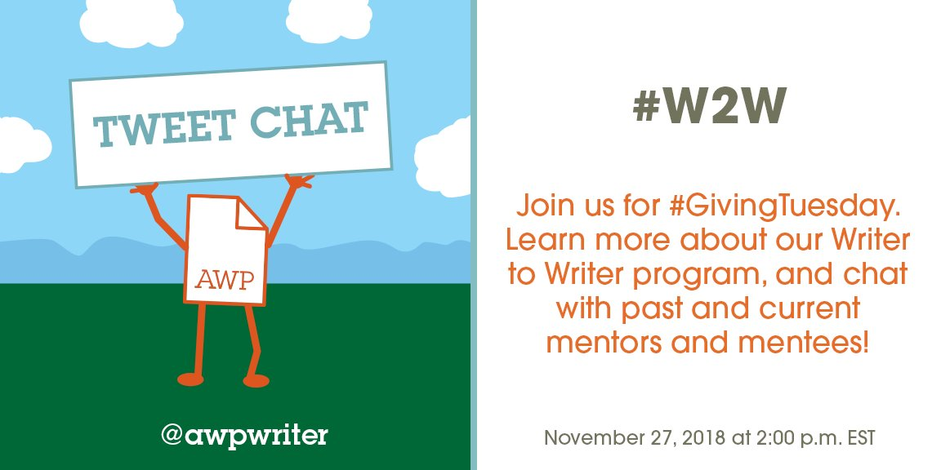

AWP‏ @awpwriter
Donate this hour and you will be entered into a drawing to win one of these five books from @joemilazzo94, Jennifer Perrine, Doug Ramspeck, @DrAminaGautier, and @AndrewBourelle. #writerslovewriters #AWPMentorship https://www.awpwriter.org/store/donations_givingtuesday …
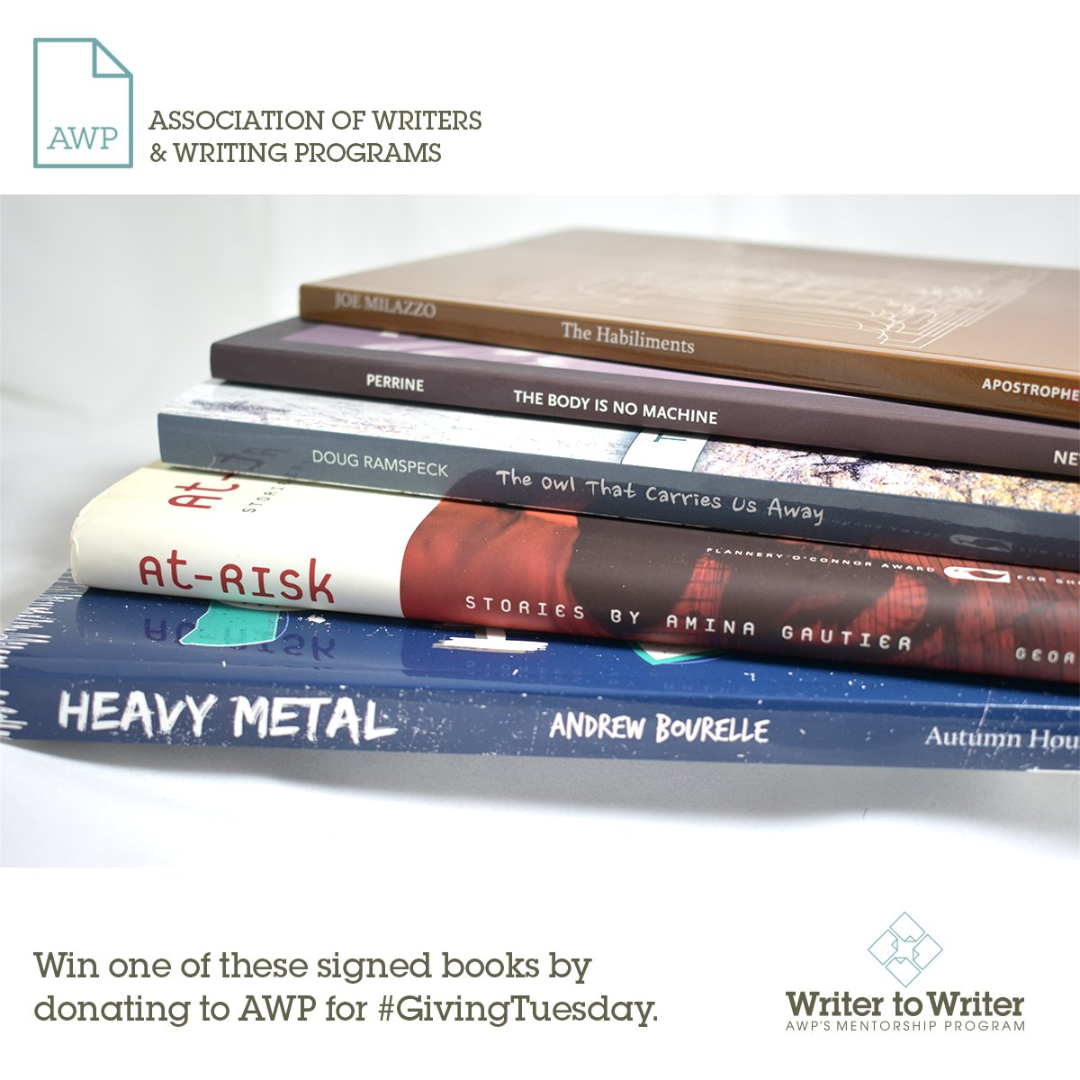
Andrew Bourelle‏ @AndrewBourelle
I was previously mentored in AWP's Writer to Writer Mentorship Program. Today, my novel Heavy Metal is one of five books you could be eligible to win if you donate to #AWPMentorship for #GivingTuesday. Thanks @DianeZinna for including my book!

AWP‏ @awpwriter
Today is the day! Donate to #AWPW2W and help us pair thirty seasoned mentors with a new batch of emerging writers. Celebrate #GivingTuesday and help #WritersLoveWriters. #AWPMentorship https://www.awpwriter.org/store/donations_givingtuesday …
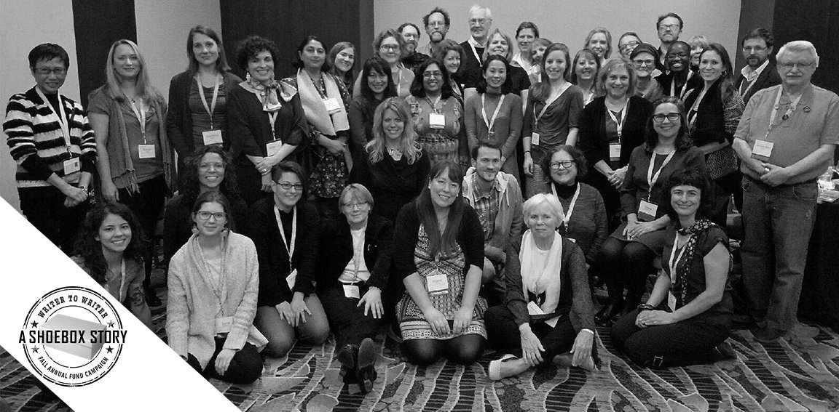

Natalia Reyes‏ @NataliaDReyes
More
Working with @normaelia as part of #AWPW2W has been wonderful. Having her insight and kindness in my corner has made the difficult practice of writing just a little more rewarding, more possible. I definitely recommend #AWPMentorship
AWP‏ @awpwriter
More
Thank you @NataliaDReyes!

Annette Wong‏ @StrnglyWrdedLTR
Happening now! #W2W. The writing life can be notoriously solitary. The #awpmentorship makes it markedly less so. Thankful for @neil_aitken's guidance, insight & support & this season's incredible cohort of fellow emerging writers. Much gratitude to @awpwriter & @DianeZinna.

Olivia Katrandjian‏ @okatrandjian
Connecting with this season's wonderful group of all women mentees has been a real treat. Building a writing community is yet another reason for authors and emerging writers to apply to the 10th season of the #AWPMentorship program! #AWPW2W

Helen Armstrong 📚 🌈‏ @hkawrites
The #AWPW2W program has been so amazing to participate in - my mentor @dirtroadsndogs is a joy to work with and @DianeZinna has truly poured her heart and soul into this. It's a lovely community. #WritersLoveWriters #AWPMentorship

Tom Stern‏ @tomsternwrites
This truly is a wonderful program. Wish I had known about it years ago as I made every stupid mistake there is to make as a writer. Honored to be a Fiction Mentor this Fall to share my experiences with others. #AWPMentorship

Olga Livshin‏ @OlgaLivshin
More
Today, in a few minutes--from 2-3 EST--I'm here with other mentors and mentees answering questions about the amazing #AWPmentorship program, which begins its 10th season in February. Join me! #AWPW2W #AWPMentorship

AWP‏ @awpwriter
Thanks for tuning in to our #GivingTuesday tweet chat with the wonderful @DianeZinna, our Director of Membership! #WritersLoveWriters #AWPMentorship

AWP‏ @awpwriter
#GivingTuesday is a national day of giving. A movement to share and spread the love—just like our mentorship program, Writer to Writer. #AWPMentorship

AWP‏ @awpwriter
So today, for #GivingTuesday, we are going to highlight Writer to Writer and tell you all the great things about it! #AWPW2W #AWPMentorship #WritersLoveWriters

Olga Livshin‏ @OlgaLivshin
If you care about writing and writers "on the outside, looking in," especially those whose lives did not previously allow sustained attention to writing, please consider donating to #AWPW2W today, this Giving Tuesday. @DianeZinna has helped so many of us transform our lives.
AWP‏ @awpwriter
Thank you @OlgaLivshin!

Diane Zinna‏ @DianeZinna
ore
Hi, Everyone! I'm AWP's membership director and over the next hour I'll be answering your questions about our program, Writer to Writer! #awpmentorship #AWPW2W
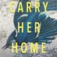Caroline Bock‏ @cabockwrites
Best thing of 2018 for me -- being a mentor in this program to another writer!! #awpmentorship

Diane Zinna‏ @DianeZinna
More
We’re also joined today by many, many, many current and past mentors and mentees who have helped make W2W what it is! They are here to answer your questions and give their perspectives, too. #awpmentorship #AWPW2W

Megan DeMatteo‏ @megdematteo
Hey emerging writers! Learn how to enroll in @awpwriter's mentorship program. LIVE Tweet Chat begins now! Bring your questions to @awpwriter ! #writerslovewriters #AWPMentorship #GivingTuesday

AWP@awpwriter
Thank you @megdematteo, it is true. Ask questions with #AWPW2W mentors and mentees and Director of Membership @DianeZinna. #AWPMentorship

Helen Armstrong 📚 🌈‏ @hkawrites
The #AWPW2W program has been so amazing to participate in - my mentor @dirtroadsndogs is a joy to work with and @DianeZinna has truly poured her heart and soul into this. It's a lovely community. #WritersLoveWriters #AWPMentorship
Hilary Zaid‏ @hilaryzaid
More
Echoing @hkawrites on the mentor side. It's a joy to mentor a rising queer novelist through #awpmentorship . Thanks, @DianeZinna !

R.L. Maizes‏ @RL_Maizes Nov 27
More
What is #AWPMentorship? A great community of established writers supporting a wonderful community of emerging writers. Need a writing mentor? Apply for February’s session. @AWPWriter @DianeZinna

Rachel King‏ @rachelkingpdx
I had never heard of this, thank you.
Diane Zinna‏ @DianeZinna
Diane Zinna Retweeted Rachel King
We hope you will apply for our Spring 2019 season, Rachel--it's free to apply and free to take part. The only requirement is that you be a member of AWP. #AWPMentorship #AWPW2W

Jennifer Wholey‏ @TheWholeyTruth
More
I didn't don't really know what I was getting into when I was selected for an #AWPMentorship. Spoiler: it helped me solidify what the heck I wanted out of my writing life! @DianeZinna @awpwriter #WritersLoveWriters #AWPW2W

Direct message
AWP‏ @awpwriter
More
Thank you @TheWholeyTruth. We are happy to have you part of #AWPW2W family! #awpmentorship

Diane Zinna‏ @DianeZinna
More
While W2W is open to all members, we especially encourage apps from writers of color, writers with disabilities, LGBTQ writers, and those who don't have an MFA. #awpmentorship #AWPW2W
Helen Armstrong 📚 🌈‏ @hkawrites
This session's group of mentees is so wonderfully diverse! It's great to have so many perspectives. #awpmentorship

Jennifer Wholey‏ @TheWholeyTruth
The best part is the community. And this year the mentees are entirely an amazing group of WOMEN!

Caroline Bock‏ @cabockwrites
I'd also add writers of any age -- you don't have to be a kid to need a mentor!! #awpmentorship

R.L. Maizes‏ @RL_Maizes
So true!
Diane Zinna‏ @DianeZinna
That is so true! We have people of all ages and all levels of experience. We have even had creative writing professors apply to explore other genres. #AWPMentorship #AWPW2W.
Jennifer Steil‏ @jfsteil7
This is a fabulous #mentorship program for #writers and I am thrilled to be part of it. Happy to answer any questions! #AWPMentorship #AWPW2W

Jarika‏ @JarikaJohnson
The #AWPMentorship has truly changed my experience as a writer for the better. The program seeks to uplift those who haven't quite found their way. That's me and so many others! It's worth the membership and the time to apply. I'm thankful for this program! #AWPW2W

Lauren K Carlson‏ @LaurenK_Carlson
I knew I'd be meeting with a mentor during the #awpmentorship but I've been introduced to an amazing group of women writers during this process. My fellow mentees have been wonderful supporters and encouragers too. I wouldn't be where I am without them. #AWPW2W
Dr. Regina Chiuminatto‏ @RChiuminatto
Replying to @LaurenK_Carlson
Here here! I’ll add: while I sometimes feel I am falling behind the pace of what has become a very vibrant community (there’s that old entrenched habit of berating oneself), the group has always been welcoming and supportive whenever I find some time to connect. #awpmentorship
Lauren K Carlson‏ @LaurenK_Carlson
Yes, we all deserve to be cherished for writing at our own pace.

Elyse Durham‏ @durham_elyse
Early this year, I realized I couldn't be a writer on my own. @AWPwriter showed me that I didn't have to. #AWPW2W #awpmentorship

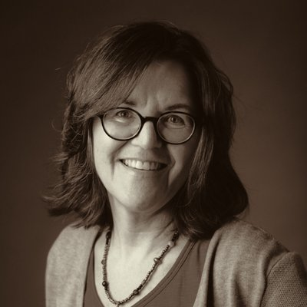 R.L. Maizes‏ @RL_Maizes
Many writers wish for a mentor. Here’s your chance! #AWPMentorship @awpwriter @DianeZinna

AWP‏ @awpwriter
Good point @RL_Maizes! #AWPMentorship

Amy Nastase‏ @AmyN_writer
Receiving mentorship from a wise and established writer was such a gift. The program is officially 12 weeks, but the advice & encouragement I got from my mentor will last for my entire writing life. #AWPMentorship #AWPW2W

Caroline Bock‏ @cabockwrites
The best of 2018 for me? Working with my talented mentee and @DianeZinna and everyone at the @awpmentorship program #awpmentorship !! #WritersLoveWriters . Inspiring.

Elyse Durham‏ @durham_elyse
Thank you, @nbakopoulos, for introducing me to @awpwriter! Because of you, I was able to be part of this year's #AWPW2W program, and I've grown by leaps and bounds. #awpmentorship

Diane Zinna‏ @DianeZinna
Being involved with the program all along the way is personally rewarding to me and helps me better understand our members. #awpmentorship #AWPW2W

Diane Zinna‏ @DianeZinna
We don't just match people and step away! We check in regularly and provide space for participants to connect & share with one another. #awpmentorship #AWPW2W
Elyse Durham‏ @durham_elyse
This is so true! @DianeZinna and @awpwriter have come right alongside us during the #AWPW2W program and offered so much support. Y'all are amazing.

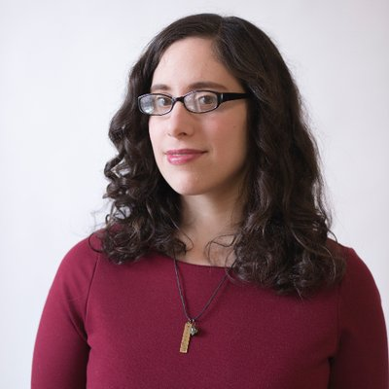 Jennifer Wholey @TheWholeyTruth
@DianeZinna is seriously a goddess.

AWP‏ @awpwriter
Well, we were trying to keep it a secret... @TheWholeyTruth #AWPMentorship

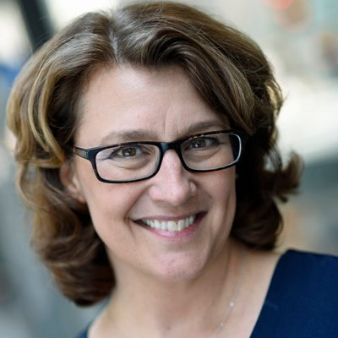Laura Laing @llaingwriter
I have been so surprised by the one-on-one support from AWP, as well as from my mentor. The bi-weekly modules give our discussions structure, plus there is room for us to develop our own way through the mentee/mentor relationship
AWP‏ @awpwriter
We are happy to have you part of the #AWPW2W family! #AWPMentorship @llaingwriter

Jarika‏ @JarikaJohnson
It really is the BEST support you could ask for. I gained this amazing opportunity but also an incredible community and support system. Like, overnight! There's nothing like #AWPMentorship

AWP‏ @awpwriter
Thank you @JarikaJohnson, there is nothing like kind words, that is the BEST when we love the support we are able to provide. #awpmentorship

Elyse Durham‏ @durham_elyse
If you're a writer looking for community, mentorship, and overall skill-sharpening/mind-boggling support and encouragement, look no further. @awpwriter @DianeZinna #awpmentorship #AWPW2W
Megan DeMatteo‏ @megdematteo
Skill sharpening and mind-boggling seem like opposites but my how they go together! Writing is magic, and and so is mentorship. #awpmentorship @awpwriter @DianeZinna

Diane Zinna‏ @DianeZinna
Many of our mentors were inspired to apply to the program because of great mentors they have had. #awpmentorship #AWPW2W

Elyse Durham‏ @durham_elyse
@DianeZinna Applying to be a mentor someday is #1 on my writing bucket list now! This program has given so much to me, and I can't wait to give back. #awpmentorship #AWPW2W @awpwriter

RomanaIorga‏ @RomanaIorga
And mine!

Diane Zinna‏ @DianeZinna
Oh wow. This means so much. Thank you, Elyse. #AWPMentorship #AWPW2W

Diane Zinna‏ @DianeZinna
This season, our amazing mentee @JarikaJohnson offered to match the mentees up with one another so everyone could have a peer critique partner, too! #matchmaking #AWPW2W #AWPMentorship

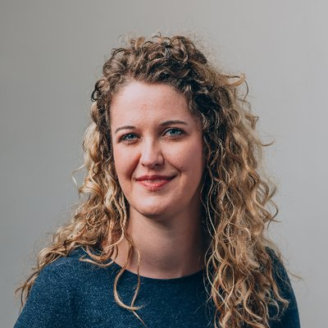 Jessica Wilbanks @creativenonfic
I'll be spending my lunch break today chatting with @DianeZinna, @awpwriter, and a bunch of mentees and mentors about #AWPMentorship's awesome Writer to Writer program. If you have questions about the program, send them my way. #AWPW2W

AWP‏ @awpwriter
Haha @creativenonfic, we're enjoying lunch with you to answer questions!

AWP‏ @awpwriter
Thank you @creativenonfic! #AWPMentorship

Diane Zinna‏ @DianeZinna
Writer to Writer modules help you answer essential questions about being a writer. How will I support myself? How do I develop my process? What do I do when I lose focus or inspiration? #AWPW2W #awpmentorship

Jennifer Steil‏ @jfsteil7
Talking with my mentee @okatrandjian is always a highlight of my week. Her novel is significant and provocative. It's a deep pleasure to be a part of her process. Our conversations always spark my brain and I return to my own work inspired. #AWPmentorship @DianeZinna #AWPW2W

Diane Zinna‏ @DianeZinna
Our mentors volunteer their time, and there is no charge for the Writer to Writer mentorship. It's free! The only requirement is that you're an AWP member. #awpmentorship #AWPW2W

Elyse Durham‏ @durham_elyse
#AWPW2W has given me the support I needed to decide that yes, it IS time to call myself a writer at last, to put out those grad apps, to start sending out work for publication. #MFA2019, here I come! @awpwriter @DianeZinna

Aaron Caycedo-Kimura‏ @AaronCK
My mentor provided a truly safe place for me to be vulnerable and ask all my "dumb" questions. I learned so much and now love poetry even more. #AWPMentorship #AWPW2W @DianeZinna @awpwriter

Olga Livshin‏ @OlgaLivshin
At one point in my #AWPMentorship, I would escape to the roof to talk on Skype with my mentor. We had a cramped apartment in Cambridge, MA, and my son took a nap--this was the only time. Leaves, snow accumulated, and Janet laughed. It was a tough time. We overcame it together!

Elyse Durham‏ @durham_elyse
I've wanted to get an MFA for ages, but family obligations dictated otherwise. This was the first year in nearly a decade I was able to put writing first. Thanks to @awpwriter and #AWPW2W, I've been able to hone in on my vocation, sharpen my skills, and find community at last.

Diane Zinna‏ @DianeZinna
We look for mentors who will, above all, be supportive, responsive, and open to learning from the experience themselves. #awpmentorship #AWPW2W

Jessica Wilbanks‏ @creativenonfic
In honor of @GivingTuesday, I'm donating a signed copy of my new book, When I Spoke in Tongues, to anyone who makes a donation of $10 or more to @awpwriter by midnight central time on 11/27. Please support the #AWPMentorship program, which has made 498 writers a lot less lonely.

Jessica Wilbanks‏ @creativenonfic
To participate, please RT and then send me a direct message. If you're selected, I'll email you and asked for a screenshot of your donation receipt. #awpmentorship #AWPW2W
Jessica Wilbanks‏ @creativenonfic
Oops, I realize I phrased this badly! One person will be selected to receive a free book...but since it was my mistake, I'll pick three people instead.
Jessica Wilbanks‏ @creativenonfic
Wish I could send every single person who donates to @AWP a copy! #LifeGoals #MaybeNextYear
Megan DeMatteo‏ @megdematteo
Thank you @creativenonfic !!! #AWPMentorship

Hélène Cardona‏ @HeleneCardona
Mentorships create bridges between writers. I loved Mentoring @awpwriter #AWPMentorship #AWPW2W @dianezinna. What an enriching, transformative experience! #WritersLoveWriters This #GivingTuesday when you donate to AWP you can win one of their signed books!

Laura Laing‏ @llaingwriter
Hey you writers! If you need a mentor or if you want to be a mentor, check out AWP's Writer to Writer program. #awpmentorship #AWPW2W. Craft. Publishing. Writing communities. I've talked about it all with my mentor @ericatrabold. You should apply.

Elyse Durham‏ @durham_elyse
The most unexpected joy of #AWPW2W has been our mentees-only Facebook group. Such awesome community! Such laughs! Such genuinely helpful suggestions and ideas! It makes the writing life a little less lonely and a hecka more fun. @awpwriter @DianeZinna

RomanaIorga‏ @RomanaIorga
Totally agree! And the best thing is, the way it's going, our community will continue to thrive when the current session is over!

Diane Zinna‏ @DianeZinna
Writers of genre-bending or unique work: apply! Our pairings often find striking commonalities—and grow through differences. We have a new favorite phrase this season: #genrepromiscuous #awpmentorship #AWPW2W

Tom Stern‏ @tomsternwrites
#AWPMentorship facilitates a unique type of dialogue, a very human conversation between two people striving towards similar goals and reflecting upon their experiences from different points of a continuum. It’s not a classroom or a writer’s group but something very singular.

Diane Zinna‏ @DianeZinna
When pairing people, we like to think there is a bit of magic at work. #awpmentorship #AWPW2W

Dr. Regina Chiuminatto‏ @RChiuminatto
Magic is a great word! In conversation with my mentor @jasonmgray I have been discovering so many points of connection and have gotten to see how lives and communities are shaped through and with poetry. I knew I wanted to find community, but now I understand why. #awpmentorship

Aaron Caycedo-Kimura‏ @AaronCK
There's also keen perception involved in considering personalities, writing samples, and views of the writing life. The #awpmentorship team is so amazing at what they do!

Margaret Grant‏ @MargaretGrant22
This mentorship was a turning point in my life as a writer. My writing improved, my confidence grew, and a story was published! #AWPMentorship #AWPW2W @DianeZinna @VirginiaPye #amwriting

Margaret Grant‏ @MargaretGrant22
I encourage writers all the time to apply to the #AWPMentorship #AWPW2W My outstanding mentor @VirginiaPye and I are still in touch reading and supporting each other nearly two years later. #amwriting @DianeZinna

Virginia Pye‏ @VirginiaPye
Such a rewarding way to get to know other writers! Join @awpwriter #AWPmentorship. I'm grateful for @MargaretGrant22 and her brilliant book!

Elyse Durham‏ @durham_elyse
Writers of the world, if you're looking for a way to support the literary community this #GivingTuesday, look no further than @awpwriter. Writer-to-Writer gives new and experienced writers the chance to connect and share what they've learned. Trust me--you want in on this.

Elyse Durham‏ @durham_elyse
And if you can't give financially, consider applying to be a #AWPW2W mentor. Through this @awpwriter program, you can help introduce a new writer into the world. We're all only here because somebody showed us the way. Why not give that same gift to someone else?

Diane Zinna‏ @DianeZinna
Sometimes apps from people of color express a desire for a mentor with the same background & those mentors aren't there. #awpmentorship #AWPW2W

Annette Wong‏ @StrnglyWrdedLTR
That my mentor @neil_aitken & I both have the experience of being Asian American, trans-national & multilingual has so enhanced our conversations abt. writing & the themes that speak to us. I hope other writers of color will have a similarly enriching experience #awpmentorship

Diane Zinna‏ @DianeZinna
When looking at mentee apps, we tend to set aside those from writers looking for a fast path to publication. #awpmentorship #AWPW2W

Diane Zinna‏ @DianeZinna
W2W is about relationship building between two writers and their mutual growth. Mentors often say they learn just as much. #awpmentorship #AWPW2W

Jarika‏ @JarikaJohnson
My mentor @tomsternwrites has given me insight into his writing journey along with encouragement & guidance. & sometimes, we just chat about family, work, and the like, bc it's all apart of the writer experience. So glad my exp now includes this program. #AWPMentorship #AWPW2W

Olivia Katrandjian‏ @okatrandjian
I'm so thankful for the guidance I've received from my mentor @jfsteil7 through #AWPMentorship. She inspires me to be a better writer. I've gained not only professional support but also a friend and role model. Thank you @DianeZinna and @awpwriter for this opportunity! #AWPW2W

Jennifer Steil‏ @jfsteil7
Also, it's just so much fun! (I am sorry for the slowness of my Tweets - I am on a train between Bournemouth and London with intermittent Internet!) But yay #AWPMentorship!

Clare‏ @clr_sanders
The AWP Writer to Writer program has been a dream come true! I've learned more about craft these past three months than I have in all the rest of my writing years combined. @DianeZinna #AWPMentorship #AWPW2W
Elyse Durham‏ @durham_elyse
Clare, it's so true! If the writing life were like Mario Kart, #AWPW2W is like running into a super-turbocharged line of bananas that explodes your writing off into the sunset...
AWP‏ @awpwriter
#besttweetever #AWPMentorship

Diane Zinna‏ @DianeZinna
To the mentees and mentors who are with us today—what advice would you give to future participants? #awpmentorship #AWPW2W

Aaron Caycedo-Kimura‏ @AaronCK
Facetime or Skype. It makes a HUGE difference. It's bonding. I know it doesn't happen this way with every pair, but my mentor and I have continued to Facetime every two or three weeks, trading poems. #awpmentorship #AWPW2W
RomanaIorga‏ @RomanaIorga
Yes! Introducing our children and pets can help, too!
Aaron Caycedo-Kimura‏ @AaronCK
:D

lisa nikolidakis‏ @lisanikol
Sometimes you need not to write. And that’s okay, too.
RomanaIorga‏ @RomanaIorga
Take yourself seriously--you're a writer if and when you write. Show up at your workplace (writing desk/cave, library, coffee shop, etc.) ready for the greatest adventure of your day.
Margaret Grant‏ @MargaretGrant22
To mentees - take responsibility for the success of your menteeship. Great support is available from @DianeZinna but it is up to you to be clear about what you need and work with your mentor to make it great. #AWPW2W #AWPMentorship
Jennifer Wholey‏ @TheWholeyTruth
Ask all the questions that pop into your head, even (and especially!) the "stupid" ones. You are in a wonderful cocoon and can do no wrong, except hold back.
Sassafras Lowrey‏ @sassafraslowrey
my #1 piece of advice for writers thinking of applying to #AWPW2W is to be *very* honest with yourself and with your application materials about what kind of writing you want to do, what your goals are and what you hope to get out of the program-don't write what you think we want

Sassafras Lowrey‏ @sassafraslowrey
My other piece of advice for folks considering applying to #AWPW2W is just apply! Don’t be a perfectionist! When I read applications I’m not looking for a perfect writer I’m looking for a passionate writer

Megan DeMatteo‏ @megdematteo
Love this advice. Perfectionism kills genius! Thanks @sassafraslowrey for your dedication and sight for passion & potential. #awpmentorship #writerslovewriters

Elyse Durham‏ @durham_elyse
@DianeZinna I would advise future #AWPW2W applicants to be 100% themselves. The more honest they are in their statement and sample, the better the match will be--and that makes all the difference.

R.L. Maizes‏ @RL_Maizes
A writing mentor you can ask all those scary questions: Can you make a living as a writer? How does one get an agent? Can I borrow $100? (kidding!) #AWPmentorship @awpwriter @DianeZinna

Diane Zinna‏ @DianeZinna
Our mentors and mentees find community with one another as well. Facebook groups and group calls help this along. #awpmentorship #AWPW2W

Diane Zinna‏ @DianeZinna
To the mentors who are chatting with us today: what made you choose your mentee? #awpmentorship #AWPW2W

Tom Stern‏ @tomsternwrites
@JarikaJohnson’s application made it clear that she was ambitious, imaginative, and grounded. Her imagination was off in the stratosphere and her mind was trained intently on being a better writer. Perfect combo for me and for #AWPMentorship
Hélène Cardona‏ @HeleneCardona
I love Laura Braverman's poetry!
Erica Trabold‏ @ericatrabold
There were so many cool metaphors and experiments my mentee wanted to try in her nonfiction, and I couldn't wait to read more!!
Erica Trabold‏ @ericatrabold
As I read apps, I thought a lot about my strengths and who I could best serve. Laura was looking for a mentor who knew nothing about abstract math (that's me!) and could encourage formal experiments (my fave!). In her app, I saw needs I could uniquely meet.
Jessica Wilbanks‏ @creativenonfic
I chose my mentee, Shannelle Mills, because I was blown away by the gorgeous language in her sample essay. Sentence by sentence, her work is stunning. Plus, we're both interested in nonfiction that integrates research while also remaining deeply personal. #AWPW2W #AWPmentorship

Diane Zinna‏ @DianeZinna
Mentees take time to consider the mentor’s work before accepting their place in the program. That way, when the mentor and mentee begin the program, they are doing so having chosen each other. #awpmentorship #AWPW2W

Elyse Durham‏ @durham_elyse
I still maintain you guys use a Sorting Hat in this magical process.
Diane Zinna‏ @DianeZinna
We actually make wishes on this Harry Potter plushie and ceramic Niffler. #HarryPotter #AWPMentorship #AWPW2W
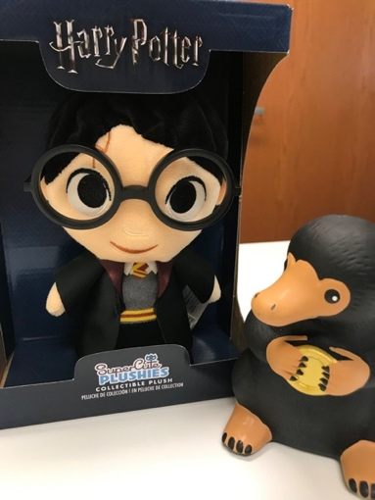

Elizabeth Zertuche‏ @WriterEZertuche
Meeting and hanging out with my Fall 2017 AWP Writer to Writer Mentor @jennyleeSD was the highlight of my AWP 2018 experience! Thank you, @DianeZinna. #awpmentorship #AWPW2W
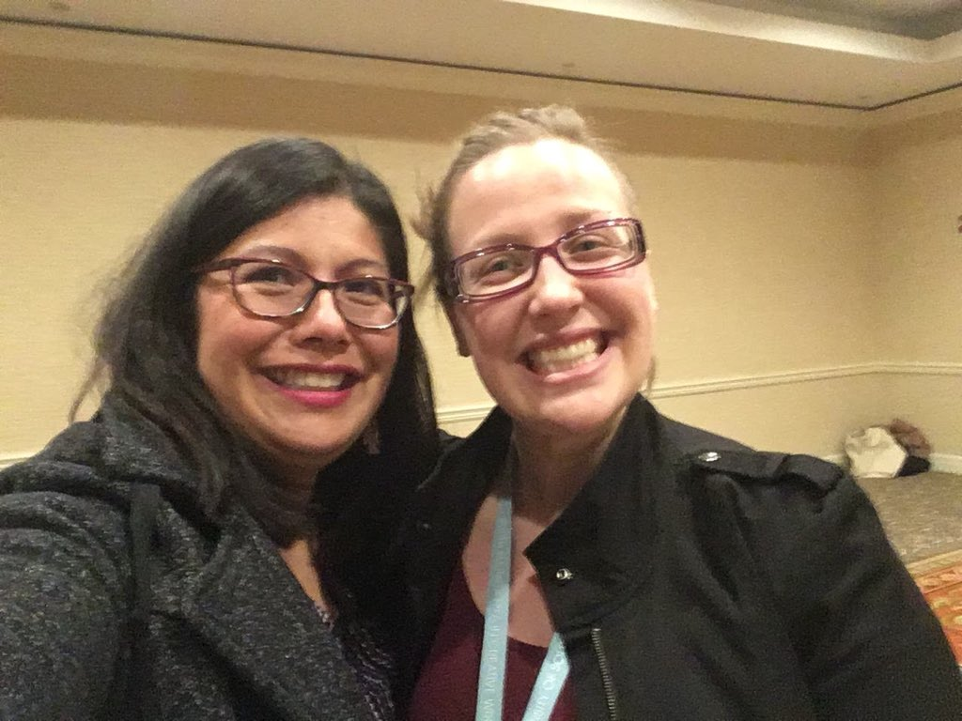

Diane Zinna‏ @DianeZinna
When submitting your 10-page writing sample, be sure to submit current work. You want someone who will read your work and say, “I can help this person with THIS project.” #AWPW2W #awpmentorship

Diane Zinna‏ @DianeZinna
We send 3 or 4 applications, along with writing samples, to each mentor. The mentor then chooses the 1 person they want to work with. #awpmentorship #AWPW2W

Diane Zinna‏ @DianeZinna
Mentors don't tend to look for the best or most accomplished writer. They look for the person they think they can best help. So don't try to be impressive. Be open and honest in your answers to the application questions. #awpmentorship #AWPW2W

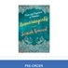Soniah Kamal‏ @SoniahKamal
Being an AWP mentor was a pleasure! Gift yourself the gift of teaching and learning @awpwriter @DianeZinna #AWPmentorship

Margaret Lazarus Dean‏ @mlazarusdean
It’s really satisfying to give the advice and encouragement you wish you’d gotten. #AWPMentorship #AWPW2W

Michael Wells‏ @stickpoet
A big thank you to @DianeZinna and her #W2W #AWPMentorship staff for making #W2W such a successful program that so many benefit from.

Diane Zinna‏ @DianeZinna
#AWPMentorship is trending on Twitter! #AWPMentorship #AWPW2W

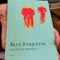Kathleen Driskell‏ @kathdriskell
Nearly every good thing in my life has come about through a connection with another writer. Maybe you feel the same? Please consider giving a donation today of $5 or more to @awpwriter Writer to Writer program. Our fundraising link is https://www.awpwriter.org/store/donations_givingtuesday … #AWPMentorship

Diane Zinna‏ @DianeZinna
To those who have applied, or are thinking of applying: what do you hope to gain from the program? #awpmentorship #AWPW2W

Diane Zinna‏ @DianeZinna
To our mentors and mentees—share your collaborations and projects that were inspired or helped along by your #awpmentorship experience. #AWPW2W
Jennifer Savran Kelly‏ @savranly
My mentor @amylizwrites helped me navigate through a novel ms with a complex structure. Through candid feedback and multiple discussions, she helped me identify the where the strengths were and reset my goals and intentions. It was a tremendous learning experience.

Helen Armstrong 📚🌈‏ @hkawrites
We've both been doing a lot of pure creation - free writes in the morning! It's been great. #AWPMentorship

RomanaIorga‏ @RomanaIorga
My mentor, @ErinHoover is helping me re-envision my whole manuscript. It's so incredible to have another writer look at my work seriously, with care and compassion for the little neurotic writer that I am.
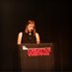Erin Hoover‏ @ErinHoover

Diane Zinna‏ @DianeZinna
Last season we selected about 50% of the people who applied to serve as mentors to participate. #awpmentorship #AWPW2W

Margaret Grant‏ @MargaretGrant22
In the application you are asked what you hope to get out of the program, so the matching is with someone who will help you with your stated goals. #AWPW2W #AWPMentorship @DianeZinna

Clare‏ @clr_sanders
AWP's Writer to Writer program is incredible for those who are searching for community and craving feedback from a more experienced writer. It's a beautiful opportunity to feel more supported and less alone as a writer! @DianeZinna #AWPW2W #AWPmentorship

Ann E Feldman‏ @AnnEFeldman11
#awpmentorship - So, if you're on the fence about applying to #AWPW2W ask yourself the question I asked myself - "Why not? What's the worst and best that can happen?" For me the best happened.

Diane Zinna‏ @DianeZinna
Before choosing our mentors, we look at all of the mentee applications first to see what that round's applicants are wanting. #awpmentorship #AWPW2W

Diane Zinna‏ @DianeZinna
We want our mentors to have pure intentions, too. If it's clear they are doing it to promote a new book, we set the app aside. #awpmentorship #AWPW2W

Diane Zinna‏ @DianeZinna
We celebrate our mentors and mentees in our social media and at the AWP conference. Sometimes it’s the first chance for a pairing to see each other face to face. #awpmentorship #AWPW2W.

Diane Zinna‏ @DianeZinna
Though we didn't expect this, about 1/3 of our mentors have come back to us asking to serve again. #awpmentorship. #AWPW2W

Diane Zinna‏ @DianeZinna
Thinking about being a mentor? You need to be an AWP member in good standing and have at least one published book. #awpmentorship #AWPW2W

Margaret Grant‏ @MargaretGrant22
My mentor @VirginiaPye is so knowledgeable and experienced in writing, publishing, and marketing. I have learned so much from her. #AWPW2W #AWPMentorship @DianeZinna #amwriting

Diane Zinna‏ @DianeZinna
Many of our mentoring pairs told us that they planned on keeping in touch once their session ended. #awpmentorship #AWPW2W

Andrew Bourelle‏ @AndrewBourelle
I still keep in touch with my mentor, the terrific writer Evan Morgan Williams. He just emailed me yesterday and said he wanted to send me a book he'd read that reminded him of what I'm working on. #awpmentorship #AWPW2W

Sassafras Lowrey‏ @sassafraslowrey
Authors: considering ways to give back to literary communities? Check out the @awpwriter #awpmentorship #AWPW2W program! I've had a wonderful experience mentoring queer writers! #LGBTQ #writing #onwriting #mentoring

Diane Zinna‏ @DianeZinna
To the mentees who are with us today—how has the #awpmentorship program affected the writing goals that you have set? Any new goals? #AWPW2W
Helen Armstrong 📚🌈‏ @hkawrites
I came in not sure if I should pursue a creative writing degree, but now I'm almost finished applying!
Elyse Durham‏ @durham_elyse
#awpmentorship showed me that yes, I do need to take my writing seriously and no, I'm not crazy for considering an MFA. More than anything, though, it showed me how amazing it is to be part of the literary community.
Helen Armstrong 📚🌈‏ @hkawrites
This!!
Margaret Grant‏ @MargaretGrant22
My goal was to write beautifully and it still is. But with the #AWPW2W #AWPMentorship I began to believe in further possibilities of finding an agent and being published. And the program has helped with both!
Aaron Caycedo-Kimura‏ @AaronCK
The #awpmentorship program made me realize that my writing goals/dreams are actually possible! I feel like I'm continuing to grow as a writer.
RomanaIorga‏ @RomanaIorga
I'm having the same experience! I've been in arm-pinching mode since September.
Jack El-Hai‏ @Jack_ElHai
Thank you for writing "affected" instead of "impacted."
Lauren K Carlson‏ @LaurenK_Carlson
My mentor and I are working on a collaborative poem. I haven't done something like this before and am looking forward to building some new creative muscles.
Caroline Plasket‏ @CarolinePlasket
I learned so much from my mentor—and she’s still there for me! I had no idea what the process of putting all of these separate parts together as one cohesive collective looked like. A W2W mentor is kind of like a writing doula, you know, the mentees are birthing their work...
RomanaIorga‏ @RomanaIorga
I have a better idea of what I need to do with my manuscript--what poems will take more work, what poems are almost there, and what poems will serve as load-bearing walls for the whole structure of the book.
Laura Laing‏ @llaingwriter
I applied to the program to learn more about breaking form, and my mentor, @ericatrabold has introduced me to a few exercises in revision to help me write against type (so to speak). It's been so inspiring, and now revision has taken on a brand new meaning. #awpw2w

Elyse Durham‏ @durham_elyse
My #AWPW2W mentor has been showing me what the writing life is like. Early on, you've got so many questions. Am I really a writer? How do start a daily practice? If I can only write for five minutes, does that "count"? (Answers: YES! Commit! Sure does!) @awpwriter @DianeZinna

Preeti Parikh‏ @PreetiSParikh
I remain thankful for how deeply invested my mentor @ShikhaMalaviya has been in the conversations we've had during (and even after) the program. Thank you, @DianeZinna and #AWPW2W for facilitating this wonderful connection!

Megan DeMatteo‏ @megdematteo
Love this story. Thank you, @PreetiSParikh . #AWPmentorship is an investment in human connection.

Ann E Feldman‏ @AnnEFeldman11
#awpmentorship: Oops! @drocklin is my MENTOR EXTRAORDINAIRE. Can you tell that I'm a Twitter newbie?

Elyse Durham‏ @durham_elyse
My #AWPW2W mentor, Zeke Jarvis, has gone out of his way to give me feedback, advice, reading recs, and encouragement--all just because he wants to give back. @awpwriter @DianeZinna

Diane Zinna‏ @DianeZinna
We want to hear from you! What are you looking for in a mentorship experience? #awpmentorship #AWPW2W

Diane Zinna‏ @DianeZinna
Mentee applications for our 10th season are welcome January 1–12. Mentor applications are welcome now. #awpmentorship https://awp.submittable.com/submit #AWPW2W

Lauren RIOT!‏ @ell_emm_dee
Lauren RIOT! Retweeted Diane Zinna
Seriously, friends. You want to apply for this!! #AWPmentorship #AWPW2W

Michael Wells‏ @stickpoet
#AWPWriter2Writer program introduced me to a number of awesome writing friends. My mentor Ken Waldman was most gracious with his time and assistance. #W2W may be the best-kept secret for emerging writers so we need to spread the word!

billykilgore‏ @billydkilgore
So grateful for my time in #AWPMentorship. My mentor introduced me to many helpful resources that improved my writing. Thankful for @beoliu’s support and the work of @DianeZinna.

Preeti Parikh‏ @PreetiSParikh
#awpmentorship Can't wait to meet #AWPW2W folks in person at AWP19!

Elyse Durham‏ @durham_elyse
I almost didn't open the email telling me I'd been selected as a #AWPW2W mentee. I'd been rejected from so many things and was really discouraged, and I didn't want more bad news. But it was good news! I shrieked in a coffeeshop. People stared. @DianeZinna @awpwriter

Shikha Malaviya‏ @ShikhaMalaviya
So happy to have had the opportunity/priviledge to be a mentor three times through #AWPW2W program. Thank you @DianeZinna and her amazing team @awpwriter!Please consider supporting AWP's mentorship program on this #GivingTuesday

Diane Zinna‏ @DianeZinna
We also have received applications from individuals who feel geographically isolated from other writers and writing communities. #awpmentorship #AWPW2W

Diane Zinna‏ @DianeZinna
Thank you ALL for taking the time to Tweet with me! This was so much fun! Prospective mentors and mentees, please reach out to me with any questions at diane@awpwriter.org. We welcome mentee applications January 1-12 and mentor applications right NOW! #AWPMentorship #AWPW2W

Elyse Durham‏ @durham_elyse
@DianeZinna This hour has gone by so fast! Thank you for giving us the chance to brag about how awesome #awpmentorship is. And thank you, @awpwriter , for making us part of this community!

AWP‏ @awpwriter
Thank you all for your participation in today's tweet chat! Thank you @DianeZinna for being our host and all #AWPW2W participants! #AWPMentorship

AWP‏ @awpwriter
You can spread the love for #W2W for #GivingTuesday by donating here: https://www.awpwriter.org/store/donations_givingtuesday … #WritersLoveWriters #AWPMentorship

AWP‏ @awpwriter
Head over to Facebook as we continue to give away signed books to those donating this #GivingTuesday! #AWPMentorship #Writerslovewriters

