AWP’s Twenty-seventh Tweet Chat: #AWPMentorship
December 3, 2019 from 2:00-3:00 p.m. ET

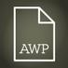AWP@awpwriter
Today we are celebrating #GivingTuesday with our annual tweet chat, at 2:00 pm EST, hosted by Diane Zinna. Learn more about our Writer to Writer program, and chat with past and current mentors and mentees! #12dayofW2W
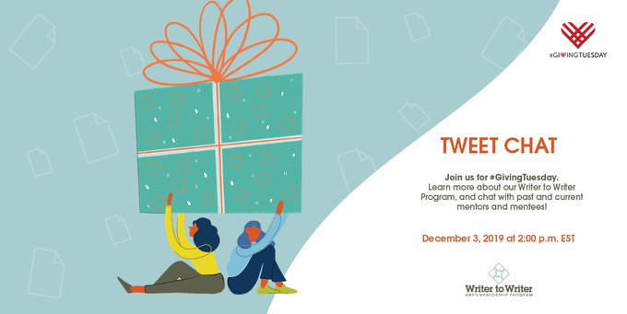

Diane Zinna @DianeZinna
Hi, Everyone! I'm Diane Zinna, and over the next hour I'll be answering your questions about AWP's Writer to Writer Mentorship Program! #awpmentorship #AWPW2W

Vanessa Chan @vanjchan
Hey there! How often to writers and mentors meet/communicate typically?
Diane Zinna @DianeZinna
Hi Vanessa! Mentors agree to spend at least 1 hour a week with their mentees, and they communicate via email, phone, or Skype--whatever works best for them!

Shikha Malaviya @ShikhaMalaviya
Hi, I’m a four time mentor in poetry and talk/connect with my mentees on a weekly basis. Our calls run between 1-2 hours. #awpmentorship #awpw2w

Diane Zinna @DianeZinna
You give so much of yourself every time. Thank you, Shikha!

Julie Draskoczy Zigoris @jzigoris
I talked on the phone for an hour bi-weekly with my mentor and had ongoing email threads for things that came up in between. Writers make individual arrangements with their mentors, so it'll be different for everyone.

Terri Wise @TNWise
Julie, my experience has been very similar to yours: bi-weekly phone calls and ongoing email threads, with extra communication if something comes up.

Irene Hoge Smith @IreneHSmith
Happy to be in touch about my experience as a mentee; I assume you are looking to be a mentor?
Vanessa Chan @vanjchan
Me? No, no, mentee!

Vanessa Chan @vanjchan
Love all this thank you everyone!

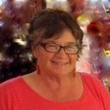 Sandra Gail Lambert @sandralambert
I'm ready for the AWP mentorship tweet chat! I've mentored a couple of times. Ask me anything. #AWPmentorship @awpwriter @dianezinna

Diane Zinna @DianeZinna
And @sandralambert will be coming back to mentor again for the Spring 2020 season! So Sandra--perhaps you can let people know here what you will be looking for in the mentee applications presented to you? #awpw2w #awpmentorship

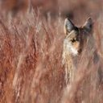 Califragile Poetry @CalifragileP
I'm in Goddard's MFA program and, in addition to publishing my poetry, I plan to teach. How does an AWP mentor help with building a career? Also, I'm older. Would I fit?

Sandra Gail Lambert @sandralambert
Someone else can provide a better answer about MFA programs, but I can say that us "older" folk definitely fit. #AWPmentorship @awpwriter @dianezinna

𝕭𝖗𝖚𝖈𝖊 𝕺𝖜𝖊𝖓𝖘 𝕲𝖗𝖎𝖒𝖒 @bruceowensgrimm
Good to know “older” folk fit. I think I’m going to apply to be a mentee.

Diane Zinna @DianeZinna
I will watch for your application!

𝕭𝖗𝖚𝖈𝖊 𝕺𝖜𝖊𝖓𝖘 𝕲𝖗𝖎𝖒𝖒 @bruceowensgrimm
Yay! Thank you!

Diane Zinna @DianeZinna
Hi! Absolutely, and you'd be so welcome! Take a look at our current mentee page & you'll see our mentees are adults from all age groups. Our program focuses on the writing life, including careers inside/outside academia. Just express that need in the app. #awpw2w #awpmentorship

Elyse Durham @durham_elyse
The biggest help #W2W gave me was a better understanding of craft (drafting, revising, etc.), which is the biggest building block in any career. My advisor also had a lot of practical advice about the submissions process and finding the right journals. #awpmentorship @awpwriter
Diane Zinna @DianeZinna
We’re also joined today by many current and past mentors and mentees who have helped make W2W what it is! They are here to answer your questions, too! #awpmentorship #AWPW2W

Trish Hopkinson @trishhopkinson
I'm a little bit late to the party, but thrilled to be a mentee this year! I've learned so much, made a good friend, and really enjoyed it. #AWPW2W

Diane Zinna @DianeZinna
Thank you, Trish! <3

Romana Iorga @RomanaIorga
I loved my experience in the W2W program! It validated my work and made me a more confident writer. Thank you, @DianeZinna and @awpwriter for matching me with my wonderful mentor @ErinHoover! #awpmentorship #AWPW2W

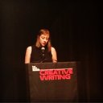 Erin Hoover@ErinHoover
I learned so much from my time serving as a mentor through #AWPW2W! Thank you @RomanaIorga for our many conversations about poetry and for the opportunity to see your work evolve. @DianeZinna matched us well! #awpmentorship @awpwriter

Diane Zinna @DianeZinna
AWP’s Writer to Writer Mentorship Program has two sessions per year (spring and fall). Our current session is our *largest* ever with 44 mentor-mentee matches. Before this one, our largest session was 30 pairs. #awpmentorship #AWPW2W

Diane Zinna @DianeZinna
You can read all about our beloved Writer to Writer (W2W) Mentorship Program (W2W) at this link: https://awpwriter.org/community_calendar/mentorship_program_overview… #awpmentorship #AWPW2W

AmyVictoriaBlakemore @AmyV_Blakemore
Y'all, this program is great. It helped me stay motivated and add structure to my writing during a bonkers busy point in my life. And I am *still* using the outlines and the drafts I started with my mentor @roberts_keena a year later. #awpmentorship #AWPW2W

Sandra Gail Lambert @sandralambert
#AWPmentorship @awpwriter @dianezinna It's not so much what I'm looking for in a mentee, but what I think I can offer them. My goal in mentoring with the program is to work with writers with disabilities.

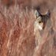 Califragile Poetry @CalifragileP
I am currently on disability. Since my family went through the Camp Fire, I decided to return to school with the plan of teaching creative writing at the college level. Although I can no longer do physical work, I want to build on my strengths.

Elyse Durham @durham_elyse
Last year, Writer to Writer gave me a mentor at the perfect time--I had just quit my day job, was plunging into writing full-time, and was absolutely terrified. W2W took my hand and gave me the courage to start. #awpmentorship #AWPW2W

Elyse Durham @durham_elyse
It's crazy to think about how much as happened since then. Last month, I just finished my first semester of my MFA and published my first short story in @CincinnReview -both unimaginable a year ago. Another person's faith in you makes all the difference.

sakae manning @sakaetrist
Join in on the #AWPmentorship convo with @DianeZinna, current mentors, and mentees. Now!

Diane Zinna @DianeZinna
Thank you, Sakae! We'd love for you to share what your experience this season has been! #awpw2w #awpmentorship

sakae manning @sakaetrist
@DianeZinna @awpwriter my mentorship with @jennyleeSD has brought me closer to understanding craft and how it relates to my work. It has gifted me with a mentor who is a writer and knows writing in an intimate way. #awpw2w #awpmentorship

sakae manning@sakaetrist
There is a generosity amongst mentees in supporting each other, and my mentor has been an incredible resource with a wicked sense of humor.
@jennyleeSD #awpw2w #awpmentorship #writingcommunity #womenwriting

Julie Draskoczy Zigoris @jzigoris
If anyone has questions about the #awpmentorship and #AWPW2W I'd be happy to answer them! I have benefited enormously from this program with @awpwriter and my mentor @ConfusedNarwhal. Thank you to @DianeZinna for everything you do to keep it going strong!

Diane Zinna @DianeZinna
I am so grateful you applied and I was able to make this match, Julie! #awpw2w #awpmentorship. I just had a feeling about you and Meg!

Emily Huso @EmilyHuso
This is me and my AWP mentor @ChaunaCraig at the Writer to Writer meetup in Portland! Chauna has been a steady source of guidance and inspiration since our W2W relationship began in spring 2017. #AWPW2W #AWPMentorship

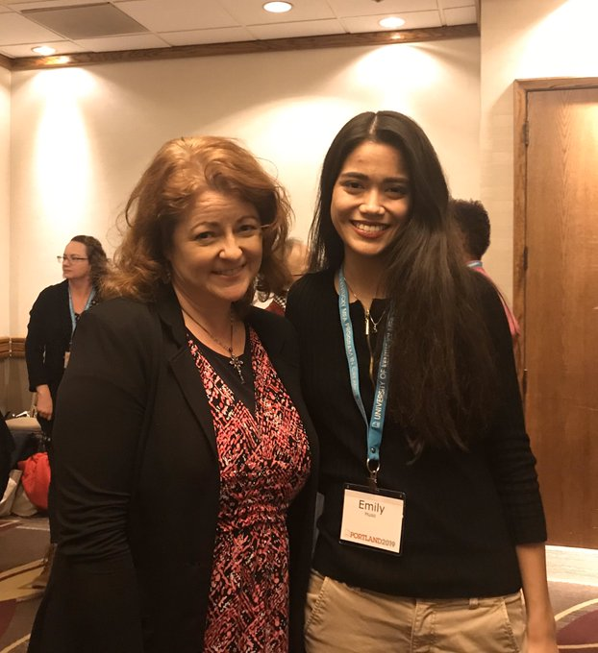
Sandra Gail Lambert @sandralambert
#AWPmentorship @awpwriter @dianezinna Also, I'm a writer very much outside of the academic world so I think I can offer some knowledge of how to make your way in the writing world without that sort of background.

Marlena Chertock @Mchertock
Participating in @awpwriter's Writer to Writer Mentorship Program has been a great experience! I've loved getting to review @cbratbyrudd's manuscript & chatting about the writing life.
Consider applying to be a mentor or mentee next season
#AWPW2W #AWPMentorship @DianeZinna

Marlena Chertock @Mchertock
So glad I got to meet @cbratbyrudd, my AWP Writer to Writer mentee in LA! Can’t wait to see where her books end up
#AWPW2W #AWPMentorship
@DianeZinna
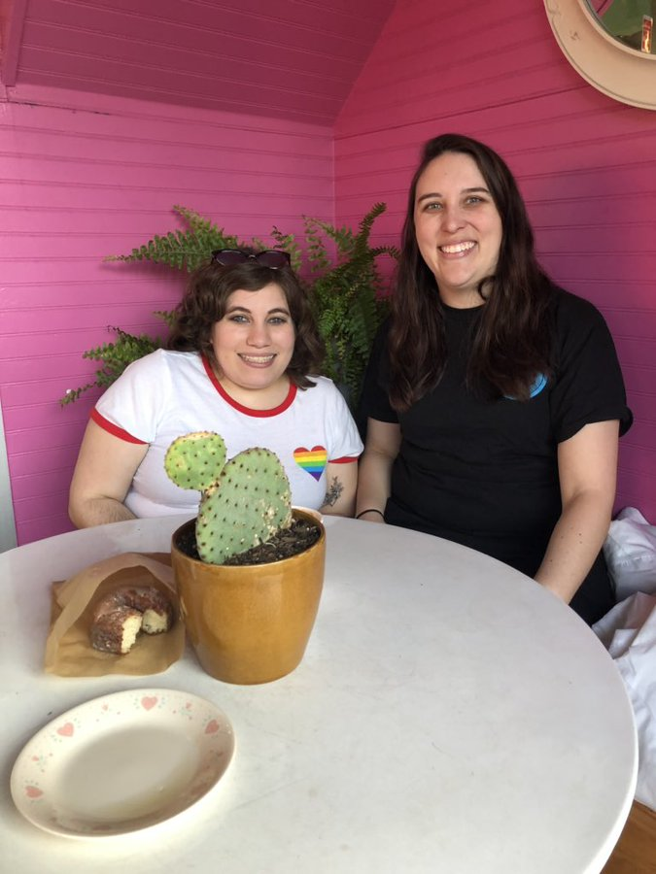
Ruth Ebenstein @RuthEbenstein
Grateful to @DianeZinna for finding me the perfect #mentor. Writers, consider supporting #awpmentorship, a free program for members of @awpwriter matching seasoned writers w/emerging ones! My experience was transformative #awpw2w #awpmentorship #writerslife #GivingTuesday
Diane Zinna @DianeZinna
Ruth, you were one of those applications where I decided I MUST find just the right mentor for you. I wouldn't give up. It took me a couple of seasons, but I know I found a beautiful partner for you! #awpw2w #awpmentorship

Juanita Romaine @NitaRomaine
I wish I could join the #awpw2w program, but I’m thrilled to be on the side to see all the wonderful mentees and mentors! Donate today #givingtuesday! #awpmentorship
@DianeZinna

Diane Zinna @DianeZinna
AWP has over 7,000 individual members, and many are writers who have never been associated with an MFA program. #awpmentorship #AWPW2W

R.L. Maizes @RL_Maizes
I was mentored through this wonderful program and have applied to be a mentor for the spring session. Check it out whether you need a mentor or are willing to be one. #awpmentorship #AWPW2W

Diane Zinna @DianeZinna
Everyone also needs to check out the incredible book of short stories by prior mentee R.L. Maizes, WE LOVE ANDERSON COOPER. I've been trying to get her to mentor for #awpw2w for a few seasons now, and she will officially be with us for the Spring 2020 season starting this Feb!

AWP @awpwriter
We are thrilled to have you @RL_Maizes back, as a mentor for season 12 of #AWPw2w!
Diane Zinna @DianeZinna
This program was created because we wanted to do something for those who are writing from backgrounds typically underrepresented in the literary world and those who have taken paths different from the MFA. #awpmentorship #AWPW2W

Leah Zitter, Ph.D @ZitterWriter
Where can I find more info on this please? Thanks.

Diane Zinna @DianeZinna
Hi Leah! You can find information about the Writer to Writer program at https://awpwriter.org/community_calendar/mentorship_program_overview

Leah Zitter, Ph.D @ZitterWriter
Hi Diana, Where is this Submittable that I can find/ download the application for a mentor? (Your link only provided mentor applications. It suggested I go to Submittable for a mentee one. Do you have the link to that?) Thanks again.

Diane Zinna @DianeZinna
That is made available when submissions open Jan 1-12!

Leah Zitter, Ph.D @ZitterWriter
Will you tweet a reminder? Or should I bookmark the link you gave me previously? (Will I find that there?)

Diane Zinna @DianeZinna
Yes, but I will also Tweet tons of reminders!

Leah Zitter, Ph.D @ZitterWriter
Wonderful! I'm following you...

LouiseWarehamLeonard @LouiseWLeonard1
Can you imagine George Eliot in an MFA program? Or the Bronte sisters?

AWP @awpwriter
#MadewithLove

Kathleen Driskell @kathdriskell
Today is beginning of #12 Days of Writer to Writer: The Gift of Caring. Give a little something in honor of one of your past writing mentors. I want to remember Jim Clark @UNCGMFA and his enormous generosity to his MFA students & the amazing @MollyPeacock3 <3 to her. @awpwriter
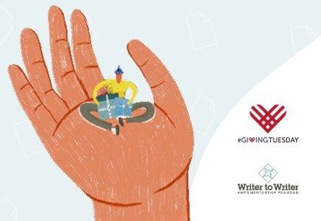

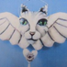 Wychserif @wychserif
How did Writer to Writer come about? Whose idea was it? How long has it been going on?

Kathleen Driskell @kathdriskell
Questions about how to find a writing mentor? Check out this chat

R.L. Maizes @RL_Maizes
Also a great place to donate to.

Ruth Ebenstein @RuthEbenstein
Grateful to @DianeZinna for finding me the perfect #mentor. Writers, consider supporting #awpmentorship, a free program for members of @awpwriter matching seasoned writers w/emerging ones! My experience was transformative #awpw2w #awpmentorship #writerslife #GivingTuesday

Kathleen Driskell @kathdriskell
Things to celebrate this season!!!! @awpwriter

Elyse Durham @durham_elyse
My W2W mentor gave me the greatest gift one writer can give another: generous and thoughtful feedback. He modeled the kind of curiosity and open-mindedness every writer needs to draft and revise. #awpmentorship #AWPW2W

Julie Draskoczy Zigoris @jzigoris
I am so grateful for my mentor @ConfusedNarwhal in the #awpmentorship. She became my "go-to" person for advice by email and during our bi-weekly chats. #AWPW2W through @awpwriter.

meg eden @ConfusedNarwhal
<3 You've been such a delight to mentor, Julie!

Michael Wells @stickpoet
The experience of the #AWPW2W program was such an encouragement and many of the mentees stay in contact which over the years adds to the value it offers.
Diane Zinna @DianeZinna
While the Writer to Writer Mentorship Program is open to all members, we especially encourage apps from writers of color, writers with disabilities, LGBTQ+ writers, and those who don't have an MFA. #awpmentorship #AWPW2W

Elyse Durham @durham_elyse
The most unexpected gift @awpwriter gave me was the gift of community. Writing can be so lonely, and having a cohort to struggle with made all the difference. We all did #W2W a year ago and we still keep in touch! We share top reading picks and cheer each other on. #awpmentorship

Diane Zinna @DianeZinna
Yes, you can apply if you already have your MFA! People need mentors at every stage of their career. Every stage comes with new questions. Each season we have many writers with MFAs take part. You are welcome! #awpw2w #awpmentorship

Elyse Durham @durham_elyse
Being knee-deep in my MFA now (at a program that I love!), I can say the two experiences are very compatible, but unique from each other. #W2W fills different needs than grad school (though I will say it prepared me well!), community being one of them. #awpmentorship @AWP

Romana Iorga @RomanaIorga
I had my MFA years ago, then got busy with work and family. #AWPW2W is just the right kind of program I needed to be in to restart my writing engine!

Rose Andersen @roseandersen
I was lucky to be able to mentor @ap_mess during this round of @awpwriter's Writer to Writer Mentorship Program. AP is damn good writer- their work is visceral, haunting and lingers long after you encounter it. Keep an eye out for their work! #AWPmentorship #AWPW2W

Rose Andersen @roseandersen
Have any questions about the AWP Writer to Writer Mentorship Program? I am happy to answer anything I can! Highly recommend signing up as a mentor or mentee! Or head over to @DianeZinna's page as she answers questions about the program! #AWPMentorship

Diane Zinna @DianeZinna
You are wonderful, Rose! I have loved watching from the sidelines with your relationship with your mentee this season. #awpw2w #awpmentorship

Evelyn LaTorre @EvelynsEdits1
I applied but wasn't given a mentor. Are there qualifications I don't know about?

Diane Zinna @DianeZinna
Hi Evelyn! We usually get around 400 applications for each session and there are usually around 30 mentors serving with us at any given time. Often people have to apply a few times before finding their right match. But when you do, it can be magic. #awpw2w #awpmentorship

AWP @awpwriter
Today is the day! Donate to #AWPW2W and help us pair seasoned mentors with a new batch of emerging writers. Celebrate #GivingTuesday with us as we begin #12daysofW2W! #12daysofGiving http://bit.ly/AWPGive2019
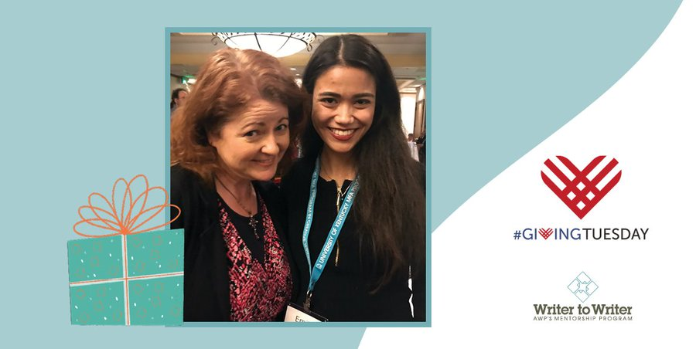

Joshunda Sanders @JoshundaSanders
It has been incredible & uplifting to work with @ToniRussell84 as part of #AWPW2W under the enthusiastic guidance of @DianeZinna. Especially as a writer who made my career largely outside of the MFA experience. It’s been good for my soul to share the journey.

Diane Zinna @DianeZinna
Joshunda, you have been AMAZING and such a positive force this season of #awpmentorship! Thank you from all of us at #AWPW2W!

Joshunda Sanders @JoshundaSanders
Wow thank you. That means so much to me. And thank you for all of your stellar work.

Hadley Moore @HadleyMoore10
I got to work with the wonderful @ChristineSneed through this program. And now I’m rich and famous! JK, but it was really helpful to my writing life.
Christine Sneed @ChristineSneed
It was a joy, and what a worthy program!

Sandra Gail Lambert @sandralambert
So far I've had a continuing connection with former mentees. Today I sent letters of recommendation to MFA programs for one and worked on editing a piece for the W2W upcoming anthology with another. #AWPmentorship @awpwriter @dianezinna

Sheila Black @SheilaFionaB
Sandra I love that - it is what makes the program so special.

Diane Zinna @DianeZinna
We often receive applications from individuals who feel geographically isolated from writers and writing communities. A program like this can help. #awpmentorship #AWPW2W

R.L. Maizes @RL_Maizes
The program has given me a wonderful community of writers. #awpw2w

Ruth Ebenstein @RuthEbenstein
My #mentor, Amy Gottlieb, made me feel that perhaps I could find a way to convey the magic of my memoir's story. It's about an #Israeli-#Palestinian friendship born through #breastcancer. #AWPMentorship opened a door to members of @apwriter, gratis. Thanks, AWP - & Amy! #AWPW2W

Julie Draskoczy Zigoris @jzigoris
Writing can be a lonely endeavor, but you don't have to do it alone! I encourage #writers to apply for the #awpmentorship run through @awpwriter. I have gained so much from this program. #AWPW2W #amwriting #amrevising #W2W

Marlena Chertock @Mchertock
Participating in @awpwriter's Writer to Writer Mentorship Program has been a great experience! I've loved getting to review @cbratbyrudd's manuscript & chatting about the writing life. Consider applying to be a mentor or mentee next season
#AWPW2W #AWPMentorship @DianeZinna

Diane Zinna @DianeZinna
It has been such an honor having you as a part of the AWP Writer to Writer Mentorship Program, Marlena! You are making such a huge difference! #awpmentorship #awpw2w

Elyse Durham @durham_elyse
I LOVED being a mentee for @awpwriter's mentoring program, Writer to Writer. It was really a life-changing experience. Hit me up with your questions! #w2w #awpmentoring

Elyse Durham @durham_elyse
The biggest help #W2W gave me was a better understanding of craft (drafting, revising, etc.), which is the biggest building block in any career. My advisor also had a lot of practical advice about the submissions process and finding the right journals. #awpmentorship @awpwriter

Diane Zinna @DianeZinna
Elyse, you have been on fire since the program ended! I love hearing about and celebrating all of your writing news! #awpw2w #awpmentorship
Elyse Durham @durham_elyse
Diane, I owe you (and @awpwriter) so much, and I'm so grateful. Hearing you celebrate is one of the biggest reasons I keep going! #W2W gives us lonely writers the chutzpah to keep at it when the work gets tough.

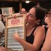 Donna Tallent @linoleumrose
#AWPMentorship program matches emerging writers w/ experienced mentors. I have been on an incredible journey with my mentor and made long-lasting friendships. Thank you, @DianeZinna and the @awpwriter folks for all you do.
A worthy program to support on #GivingTuesday #AWPW2W
Diane Zinna @DianeZinna
Thank you, Donna!

Diane Zinna @DianeZinna
We don't just match people and step away! We check in regularly and provide space for participants to connect & share all they are learning with one another. #awpmentorship #AWPW2W

Elyse Durham @durham_elyse
This is SO true! @DianeZinna and @awpwriter and my #W2W cohort have continued to be an amazing source of support, even a year later. My mentor and I also keep in touch--you all are like my shoulder angels!

Lisa Whalen @LisaIrishwhalen
I agree! The #W2W cohort is a great source of support, and my mentor,
@gailfolkins, offered to co-write an essay with me a year after our official mentorship ended, so the learning doesn't always end once the mentorship does.

AWP @awpwriter
#MadewithLove @awpw2w #givingtuesday

Ruth Ebenstein @RuthEbenstein
My #mentor, the wonderful Amy Gottlieb, writes poetry and fiction. I write #creativenonfiction. I applied a few times to #AWPMentorship - but did not give up. @DianeZinna
also didn't! She crossed genre lines - & found me Amy! Am I blessed, or what? Thanks #AWP & Diane! #AWPW2W

Diane Zinna @DianeZinna
Being involved with the program all along the way is so rewarding to me. Reading every application helps all of us on the membership team better understand our members’ needs and dreams. #awpmentorship #AWPW2W

Joe Milazzo @joemilazzo94
When I first applied to #AWPW2W, the #AWPMentorship program, my aspiration was to be a mentee. Somehow, I ended up being a mentor instead. Big thanks to
@DianeZinna, her staff, and the writers with whom I've worked for welcoming me into their literary communities.

Diane Zinna @DianeZinna
Many of our mentors were inspired to apply to the program because of great mentors they have had, a desire to pay it forward. #awpmentorship #AWPW2W

Sandra Gail Lambert @sandralambert
And some of us want to be a mentor because we never had one.

Olivia Katrandjian @okatrandjian
This #GivingTuesday, consider giving the gift of a mentor to an emerging writer in need through the incredible program run by @DianeZinna and @awpwriter. I could not be more grateful for the time I spent soaking up everything @jfsteil7 had to say! #AWPMentorship

Olivia Katrandjian @okatrandjian
The #AWPMentorship program also connects you with other writers, and a year after participating, our cohort is still in touch almost every week. Having such a supportive and inspiring community is a special gift in such a solitary profession.

Diane Zinna @DianeZinna
Olivia! We continue to celebrate your being a finalist for the Luxembourg National Literary Prize! We are all so proud of you.

Olivia Katrandjian @okatrandjian
Thank you, @DianeZinna. The first person I told after my husband was @jfsteil7!

Jennifer Steil @jfsteil7
I am equally grateful for all I learn from you and for all of your support @okatrandjian!!! I am so lucky to have you in my life.

Diane Zinna @DianeZinna
Other mentors apply because they know what a difference a mentor would have made on their journey. #awpmentorship #AWPW2W

Elyse Durham @durham_elyse
I still remember the moment @DianeZinna told me I'd been accepted to #W2W. I had just gotten a slew of rejections and I was starting to wonder if this writing thing was for me. Diane's email felt like the universe had grabbed a megaphone and yelled "KEEP GOING" @awpwriter

Elyse Durham @durham_elyse
I was in a coffeeshop when I got that life-changing email from @DianeZinna. I yelled. People stared. I think I even jumped up and spilled my coffee. If my otherwise-boring life is ever made into a movie, that moment will be in the trailer.

Diane Zinna @DianeZinna
Attention please: I still want you to KEEP GOING!
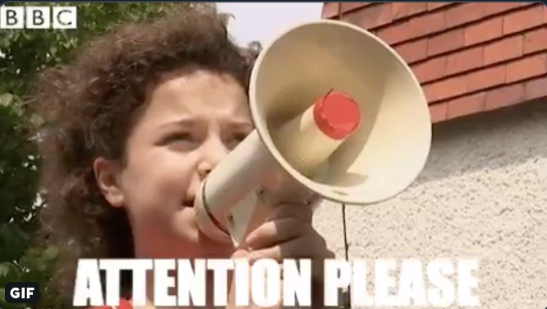

AWP @awpwriter
A #moviemoment if we've heard one. #awpw2w #awpmentorship #givingtuesday

Julie Draskoczy Zigoris @jzigoris
I had such a similar experience!

sakae manning @sakaetrist
<3

Diane Zinna @DianeZinna
We’re also joined today by many current and past mentors and mentees who have helped make W2W what it is! They are here to answer your questions, too! #awpmentorship #AWPW2W

Trish Hopkinson @trishhopkinson
I'm a little bit late to the party, but thrilled to be a mentee this year! I've learned so much, made a good friend, and really enjoyed it. #AWPW2W

Diane Zinna @DianeZinna
Thank you, Trish! <3

Diane Zinna @DianeZinna
The 6 modules of the Writer to Writer Program are meant to help you think about life as a writer. How will I find support? How do I develop my process? What do I do when I lose focus or inspiration? #AWPW2W #awpmentorship

Diane Zinna @DianeZinna
Our mentors volunteer their time, and there is no charge for the Writer to Writer mentorship. The only requirement is that you're a member of AWP. This is a program meant to build our community--and it has in such amazing ways! #awpmentorship #AWPW2W

Juanita Romaine @NitaRomaine
As I sit across from @DianeZinna, I see the overwhelming emotion on her face of all the mentees and mentors and their kind words. What a community, what a beautiful family #AWPMentorship #awpw2w #givingtuesday

Diane Zinna@DianeZinna
#W2W Tweet Chats make me emotional.

Ruth Ebenstein @RuthEbenstein
On #GivingTuesday consider supporting #AWPMentorship, which connects seasoned #writers w/emerging ones. Even just ten dollars can make a difference. Writers open hearts, minds, souls. Be a part of that creative magic! A worthwhile investment! #AWPW2W #AWPwriter #writerslife

Diane Zinna @DianeZinna
Spring 2020 will be our 12th season, and we can’t wait to show you our new slate of mentors. This program keeps getting better! #awpmentorship #AWPW2W

Diane Zinna @DianeZinna
Our mentors have to apply as well. We look for mentors who will, above all, be supportive, responsive, and open to learning from the experience themselves. #awpmentorship #AWPW2W

Lisa Whalen @LisaIrishwhalen
This #GivingTuesday, consider giving the gift of a mentor to an emerging writer through the incredible #writer2writer program run by @DianeZinna and @awpwriter. I'm grateful to have learned from my mentor, @gailfolkins. #AWPMentorship

Diane Zinna @DianeZinna
Did I mention mentors volunteer their time for this program? We are so grateful and watch from the sidelines with full hearts. #awpw2w #awpmentorship
Abbie Kiefer @heyAbbieK
Such an act of generosity!

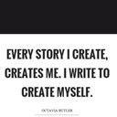 sakae manning @sakaetrist
*clap* *clap* *clap* *heart*

Raksha Vasudevan@RakshaVasudevan
I often talk to my mentor @sayan10 on weekends, given her busy teaching schedule. I'm so grateful for her generous she is with her time "off." #awpw2w #awpmentorship

Kathy Ridenhour@herwimsey
As W2W poetry reader, one of my favorite things about our program is our News & Celebrations page http://bit.ly/380howM, where we share the good news and achievements of our former mentors and mentees. #awpmentorship #AWPW2W

Diane Zinna@DianeZinna
We also look at excellent applicants from previous sessions who didn't get matched and try again to pair them. Sometimes we read something in that app that won't let us go. #awpmentorship #AWPW2W

Romana Iorga@RomanaIorga
I was one of those applicants. So glad I applied again--thank you for not giving up on me!

Diane Zinna@DianeZinna
We love you, Romana! #awpw2w #awpmentorship
Romana Iorga @RomanaIorga
Love you right back!

Diane Zinna@DianeZinna
When matching writers for Writer to Writer, we like to think there is a bit of magic at work. #awpmentorship #AWPW2W

Diane Zinna@DianeZinna
Writers of genre-bending or unique work: please apply! Our pairings often find striking commonalities—and grow through differences. One of our favorite phrases: #genrepromiscuous #awpmentorship #AWPW2W

Elyse Durham@durham_elyse
For those who want to apply to Writer to Writer, @awpwriter's mentoring program, but are feeling sheepish, DO IT! Even the process of applying and articulating yourself and your work is a valuable experience. PS: the program is also awesome #W2W #awpmentor

Elyse Durham @durham_elyse
Everybody deals with impostor syndrome, but for emerging writers it's especially bad. It feels like such an audacious thing to call yourself a writer. @DianeZinna @awpwriter and my Writer to Writer mentor taught me that YOU decide if you're a writer. (PS: you are) #W2W

wychserif@wychserif
I knew people in my MFA program who showed up with a novel and just wanted to get it published. That doesn't seem like much of a learning experience! W2W looks more like a "teach a person to fish" experience.

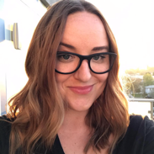 Rose Andersen @roseandersen
Me, ready and waiting to answer any questions about the @awpwriter’s Writer to Writer Mentorship Program. #AWPMentorship

Diane Zinna @DianeZinna
What makes us set an application aside? When looking at mentee apps, we tend to set aside those from writers looking for a fast path to publication. We are not that. #awpmentorship #AWPW2W

Elyse Durham@durham_elyse
I see a lot of brand-new writers eager to jump into publication, get agents, sign book deals, etc. Honey, life is long, and being a writer is so much more than that. Plan for the long haul! @awpwriter helped me understand that the work is its own reward. #W2W

Jennifer Savran Kelly@savranly
It's true that #awpmentorship is not a fast path to publication. Since my session in '14, I've continued to write and to look for a home for the 2 novels I've completed. But the program does offer wonderful support through the long and sometimes arduous journey!

Diane Zinna@DianeZinna
W2W is about relationship building between 2 writers and their mutual growth. Mentors often state they learn just as much. #awpmentorship #AWPW2W

Shikha Malaviya @ShikhaMalaviya
I’m so proud to be associated with AWP’s Writer to Writer program these past 4 years! Please consider supporting them this Giving Tuesday. #awpmentorship #AWPW2W

Diane Zinna@DianeZinna
Thinking about applying? When submitting your 10-page writing sample, be sure to submit CURRENT work (and for fiction/CNF, please, the first 10 pages). You want someone who will read your work and say, “I can help them with this project.” #AWPW2W #awpmentorship

Diane Zinna @DianeZinna
Mentors don't tend to look for the best or most accomplished writer. They look for the person they think they can best help. #awpmentorship #AWPW2W

Juanita Romaine@NitaRomaine
For those just joining, I’m Nita, Director of Social Media with @awpwriter. I am thrilled to say we have raised $5,150 thus far! We are now over half way to our goal of $10,000! Thank you so much to all those who have donated/pledged to #awpw2w for #givingtuesday.

Diane Zinna @DianeZinna
To those who have applied, or are thinking of applying, what do you hope to gain from the program? #awpmentorship #AWPW2W

Diane Zinna@DianeZinna
To the mentors who are chatting with us today--what made you choose your mentee? #awpmentorship #AWPW2W

Diane Zinna@DianeZinna
Our mentors and mentees find community with one another as well. (I've seen lots of mentees meet new critique partners!) Closed Facebook groups and group calls help this along. #awpmentorship #AWPW2W

Diane Zinna@DianeZinna
We have had some very memorable pairings. #awpmentorship #AWPW2W

Diane Zinna@DianeZinna
@realjefferyhess runs a writing group for military vets; in our first season, he was paired with a military wife longing to tell her husband's story. #awpmentorship #AWPW2W

Elyse Durham@durham_elyse
It's been kind of funny going from #W2W to the MFA at Warren Wilson College, where we are also given advisors each semester by some mysterious process. I'm pretty sure both programs own The Sorting Hat and just pass it back and forth. In both cases, magic.
@awpwriter
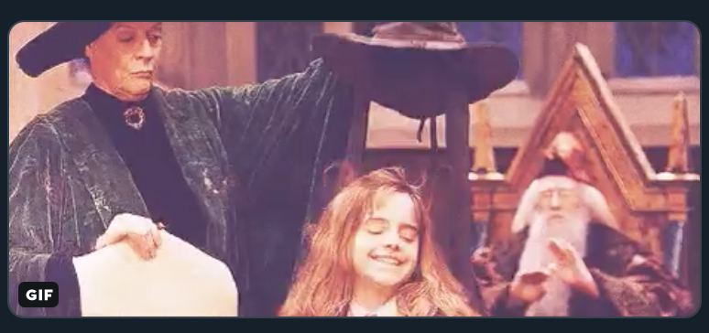

Diane Zinna@DianeZinna
We send 3 or 4 applications, along with writing samples, to each mentor. The mentor then chooses the 1 person they want to work with. This season 2 mentors couldn't choose and promised to work with 1 in the fall & 1 in the spring. We're great matchmakers! #awpmentorship #AWPW2W

Diane Zinna@DianeZinna
Mentees also take time to consider the mentor’s work before accepting their place in the program. That way, when the mentor and mentee begin the program, they are doing so having chosen each other. #awpmentorship #AWPW2W

Elyse Durham@durham_elyse
Every single writer succeeds in part because many, many people have supported them. If that's you, and you're looking for a way to pay it forward, consider giving to @awpwriter. Their mentorship program welcomes emerging writers into the community we all love so dearly. #W2W
Diane Zinna@DianeZinna
Thank you, Elyse! The #AWPMentorship #GivingTuesday link is here for anyone looking to share: https://awpwriter.org/store/donations_givingtuesday

Diane Zinna@DianeZinna
Next season, previous mentee Amanda Niehaus will be serving as a mentor. (So excited about this!) The cover of her new book THE BREEDING SEASON bears a blurb from Alice Sebold...who was her mentor in 2015. #awpw2w #awpmentorship

Kathy Ridenhour@herwimsey
Want to hear even more after the tweet chat? You can read about our mentors' and mentees' experiences in their own words at our W2W Program Reflections page. http://bit.ly/2rcbckD #awpw2w #awpmentorship

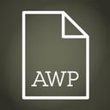 AWP@awpwriter
Kathy @herwimsey is also a great source of information! Thank you Kathy for all that you do for members and #awpmentorship also!

Diane Zinna@DianeZinna
Pairs talk about ways to maintain a writing life while balancing family and paying jobs. Mentors and mentees, share your stories! #awpmentorship #AWPW2W

Diane Zinna@DianeZinna
To our mentors and mentees—share your collaborations and projects that were inspired or helped along by your #awpmentorship experience. #AWPW2W

Hadley Moore@HadleyMoore10

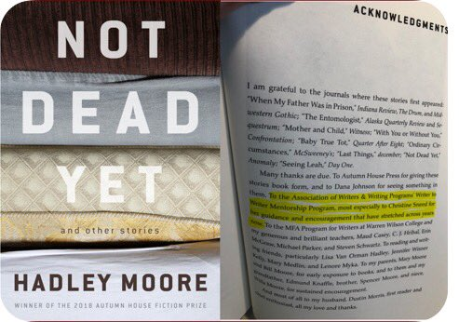

Diane Zinna@DianeZinna
Oh, Hadley, it makes me so happy to read this note for your mentor Christine Sneed on your acknowledgements page! Congratulations on this collection from all of us!

Elyse Durham@durham_elyse
I just published my first short story, and when I read a draft of that story to my #W2W mentor last year, hearing him laugh over the phone was what told me I was on to something. Sometimes, it's so hard to know that all alone!
@awpwriter

sakae manning@sakaetrist
Congratulations!!

Diane Zinna@DianeZinna
We celebrate our mentors and mentees in our social media and at the AWP conference at our annual reception! Sometimes it’s the first chance for a pairing to see each other face to face. #awpmentorship #AWPW2W.

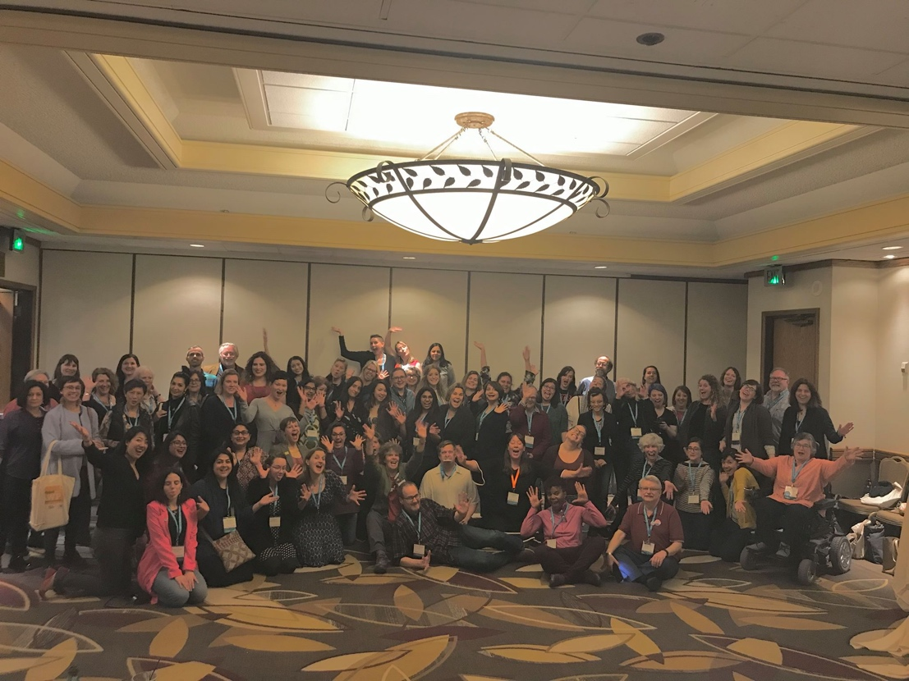

Diane Zinna@DianeZinna
Though we didn't expect this, about 1/3 of our mentors have come back to us asking to serve again. #awpmentorship. #AWPW2W

Elyse Durham@durham_elyse
I can't WAIT until I'm far enough along to be a mentor for #W2W! This program made so much possible for me, and I want to be that support for someone else.
@awpwriter

Diane Zinna@DianeZinna
This touches me so much! Thank you, Elyse! I will be SO THRILLED to have you as a mentor. I will be even more excited to see your book out in the world and will celebrate you every step of the way. #awpw2w #awpmentorship

Shikha Malaviya@ShikhaMalaviya
I love one on one mentorship because it’s not one size fits all. You get to work with a mentee’s specific requirements and give them support where it’s most needed.

Shikha Malaviya@ShikhaMalaviya
I’m so proud to be associated with AWP’s Writer to Writer program these past 4 years! Please consider supporting them this Giving Tuesday. #awpmentorship #awpw2w #awp https://www.awpwriter.org/store/donations_givingtuesday

Diane Zinna@DianeZinna
Many of our mentoring pairs told us that they planned on keeping in touch once their session ended. Many are still working together 5 years later, even though the formal commitment is only 3 months. #awpmentorship #AWPW2W

Diane Zinna@DianeZinna
To the mentees who are with us today—how has the #awpmentorship program affected the writing goals that you have set? Any new goals? #AWPW2W

Elyse Durham@durham_elyse
Working with my #W2W mentor helped me realized that I was dreaming too small. Why not do four more drafts of this story to make it the best it can be? Why not start submitting to journals? Why not apply to grad school? And above all--why not keep writing forever?
@awpwriter

Elyse Durham@durham_elyse
I once asked my #W2W mentor what success as a writer meant to him. He said, "It means wanting to get up the next day and write again." And that, friends, is the best part of any of this. Aren't we all here for the love of words? Grateful for my mentor's sage advice.
@awpwriter

Romana Iorga@RomanaIorga
I wanted some guidance on putting together a manuscript and
@ErinHoover gave me brilliant advice! The new goal is to keep at it--writing and submitting and reading other people's work. I have a sense of belonging after my experience in the #AWPW2W program.

Erin Hoover@ErinHoover
<3 emojis

sakae manning@sakaetrist
After my 50 page feedback and outline work, I’m entering my book with fresh eyes and a process I can tangibly manage. It’s been an at times scary thing to consider I can actually do this book. #awpw2w #awpmentorship

Diane Zinna@DianeZinna
To the mentees and mentors who are with us today—what advice would you give to future participants? #awpmentorship #AWPW2W

sakae manning@sakaetrist
Mentees; do not give up even if declined many times. It costs nothing to apply, and not finding a mentor right away isn’t a reflection on you. It just means the right match hasn’t happened yet. #awpw2w #awpmentorship

Shikha Malaviya@ShikhaMalaviya
The clearer you are on what you want from the mentorship, the more you’ll get out of it :) Also, keep your expectations realistic. Pace yourself and don’t expect a full manuscript revision. Good things take time.

Sayantani Dasgupta@sayan10e
Be flexible! I couldn’t me more appreciative of my mentee @RakshaVasudevan and how open she’s been to all that we’ve tried.

Elyse Durham@durham_elyse
Make space in your life for being part of this amazing experience! You only get one chance to be a mentee, and you'll get as much out of it as you put in. (Also, build connections with your cohort! They'll be your cheering squad as life goes on.)

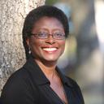 BrendaJoycePatterson@BJoycePatterson
I'm so thankful for #awpw2w. @CallistaBuchen's @awpmentorship gave me such a boost in confidence & changed how I view my writing for the better. I so agree about building connections. If not for @awpwriter, I'd never met @RomanaIorga.

BrendaJoycePatterson@BJoycePatterson
She convinced to me, a black girl from Central Florida, to try translating Romania poetry into English. I'm still SMH about that bit of miracle. #awpw2w opens doors and broadens horizons. I'm eternally grateful to Diane, Callista, Romana, and my entire Fall 2018 (9th) cohort.
Romana Iorga@RomanaIorga
Brenda, it was amazing to a translation project together! We definitely tried at least one (if not six!) seemingly impossible thing(s) before breakfast.

BrendaJoycePatterson@BJoycePatterson
Romana, don't count us out. Life has indeed been chaotic but I still want to keep doing the impossible. I'm itching to work on more translating. Fingers crossed I'll get better at it.
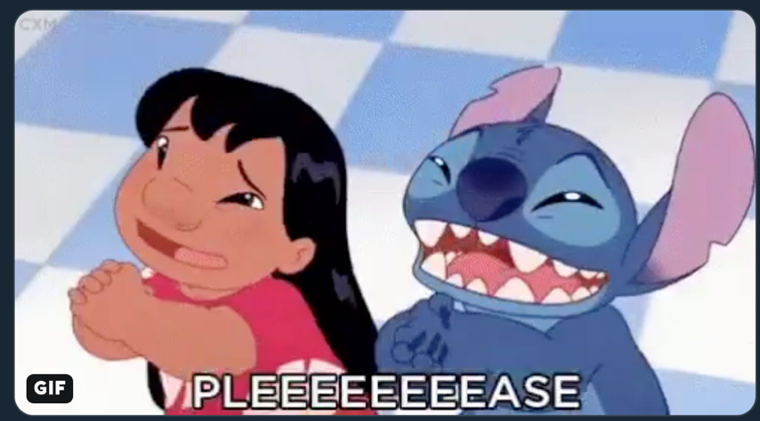

Romana Iorga@RomanaIorga
I'm here, in the Swiss woods, hugging trees. Always ready for more impossible things. We all get better at the impossible the more we chip at it.

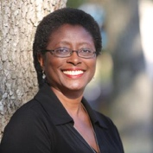 BrendaJoycePatterson
@BJoycePatterson
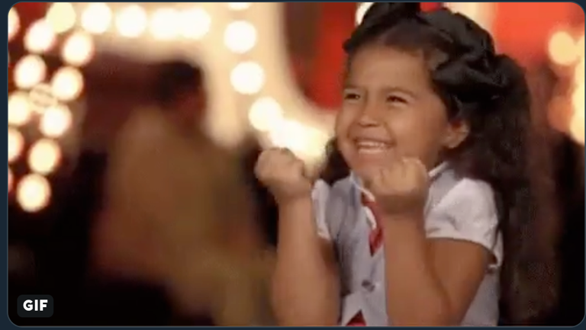

Kate Ristau @KateRistau
I’ve loved working with @jennysuegamboa! We have adapted the program to fit us, and are stretching out our time together. It’s been an amazing experience!

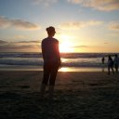 Maureen McGuirk @mcguirkstudios
Keep applying! It took me three goes to be paired up, and it truly is a great match. If you're picked, enjoy the experience, because it goes by so fast.

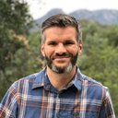 Matt Bell @mdbell79
I'll second @mcguirkstudios's suggestion! I'm glad she was in the pool this year so we could work together!

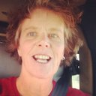 Sarah Leamy @dirtroadsndogs
Set realistic goals for revision and submission.

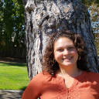 Sarah Dalton@sdaltonwrites
Get involved- online, AWP readings, the booth, W2W panels. Make connections. Meet the incredible network of talented, inspiring ppl. Don't be afraid to be vulnerable abt imposter syndrome, doubts, frustrations and joys

Diane Zinna@DianeZinna
We want to hear from you! What are you looking for in a mentorship experience? #awpmentorship #AWPW2W

Diane Zinna@DianeZinna
Mentee applications for our 12th season of the Writer to Writer Mentorship Program are welcome January 1-12. Mentor applications are welcome now. #awpmentorship https://awp.submittable.com/submit #AWPW2W

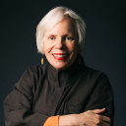 Irene Hoge Smith@IreneHSmith
#AWPMentorship and #AWPW2W
@awpwriter @dianezinna
AWP’s Writer-to-Writer program changed my writing life. Claude Clayton Smith was the perfect mentor and @DianeZinna is a rock star

Diane Zinna@DianeZinna
YOU are a rock star. I'm still kicking myself that I didn't get to your reading at the Writer's Center!

Erin Hoover@ErinHoover
I learned so much from my time serving as a mentor through #AWPW2W! Thank you
@RomanaIorga for our many conversations about poetry and for the opportunity to see your work evolve. @DianeZinna matched us well! #awpmentorship @awpwriter

Ruth Ebenstein@RuthEbenstein
This is the title of the gorgeous novel of my #mentor, Amy Gottlieb. It's a metaphor for the #AWPMentorship! This #mentorship is the beautiful possible. It makes dreams come true. It's definitely doing that for me! Gratitude to @AWPwriter, @DianeZinna, & of course, Amy! #AWPW2W

AWP@awpwriter
We want to thank you all so much for participating in our annual #GivingTuesday tweet chat! It isn't too late to learn more about #AWPW2W by visiting: https://awpwriter.org/community_calendar/mentorship_program_overview, or donate: https://www.awpwriter.org/store/donations_givingtuesday

