AWP’s Eighteenth Tweet Chat: #AWPMentorship
July 14, 2016 from 2:00-3:00 p.m. ET

AWP ‏@awpwriter
Writers of all levels! Hop to our tweet chat, today at 2pm ET, about our mentorship program. Use #AWPmentorship
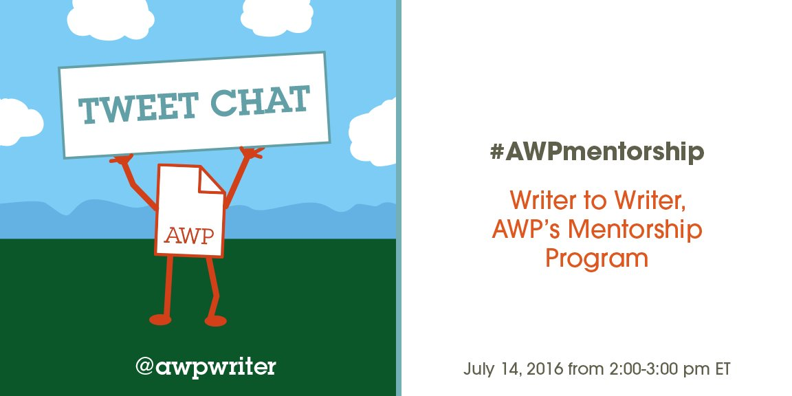

DiverseThoughtLLC ‏@DiverseMac
looking forward to #AWPmentorship session
R.L. Maizes ‏@RL_Maizes
Great program. Tweetchat starts in 5 minutes. #AWPmentorship

Rachel Mennies ‏@rmennies
moments away! #AWPmentorship
AWP ‏@awpwriter
Thanks for tuning in to the #AWPmentorship tweet chat! We hope it will help you decide whether or not this program is "write" for you.
AWP ‏@awpwriter
With us today is Membership Director and Writer to Writer Mentorship Program creator, @DianeZinna! #AWPmentorship
AWP ‏@awpwriter
Also answering your questions for the tweet chat: our Membership Associate, Kenny Lakes (@usyboroda). #AWPmentorship

AWP ‏@awpwriter
To ask a question about AWP’s Writer to Writer Mentorship Program at any time, use the hashtag #AWPmentorship.
Diane Zinna ‏@DianeZinna
Hello! I am Diane Zinna & today I'll be tweeting about our wonderful Writer to Writer Mentorship Program! #awpmentorship
Diane Zinna ‏@DianeZinna
Also on w/ us today are many past mentors & mentees--they are here to help answer your questions about Writer to Writer! #awpmentorship
Diane Zinna ‏@DianeZinna
I'll tweet info about W2W and our upcoming mentee application period (8/1-8/12) plus lots of participant quotes & photos #awpmentorship
Diane Zinna ‏@DianeZinna
Mentor applications are accepted all year. Mentee applications are welcome on Submittable 8/1-8/12 for our Fall 2016 session. #awpmentorship
R.L. Maizes ‏@RL_Maizes
The window for mentee applications is short. Don't miss it! #AWPmentorship
Nancy Hawkins‏ @NancyHa38987620
@DianeZinna How does a writer choose a mentee?
Diane Zinna ‏@DianeZinna
@NancyHa38987620 Hi Nancy! We give each mentor 3-4 apps and they choose the person they feel they can most help. #awpmentorship

Diane Zinna ‏@DianeZinna
A quote from mentor Jennifer Morales #AWPmentorship
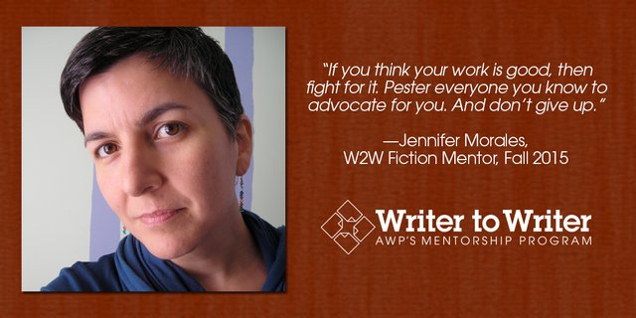

Diane Zinna ‏@DianeZinna
A quote from mentee Khara House. #awpmentorship
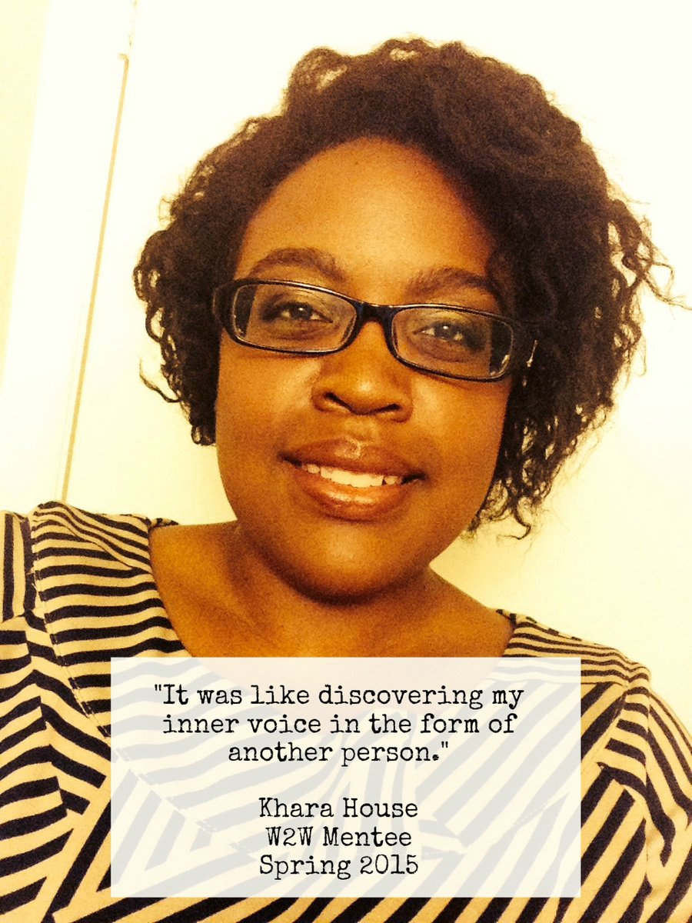
Diane Zinna ‏@DianeZinna
We have about 7,000 individual members, and many are writers who have never been associated with an MFA program. #awpmentorship
Michael Wells ‏@stickpoet
@DianeZinna #AWPmentorship That's interesting because when I joined in 2014 I assumed I must have been one of only a few with no MFA
Diane Zinna ‏@DianeZinna
Definitely not, Michael! #awpmentorship

Diane Zinna ‏@DianeZinna
We also wanted to do something for those who are writing from backgrounds typically underrepresented in the literary world. #awpmentorship
Jennifer Morales ‏@MoralesWrites
Going on now: Is #AWPmentorship "write" for you?
Diane Zinna ‏@DianeZinna
We encourage apps fm writers of color, LGBTQ & disability communities, those w/ no MFA. #awpmentorship
Diane Zinna ‏@DianeZinna
We don't just match people and step away! We check in regularly and provide space for participants to connect & share tips #awpmentorship

Diane Zinna ‏@DianeZinna
Being involved with the program all along the way is personally rewarding to me and helps me better understand our members. #awpmentorship
Michael Wells‏ @stickpoet
@awpwriter @DianeZinna Hi Diane, as someone who applied multiple times, is the demand way outpacing the number of mentors?
Diane Zinna ‏@DianeZinna
@stickpoet @awpwriter Hi Michael! Your new website looks amazing, btw. We do try to keep the program small. #awpmentorship
Diane Zinna ‏@DianeZinna
@stickpoet @awpwriter We do not accept every mentor who applies. Each session about 50% of the participants applied before. #awpmentorship
Michael Wells‏ @stickpoet
@DianeZinna @awpwriter Thanks @DianeZinna - Hope other writers will take advantage of the .ink deal. It's a great service.

Diane Zinna ‏@DianeZinna
There is no charge for the Writer to Writer mentorship program. The only requirement is that you're an AWP member. #awpmentorship
Diane Zinna ‏@DianeZinna
You may have seen the W2W ad on the back of @poetswritersinc last issue. #awpmentorship
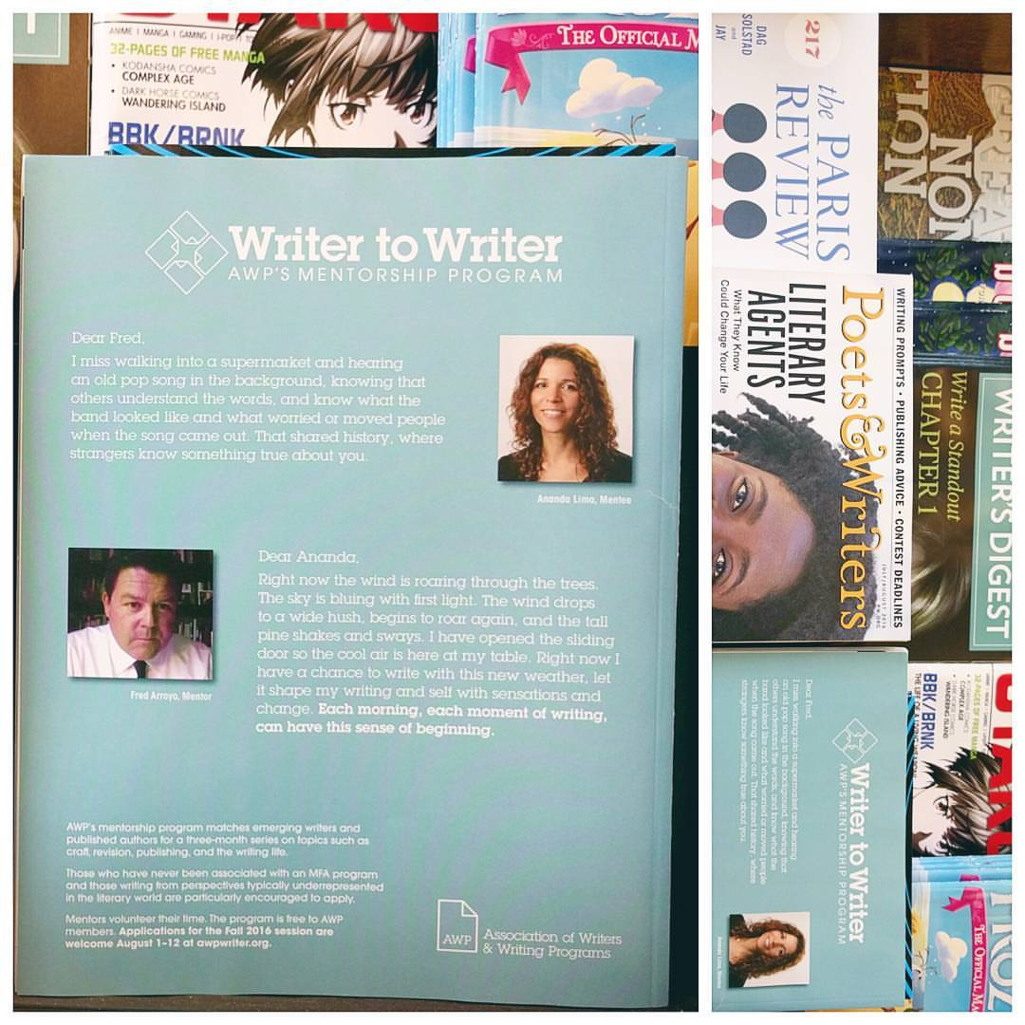
Diane Zinna ‏@DianeZinna
A quote from fiction mentor Alice Sebold #awpmentorship
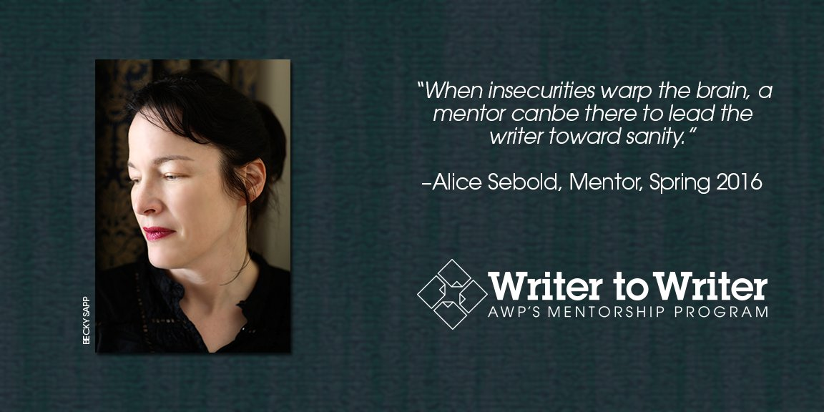
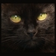Listen to KittyMouth ‏@stefburn
Is there anything in particular that is being looked for with regards to mentees?#awpmentorship
Diane Zinna ‏@DianeZinna
@stefburn Too often people apply with one-sentence answers to the questions. Tell us enough to find the right match for you! #awpmentorship
Rachel Mennies ‏@rmennies
@DianeZinna @stefburn would def. second this as a former mentor—getting a full picture was so helpful in selecting a mentee! #AWPmentorship

Diane Zinna ‏@DianeZinna
A quote from Irene Hoge Smith, AWP mentee last season #awpmentorship @IreneHSmith
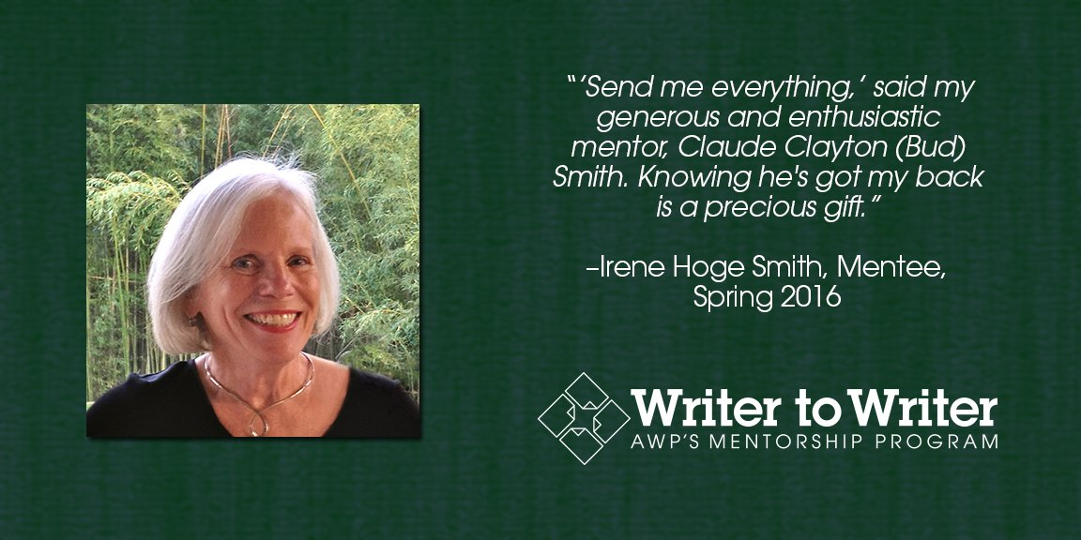

Diane Zinna ‏@DianeZinna
Fall '16 will be our 5th session. Application numbers keep growing, so we're bracing ourselves. #awpmentorship
Diane Zinna ‏@DianeZinna
Each session we try to match between 15 and 25 pairs, all genres #awpmentorship.
Diane Zinna ‏@DianeZinna
We are able to match about 10% of those who apply with a personal mentor #awpmentorship
Listen to KittyMouth ‏@stefburn
How often can you apply for the mentee program if you're turned down the first time? #AWPmentorship
Diane Zinna ‏@DianeZinna
@stefburn 1/2/ You are absolutely encouraged to apply as often as you wish! #awpmentorship
Diane Zinna ‏@DianeZinna
@stefburn 2/2 It may just be that the mentor right for you is waiting for you in another session. #awpmentorship
Diane Zinna ‏@DianeZinna
We look for mentors who will, above all, be supportive, responsive, and open to learning from the experience themselves. #awpmentorship
Karin Killian ‏@karinkillian
The awesome sense of community was a surprise bonus of my #AWPmentorship
Diane Zinna ‏@DianeZinna
Here are our supportive, responsive, amazing W2W mentors from last session: http://bit.ly/1r1Cltr #awpmentorship
Ladybuglizzie ‏@sagevalentine
What are the benefits of this mentorship? #AWPmentorship
Colette Lunday ‏@ColetteLunday
@sagevalentine having an #awpmentorship lets you step out of your comfort zone with a companion and guide
Ladybuglizzie ‏@sagevalentine
@ColetteLunday Thank you for answering me :)
Colette Lunday ‏@ColetteLunday
@sagevalentine you are welcome!
Diane Zinna ‏@DianeZinna
@sagevalentine There are so many. For the mentors AND the mentees. To have a writerly friend, a guide, a true listener. #awpmentorship
Ladybuglizzie ‏@sagevalentine
@DianeZinna That's exactly what I need. Thank you for answering me. :)

Diane Zinna ‏@DianeZinna
Mentors volunteer their time and receive a free one-year AWP membership. #awpmentorship
Diane Zinna ‏@DianeZinna
When pairing people, we like to think there is a bit of magic at work. #awpmentorship
Diane Zinna ‏@DianeZinna
Quote from Catherine Keefe, AWP mentee from last season #awpmentorship
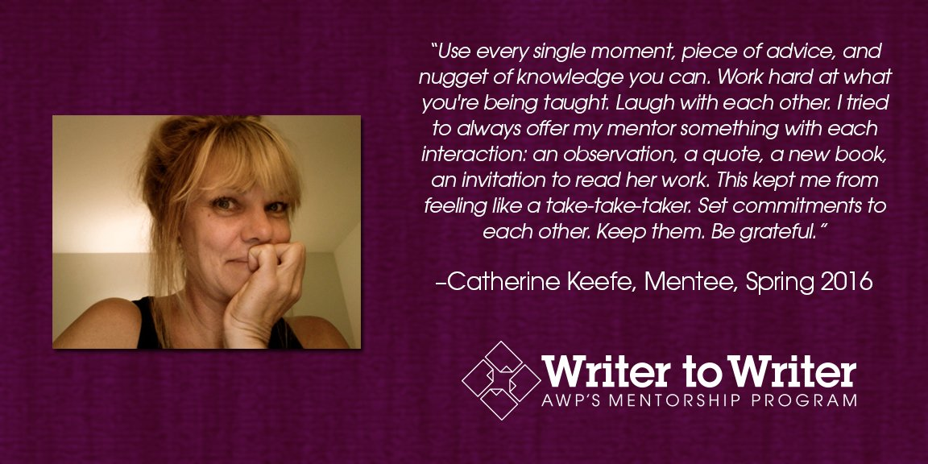
Colette Lunday ‏@ColetteLunday
I didn’t know I needed a mentor until I had one. I have grown in ways I didn’t expect #awpmentorship
Naima Hazelton ‏@NaimaHazelton
When is the mentee application going up?I see the mentor one, so if I could ask past mentees what they focused on...
Diane Zinna ‏@DianeZinna
Hi, Naima! From August 1-12, the mentee application will be available on Submittable. #awpmentorship
Naima Hazelton ‏@NaimaHazelton
@DianeZinna Oh, okay. Can't obsess about the questions then, lol.
Diane Zinna ‏@DianeZinna
@NaimaHazelton @awpwriter I think the questions show that we care about your journey and not just your level or publications. #AWPmentorship

Diane Zinna ‏@DianeZinna
We tend to set aside the apps from those looking at this as a fast path to publication. #awpmentorship

Diane Zinna ‏@DianeZinna
W2W is about relationship building between 2 writers and their mutual growth. Mentors often state they learn just as much. #awpmentorship
Emily Walling ‏@er_walling
Do some of the mentors and mentees continue a relationship or stay in contact after the program is over? #AWPmentorship
Diane Zinna ‏@DianeZinna
Absolutely, Emily! We send out surveys to past participants and almost everyone is still in contact #awpmentorship

Diane Zinna ‏@DianeZinna
We send 3 applications, along with writing samples, to each mentor. The mentor chooses the 1 person they want to work with. #AWPmentorship
Diane Zinna ‏@DianeZinna
This past session all of our mentees were women: http://bit.ly/216bgYq #AWPmentorship

Diane Zinna ‏@DianeZinna
Mentors don't tend to look for the best or most accomplished writer. They look for the person they think they can best help. #AWPmentorship
Seth Brady Tucker ‏@Airbornepoet
#awpmentorship This is a great program for both mentors and mentees alike. Be warned, however: autocorrect changes mentees to menses!
Naima Hazelton ‏@NaimaHazelton
#AWPmentorship What did you focus on in your applications, mentees? Strengths/weaknesses, goals, past mentor/mentee experiences, etc?
R.L. Maizes ‏@RL_Maizes
@NaimaHazelton The questions in the application gave me an opportunity to think deeply about what I wanted from a mentorship. @awpmentorship
Naima Hazelton ‏@NaimaHazelton
@RL_Maizes Did you find that or something else though the process? I have ideas...but you don't know what you don't know, you know?
R.L. Maizes ‏@RL_Maizes
@NaimaHazelton not sure what you are asking. Can you explain?
Naima Hazelton ‏@NaimaHazelton
@RL_Maizes Did u get what you wanted out of the mentorship process? In retrospect, did u discover something u weren't explicitly expecting?
R.L. Maizes ‏@RL_Maizes
@NaimaHazelton my mentor was generous in sharing his story. The program got everyone thinking big picture. And my cohort became close.

Diane Zinna ‏@DianeZinna
Mentees then have the final decision on whether that person is best for them. #AWPmentorship
Diane Zinna ‏@DianeZinna
To the mentors who are chatting with us today--what made you choose your mentee? #AWPmentorship
Naima Hazelton ‏@NaimaHazelton
@DianeZinna Oh, I learned something there...didn't know they *choose* mentees!
Diane Zinna ‏@DianeZinna
@NaimaHazelton @awpwriter Yes, the mentors come into it wanting to work with YOU. #AWPmentorship
Brandi Megan Granett ‏@brandigranett
@DianeZinna gut feeling! I opened the app and thought oh, there she is!!!
Paul Pedroza ‏@paulsilence
@DianeZinna enthusiasm; strong sample; a true fit for this program, not someone asking for help placing complete manuscript; dedication
Jennifer Morales ‏@MoralesWrites
@NaimaHazelton @awpwriter I wanted to explore a different form of teaching (and learning) & help other queer writers of color grow.
Jennifer Morales ‏@MoralesWrites
@DianeZinna @awpwriter The quality of her writing, for sure. But also the opportunity to assist a queer POC in navigating the writing world.

Ruth Ebenstein ‏@RuthEbenstein
Any tips you'd give your sibling on what to include in application? #AWPmentorship so exciting that this opportunity is out there! thanks!!
Diane Zinna ‏@DianeZinna
@RuthEbenstein You can preview the mentor: http://bit.ly/29SEPyx and mentee: http://bit.ly/29zhgWN questions on our site #awpmentorship
Ruth Ebenstein ‏@RuthEbenstein
@DianeZinna, thank you!! Much appreciated. Regards from Jerusalem, Israel
Diane Zinna ‏@DianeZinna
@RuthEbenstein 2/2 These give you a sense of the kinds of questions we ask. Be open. Give us enough info to find YOUR mentor #awpmentorship
Ruth Ebenstein ‏@RuthEbenstein
@DianeZinna, I hear you. I'll have a look. I'm VERY open in sharing. Agree that it's critical - matchmaking is an art. Thanks for your time.

Diane Zinna ‏@DianeZinna
Getting so may questions! Thank you! It may take me a bit of time to address them all, but I will! #AWPmentorship
Diane Zinna ‏@DianeZinna
For our mentors on this chat—What advice do you have for future Writer to Writer mentors? #AWPmentorship
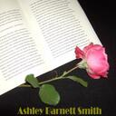Ashley Barnett Smith‏ @Ashlybsmith
@DianeZinna @awpwriter Be true to your story, give you heart in it.

Diane Zinna ‏@DianeZinna
And for our mentees on this chat—What advice do you have for future Writer to Writer mentees? #awpmentorship
R.L. Maizes ‏@RL_Maizes
@DianeZinna participate in all that you can, Skypechats, modules, and don't be shy about communicating with your mentor. #AWPmentorship
Colette Lunday ‏@ColetteLunday
@DianeZinna don't be afraid to take the challanges from your mentor. They want be a mentor and they are sharing their path #awpmentorship

Diane Zinna ‏@DianeZinna
A quote from past W2W mentor Emilia Phillips: @gracefulemilia #awpmentorship
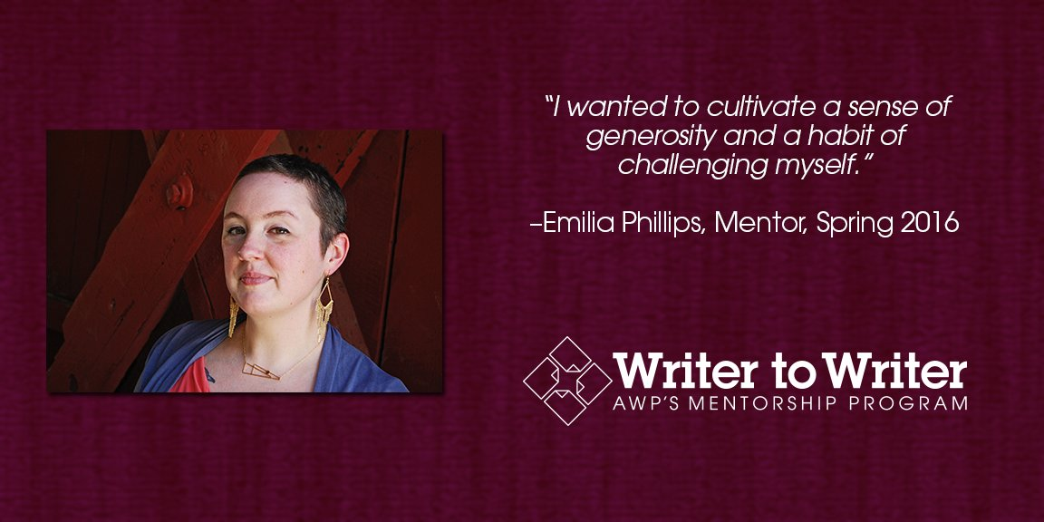

Naima Hazelton ‏@NaimaHazelton
#AWPmentorship Once and future mentors, what do you personally hope to get out of working with a mentee? Other than the gratis membership :)
Rachel Mennies ‏@rmennies
@NaimaHazelton I found that the program also helped me grow as a writer—a welcome challenge to consider writing practices from either “side"

Naima Hazelton ‏@NaimaHazelton
@rmennies I've found that - in areas where I've mentored/taught - teaching it made it clearer to me. Like that?
Rachel Mennies ‏@rmennies
@NaimaHazelton yes definitely! you’re never too experienced to skip interrogating your own writing practices.
Naima Hazelton ‏@NaimaHazelton
@rmennies Oh, nice!
Jennifer Morales ‏@MoralesWrites
@NaimaHazelton @awpwriter I wanted to explore a different form of teaching (and learning) & help other queer writers of color grow.
Naima Hazelton ‏@NaimaHazelton
@MoralesWrites @awpwriter Oh, yes, I saw not-traditionally represented communities was a criteria. Do you think *confidence plays into that?

Jennifer Morales ‏@MoralesWrites
@NaimaHazelton @awpwriter Yes. The "successful" writing world is super male, white & hetero. Tough for LGBTQ/POC writers to envision success
Naima Hazelton ‏@NaimaHazelton
@MoralesWrites @awpwriter That's why I didn't accept an invitation to MFA/PhD from my professor. Tho my college mentors were great.
Naima Hazelton ‏@NaimaHazelton
@MoralesWrites @awpwriter Oh, yes, I saw not-traditionally represented communities was a criteria. Do you think *confidence plays into that?
S.L.Penner ‏@sl_penner
@NaimaHazelton @awpwriter my main reason for applying will be advice re: manuscript revisions - approach, sequence, etc.

Diane Zinna ‏@DianeZinna
A quote from Lara Palmqvist, who took part as a mentee while residing in the Ukraine last season #AWPmentorship
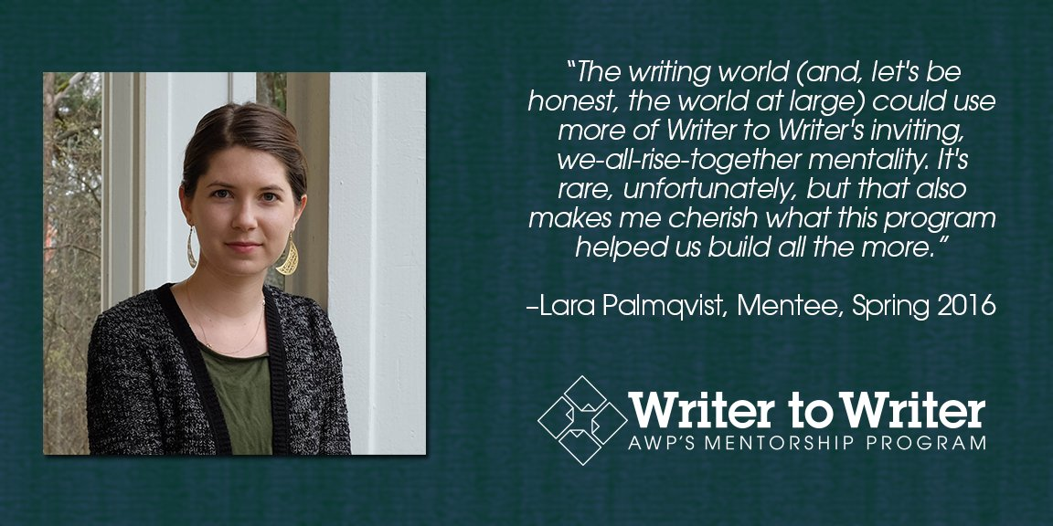
Diane Zinna ‏@DianeZinna
Sometimes apps from people of color express a desire for a mentor with the same background & those mentors aren't there. #awpmentorship.
Diane Zinna ‏@DianeZinna
Mentor applications are available year-round. Apply today. http://bit.ly/1lS31v2 #AWPmentorship
Diane Zinna ‏@DianeZinna
Mentee applications will be available August 1–12. Put it on your calendar! http://bit.ly/1lS31v2 #AWPmentorship
Diane Zinna ‏@DianeZinna
Again, AWP membership is required to apply, but there is no additional fee. #awpmentorship
Diane Zinna ‏@DianeZinna
Our mentoring sessions cover six modules over a three-month period. #AWPmentorship
Diane Zinna ‏@DianeZinna
Module 1 focuses on beginnings: “What initially attracts you most to a piece of writing?” #AWPmentorship
Diane Zinna ‏@DianeZinna
Module 2 is all about community and connections: “How can I find a community that will support me?” #AWPmentorship
Diane Zinna ‏@DianeZinna
Module 3 centers on craft: “What is the most interesting craft or forms exercise you have taught or done?” #AWPmentorship
Diane Zinna ‏@DianeZinna
Module 4’s topic is revision: “Have you ever started a new piece with a section you removed from another?” #AWPmentorship
Diane Zinna ‏@DianeZinna
Module 5 looks at publishing: “What is something you didn’t expect that happened as a result of your being published?” #AWPmentorship
Diane Zinna ‏@DianeZinna
Module 6 examines sustaining a writing life: How do you make time to write while dealing with family & job responsibilities? #AWPmentorship
Michael Wells ‏@stickpoet
@DianeZinna Can you explain the modules?
Diane Zinna ‏@DianeZinna
@stickpoet Hi Michael! I just tweeted a few module questions if you scroll backwards. Or email me: diane@awpwriter.org #awpmentorship
Michael Wells ‏@stickpoet
@DianeZinna I saw them, Thank you! this has been interesting.

Diane Zinna ‏@DianeZinna
These module questions I posted are just examples. Each module includes several q's and then activities to do together. #AWPmentorship
Diane Zinna ‏@DianeZinna
We have had some very memorable pairings. #AWPmentorship
Diane Zinna ‏@DianeZinna
@realjefferyhess runs a writing group w/ military vets; was paired with a military wife longing to tell her husband's story. #AWPmentorship
Diane Zinna ‏@DianeZinna
We had a writer working on an opera libretto about a Native American tribe paired with the amazing Native author @ehhayes. #AWPmentorship
Diane Zinna ‏@DianeZinna
@rmennies, whose WWII-era book the Glad Hand of God Points Backwards was paired with a writer working on a similar theme #AWPmentorship
Paul Pedroza ‏@paulsilence
Because an MFA program isn't the only or always the best option #AWPmentorship
Diane Zinna ‏@DianeZinna
A beautiful quote from @rmennies, past W2W mentor #awpmentorship
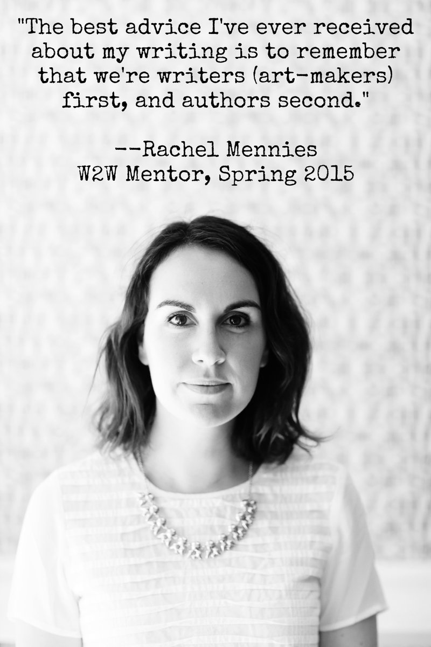

Diane Zinna ‏@DianeZinna
Our first playwrights, @kellyjo9 @dgswriter wrote of their W2W experience: http://bit.ly/1Opp9uK #AWPmentorship
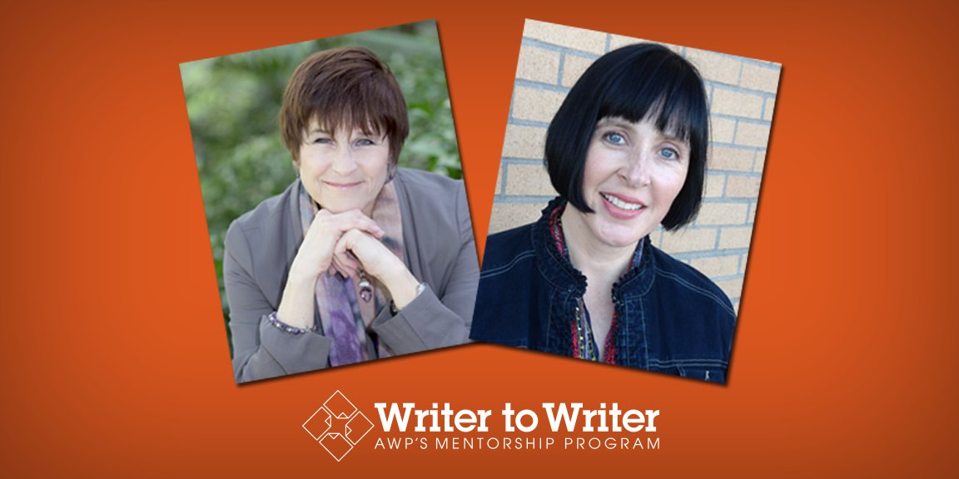
Diane Zinna ‏@DianeZinna
2 writers with disabilities wrote of their W2W experiences: http://bit.ly/1Rok6AC #awpmentorship
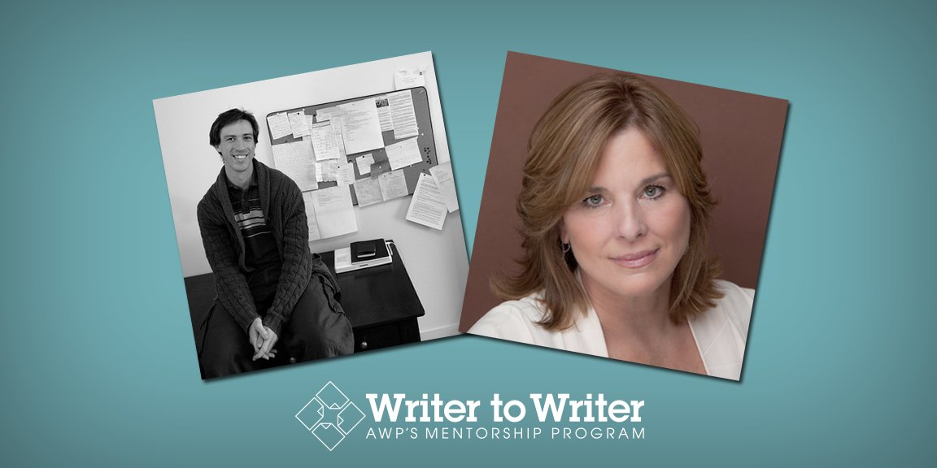
Diane Zinna ‏@DianeZinna
Last session we selected fewer than 50% of the people who applied to serve as mentors to participate.#AWPmentorship
Nancy Hawkins ‏@NancyHa38987620
@DianeZinna How wonderful that you have so many fine people to choose from!

Diane Zinna ‏@DianeZinna
Before choosing our mentors, we look at all of the mentee applications first to see what that round's applicants are wanting. #AWPmentorship
Brandi Megan Granett ‏@brandigranett
@DianeZinna it is great to match with a mentee #AWPmentorship
Diane Zinna ‏@DianeZinna
@brandigranett has served with us twice--two great, unique pairings! #awpmentorship @awpwriter
R.L. Maizes ‏@RL_Maizes
As a mentee it was fascinating to learn the journey of an accomplished writer, the bumps and setbacks, and the successes. #AWPmentorship
Diane Zinna ‏@DianeZinna
We want our mentors to have pure intentions, too. If it's clear they are applying to promote a book, we set the app aside. #AWPmentorship
Diane Zinna ‏@DianeZinna
We celebrate our mentors and mentees in our social media and at the AWP conference. #AWPmentorship
Diane Zinna ‏@DianeZinna
Speaking of the conference, I'll post some pictures now of faces you may have seen at the AWP Booth at the LA Bookfair #AWPmentorship
Diane Zinna ‏@DianeZinna
Mentor-mentee pair Brandi Granett @brandigranett & her mentee, Taylor Lauren Ross @Taylorlaurenr #AWPmentorship
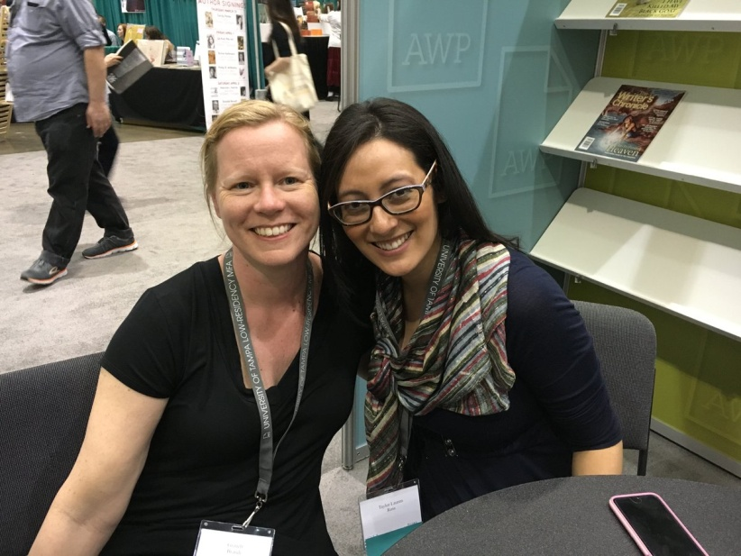

Diane Zinna ‏@DianeZinna
Mentor-mentee pair Najiyah Maxfield & her mentee Cynthia Huijgens #AWPmentorship
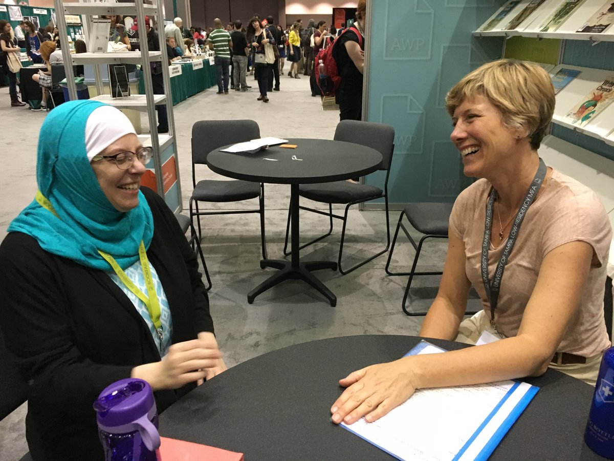
Listen to KittyMouth ‏@stefburn
So if I'm looking for a Black mentor, there's a possibility that one may not be present that is familiar with my genre? #AWPmentorship
Naima Hazelton ‏@NaimaHazelton
@stefburn read back in the last #AWPmentorship chat and they matched an indigenous mentee and mentor which was, I think, the 'magic' at wrk
Naima Hazelton ‏@NaimaHazelton
@stefburn I think it was 7/7.
Listen to KittyMouth ‏@stefburn
@NaimaHazelton okay thanks I'll check that out.
Naima Hazelton ‏@NaimaHazelton Jul 14
@stefburn I'm in the same boat. Writing a historical non-fiction at an AA hospital. If not now, maybe another session.
Diane Zinna ‏@DianeZinna
@stefburn 2/2 Last season, for example, we had 19 pairings. Divided by 4 genres...you can see how it can be challenging! #awpmentorship
Diane Zinna ‏@DianeZinna
@stefburn 1/1 We actively reach out to writers of color to be mentors but it's possible we won't have a WOC in your genre @awpmentorship

Diane Zinna ‏@DianeZinna
Mentor-mentee pair Lori Ostlund @Loriostlund & Whitney Wimbish @whitneycwimbish #AWPmentorship
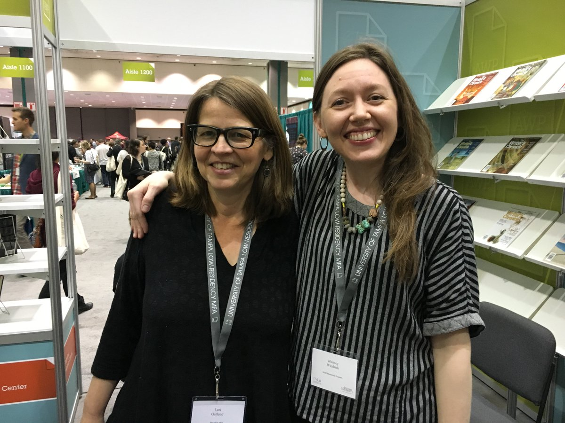
Diane Zinna ‏@DianeZinna
At the W2W LA conference reception: Sharon Estill Taylor & her mentee, Mariah Mottley #awpmentorship
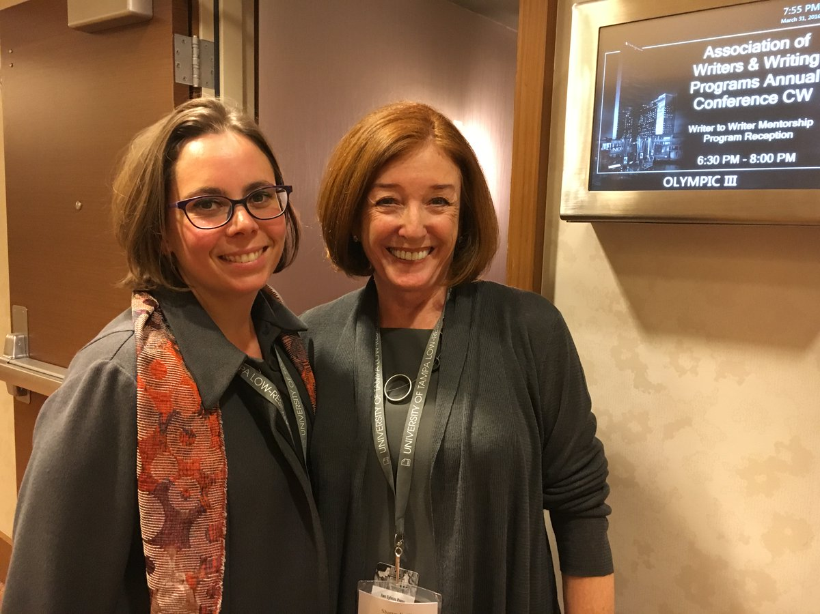
Diane Zinna ‏@DianeZinna
At the W2W LA conference reception: Mentor Norma Cantú @normaelia & her mentee, Mele Martinez #awpmentorship
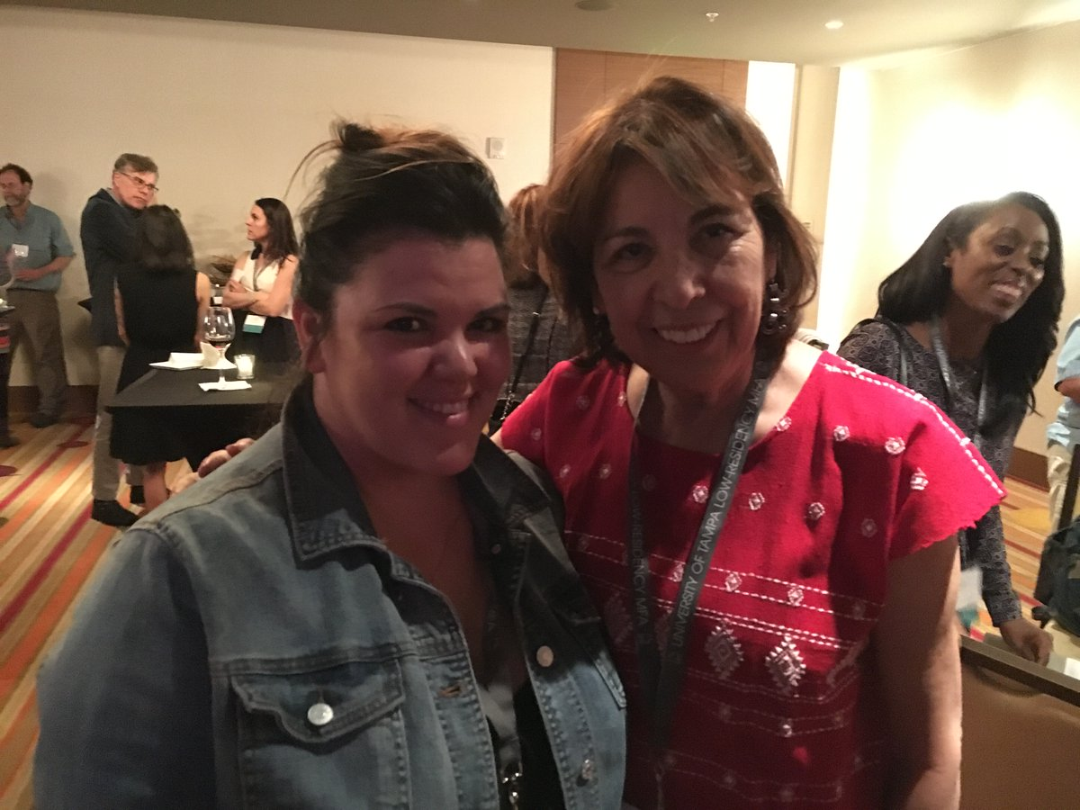
Diane Zinna ‏@DianeZinna
At the W2W LA conference reception: Mentor Kristiana Kahakauwila & her mentee, @SeaStachura #awpmentorship
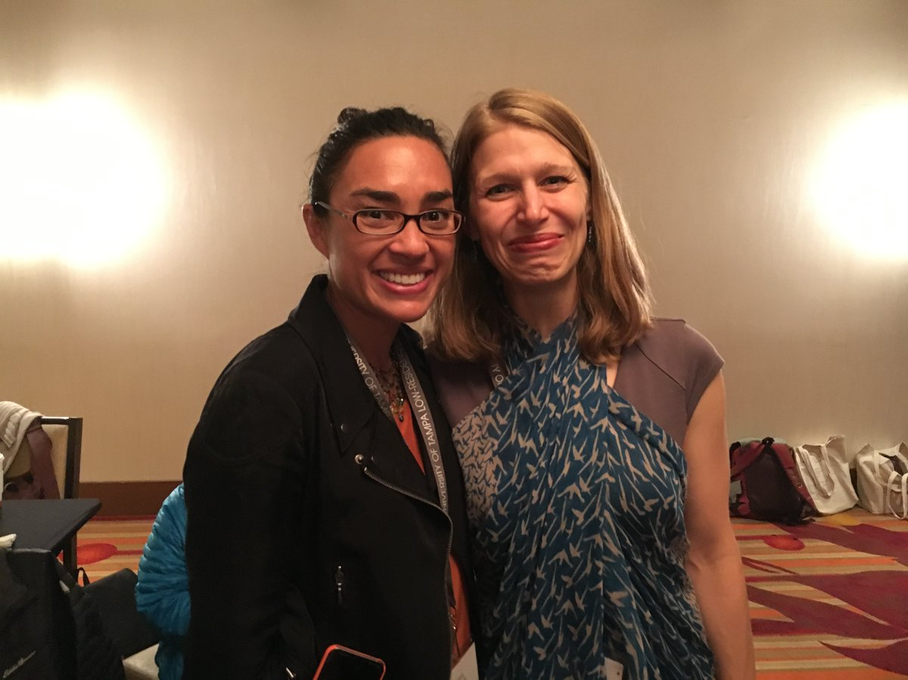
Diane Zinna ‏@DianeZinna
Their joint reading made the bartender cry: Mentor Fred Arroyo & his mentee, @anandalima #awpmentorship
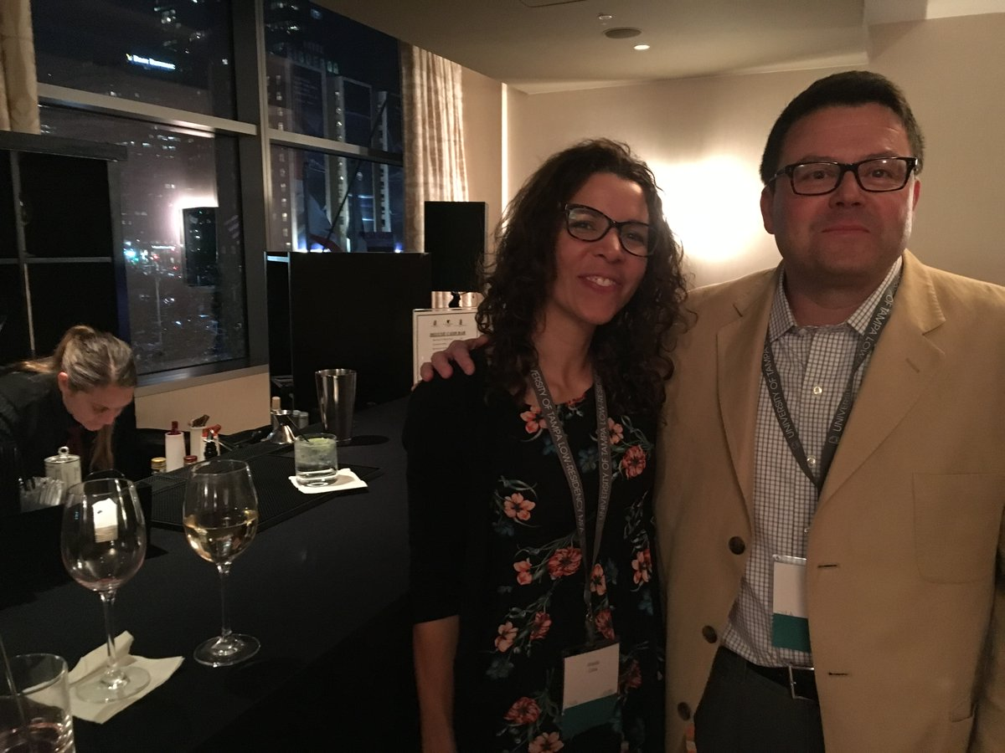
Diane Zinna ‏@DianeZinna
Though we didn't expect this, almost half of our mentors have asked to serve again. #awpmentorship.
Diane Zinna ‏@DianeZinna
Mentors need to be AWP member in good standing and have at least one published book. #awpmentorship.

billykilgore ‏@billydkilgore
Great program! a tremendous help to my writing life and pointed me in the right direction. Grateful for the opportunity #AWPmentorship
Emily Walling ‏@er_walling
@DianeZinna Can you give us an idea of how many mentors and mentees apply each time? #AWPmentorship
Diane Zinna ‏@DianeZinna
@er_walling 1/2 It varies...I would say between 200 and 400 apps from potential mentees each session. #AWPmentorship
Diane Zinna ‏@DianeZinna
@er_walling 2/2 If you don't get matched one season, try again! Your mentor may be just waiting for you! #AWPmentorship
Diane Zinna ‏@DianeZinna
#AWPmentorship was a v rich experience; my mentee & I are still in touch & she's working on a couple of diff #fiction mss --@ChristineSneed

Ruth Ebenstein ‏@RuthEbenstein
#AWPmentorship, This whole conversation alone inspires and injects hope and a sense of community! I keep saying, WOW, and great. Thanks!
Diane Zinna ‏@DianeZinna
"The program was amazing! Great questions to jumpstart conversations w/ my mentor. " --Ann DeVilbiss, Mentee, Spring 2016 #awpmentorship
Diane Zinna ‏@DianeZinna
“Indebted to my #awpmentorship mentor, Fred Arroyo, for his insight, patience, & guidance.” –Mona Alvarado Frazier, Mentee, Fall 2014
R.L. Maizes ‏@RL_Maizes
The program is also a chance to get to be part of a community of writers. Mentees help and support one another. #AWPmentorship
Diane Zinna ‏@DianeZinna
Keep your questions coming! I'm getting faster at these! #awpmentorship
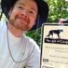Evan Morgan Williams ‏@EvMoWi
#AWPmentorship Hope people see that the workshop model isn't the be-all-end-all. Mentoring-Protege is time-honored tradish. #SteinHemingway
Diane Zinna ‏@DianeZinna
A quote from mentor Earl Swift. #AWPmentorship
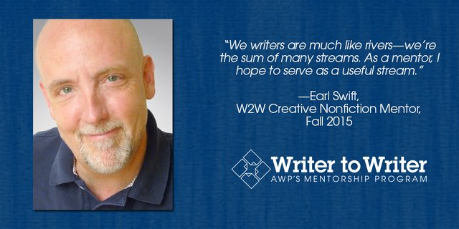
Diane Zinna ‏@DianeZinna
A quote from past mentor dawn lonsinger #AWPmentorship
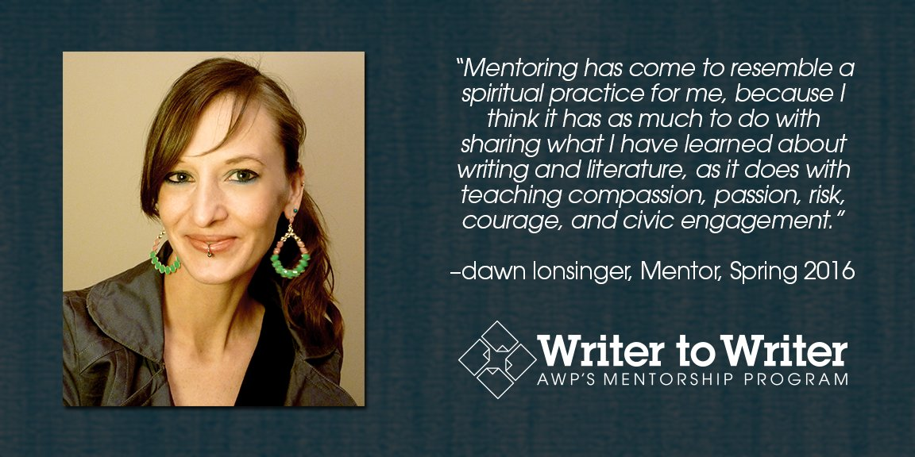
Diane Zinna ‏@DianeZinna
A quote from past mentee @JuliaLaxer #AWPmentorship
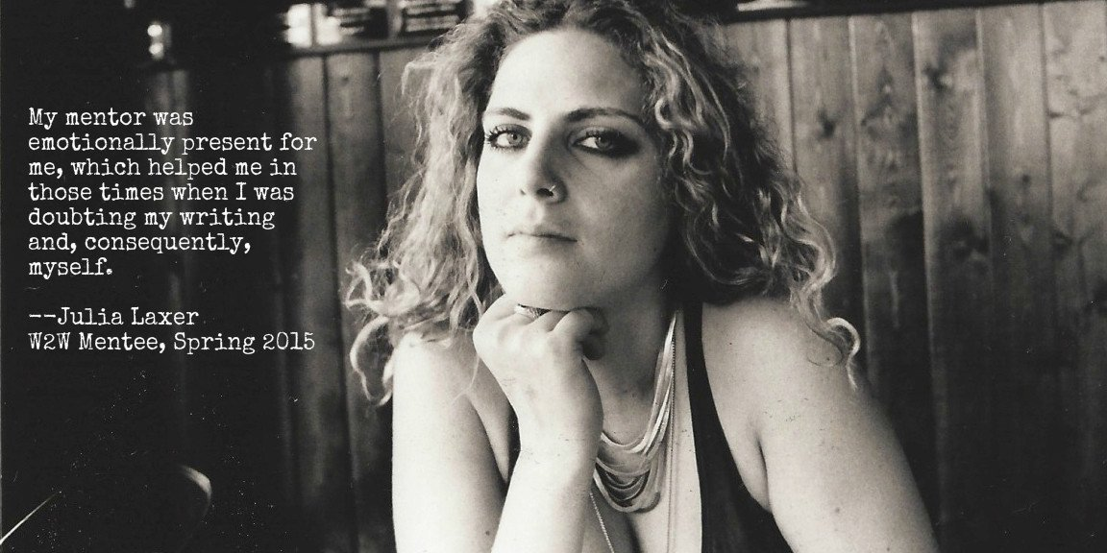
Diane Zinna ‏@DianeZinna
A quote from past mentor Kristiana Kahakauwila #awpmentorship
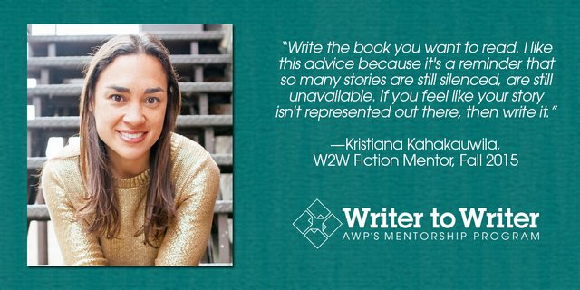
Naima Hazelton ‏@NaimaHazelton
#AWPmentorship so much to ask...what if you don't know what you don't know. I'm sure I could make a guess, but what's a good way to examine?
Diane Zinna ‏@DianeZinna
A quote from mentee @WhitneyCWimbish #awpmentorship
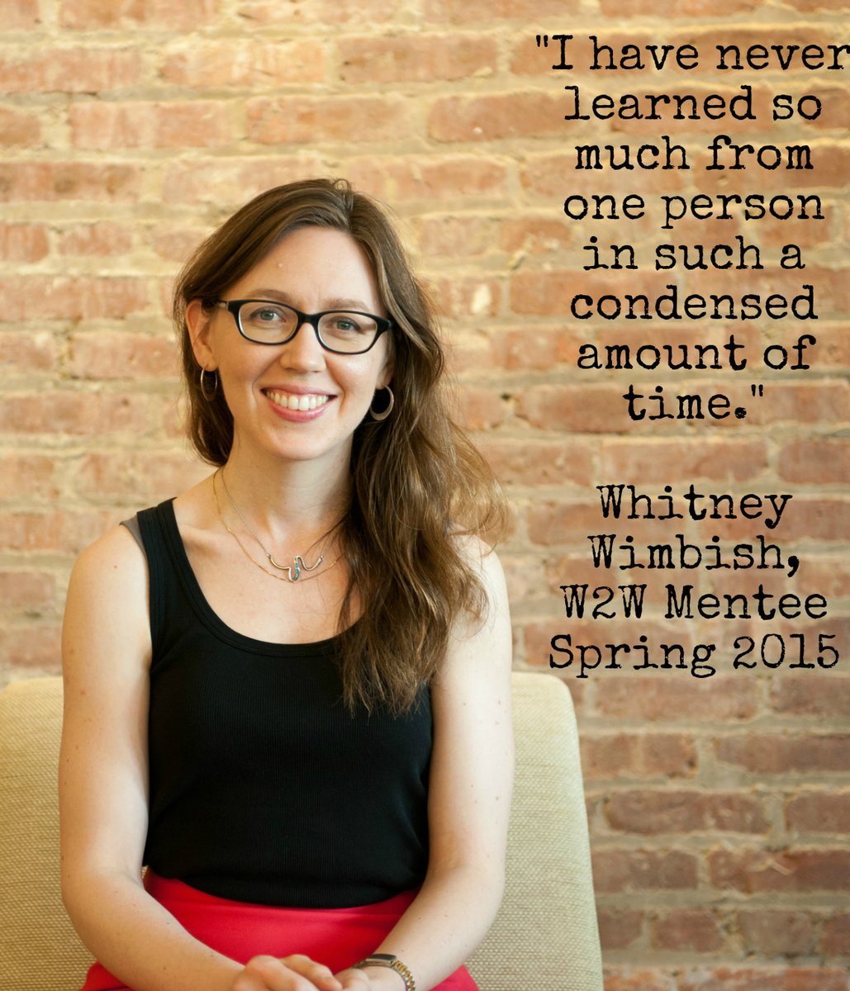
Diane Zinna ‏@DianeZinna
A quote from Michael Broder, past W2W mentor #AWPmentorship
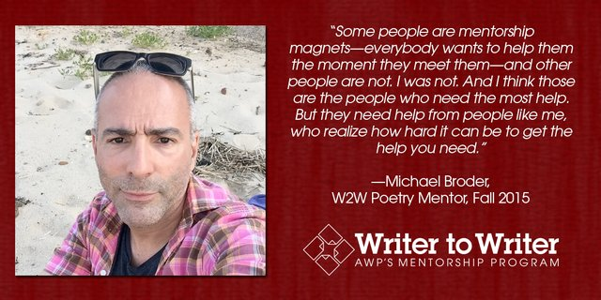
Diane Zinna ‏@DianeZinna
A quote from @Kerrin_McCadden, past W2W mentor #AWPmentorship
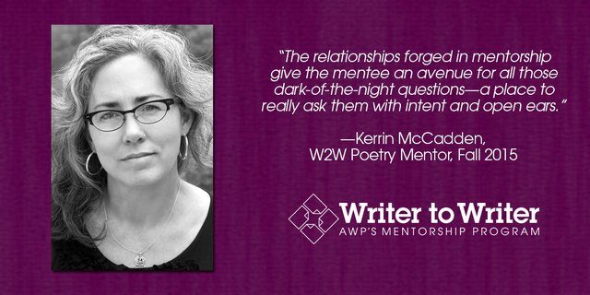
Diane Zinna ‏@DianeZinna
A quote from Leslie Schwartz, past W2W mentor. #AWPmentorship
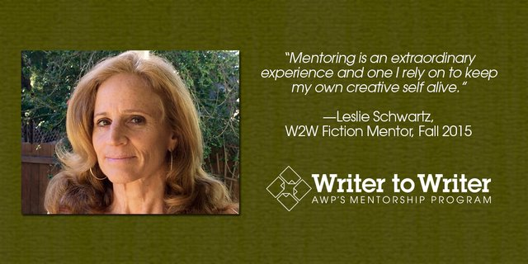
Diane Zinna ‏@DianeZinna 21m21 minutes ago
A quote from past W2W mentor, @RachelHowzell Hall #AWPmentorship
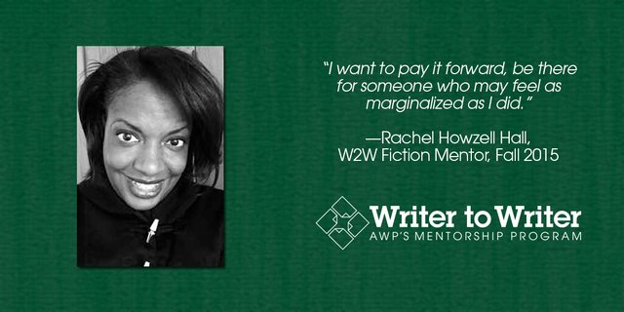
Diane Zinna ‏@DianeZinna
I see a ton of questions coming to my email box, too! Email me your questions: diane@awpwriter.org #AWPmentorship
Diane Zinna ‏@DianeZinna
For more information about the Writer to Writer Mentorship Program: https://www.awpwriter.org/community_calendar/mentorship_program_overview … #AWPmentorship
Naima Hazelton ‏@NaimaHazelton
@MoralesWrites @awpwriter And not having an MFA works well for #AWPmentorship so...hopeful.
Jennifer Morales ‏@MoralesWrites
@NaimaHazelton @awpwriter My mentee didn't have an MFA, but had written a couple book drafts, stories, lectures--doing the work! Apply!

Diane Zinna ‏@DianeZinna
Thank you all for taking the time to learn about Writer to Writer Mentorship Program today. It has been a joy! #AWPmentorship
Naima Hazelton ‏@NaimaHazelton
Thank you so much. And thanks to all the #AWPmentorship community for answering questions and giving feedback!

AWP ‏@awpwriter
Thanks for joining us for our #AWPmentorship tweet chat!
AWP ‏@awpwriter
Find all of our previous chats in our archive: https://www.awpwriter.org/community_calendar/tweet_chats … #AWPmentorship
Naima Hazelton ‏@NaimaHazelton
@awpwriter Hey, everyone applying: let's tweet when we get our applications submitted? Just for accountability! For me, lol. #AWPmentorship
Emily Walling ‏@er_walling
Great advice from the #AWPmentorship Tweet Chat. Can't wait to send in my application again next month!

Eliot Treichel ‏@eliottreichel
#AWPmentorship is a powerful and affirming program! Highly recommend it!
Peace ‏@pdkeenen
At LA #awp16 Conference Mentor @minalh & mentee @pdkeenen #awpmentorship APPLY NOW meet your mentor!
