AWP’s Nineteenth Tweet Chat: #AWPpubs
August 25, 2016 from 3:00-4:00 p.m. ET

AWP ‏@awpwriter
Got advice about writing careers or an essay about craft? Send it our way! Learn more today at 3pm ET using #AWPpubs
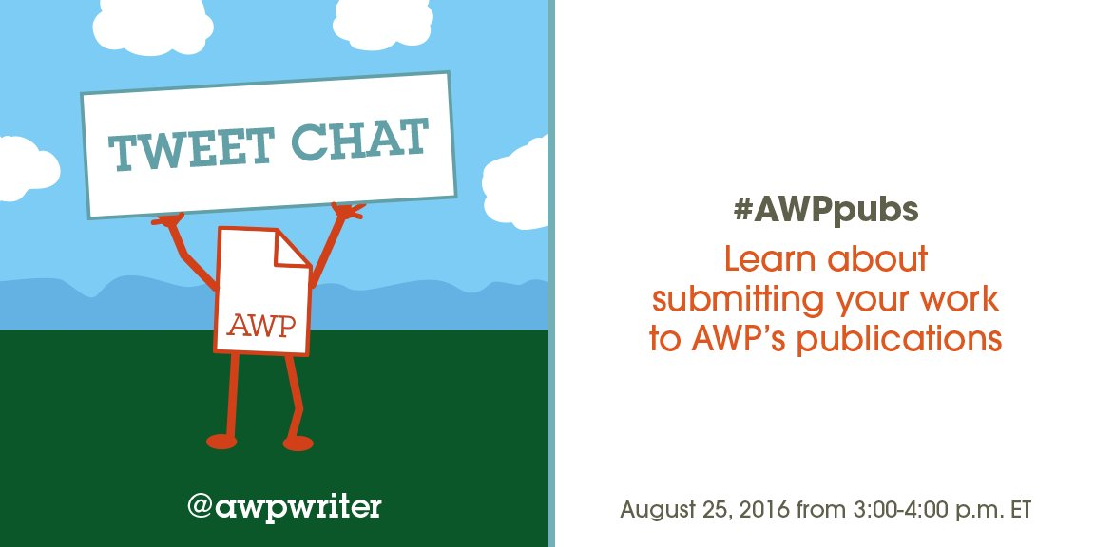
Sian Griffiths ‏@BorrowedHorses
If you're interested in chatting about publishing in AWP pubs, there's a tweet chat today at 3 pm ET, #AWPpubs. @awpwriter @jasonmgray
AWP ‏@awpwriter
Welcome to our #AWPpubs tweet chat! For the next hour, we'll discuss AWP's various publications and how you may submit to them. #AWPpubs
AWP ‏@awpwriter
Joining us today is Jason Gray, @jasonmgray, AWP's Associate Editor #AWPpubs #AWPpubs
AWP ‏@awpwriter
Also here is Supriya Bhatnagar, @sbhatnag, AWP's Director of Publications #AWPpubs
AWP ‏@awpwriter
To ask a question about AWP publications any time, just use #AWPpubs in your tweet.
Jason Gray ‏@jasonmgray
Hello to all! #AWPpubs
Supriya Bhatnagar ‏@sbhatnag
#AWPpubs Hello! we are on the lookout for appreciations of writers who made an impact on the literary scene in the last five decades.
Kelly Thompson ‏@stareenite
@sbhatnag @awpwriter @LidiaYuknavitch is one.
AWP ‏@awpwriter
@stareenite @sbhatnag Great! We'd love for you to write an appreciation piece.
Kelly Thompson ‏@stareenite
@awpwriter @sbhatnag DM me where to send and deadline?
AWP ‏@awpwriter
Chronicle submission ends 9/30. Writer's Notebook is open year-round. Guidelines: https://www.awpwriter.org/magazine_media/submission_guidelines … #AWPpubs

Supriya Bhatnagar ‏@sbhatnag
#AWPpubs Help us celebrate AWP's 50th Anniversary next year!

Jason Gray ‏@jasonmgray
FYI: Our Chronicle sub window closes 9/30 this year. Reopens 2/1/17 Notebook and Career advice open all year. #AWPpubs
Jason Gray ‏@jasonmgray
And submissions should come to us via http://awp.submittable.com . #AWPpubs
AWP ‏@awpwriter
Last year's issues of The Writer's Chronicle #AWPpubs
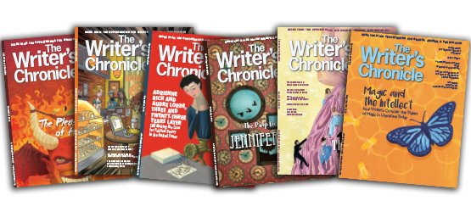
Jason Gray ‏@jasonmgray
Chronicle articles dedicated to craft essays, appreciations of writers, interviews, current literary culture critique. #AWPpubs
Jason Gray ‏@jasonmgray
Check out our latest issue here: https://www.awpwriter.org/magazine_media/writers_chronicle_overview … #AWPpubs
Supriya Bhatnagar ‏@sbhatnag
#AWPpubs We are also looking for historical material on AWP’s early days, as well as photographs from past conferences.
Supriya Bhatnagar ‏@sbhatnag
#AWPpubs And photographs of past board members.
Supriya Bhatnagar ‏@sbhatnag
#AWPpubs Our next Oct/Nov issue promises to be a great one!
Jason Gray ‏@jasonmgray
Writer’s Notebook for blog-length posts. We want to have more engagement, more commentary on lit culture. https://www.awpwriter.org/magazine_media/writers_notebook … #AWPpubs
Jason Gray ‏@jasonmgray
For instance, see Kyle Dargan’s new piece. https://www.awpwriter.org/magazine_media/writers_notebook_view/45/the_other_side_of_the_game_reconciling_my_reading_and_my_rearing_in_the_literary_world … #AWPpubs
Supriya Bhatnagar ‏@sbhatnag
#AWPpubs Have you taught at a writers' workshop over the summer? Adapt your craft lecture as an essay and send it on to us!
Jason Gray ‏@jasonmgray
The Writer's Notebook also hosts shorter craft and advice pieces, short q&a posts. #AWPpubs
Michael Wells ‏@stickpoet
Have enjoyed Writer's Notebook
Jason Gray ‏@jasonmgray
@stickpoet Thanks!

Supriya Bhatnagar ‏@sbhatnag
#AWPpubs While thinking of writing for us, do keep the Career Advice section on our website in mind.
Jason Gray ‏@jasonmgray
Yes, we need good career articles. Know an industry where writers would do well? #AWPpubs
AWP ‏@awpwriter
@jasonmgray Question: what if I have a new spin on a subject already covered in a past career advice article? #AWPpubs
Jason Gray ‏@jasonmgray
@awpwriter That''s great! These are topics that need to be revisited, as times and employment trends change. #AWPpubs
Jason Gray ‏@jasonmgray
Like everyone will tell you, the best way to know what we like is read what we’ve already published. #AWPpubs
Supriya Bhatnagar ‏@sbhatnag
#AWPpubs Do visit the Chronicle archives on our website to read essays from our back issues.
Jason Gray ‏@jasonmgray
Our archive is available for members, and many articles are open to all. Take a look. #AWPpubs https://www.awpwriter.org/magazine_media/writers_chronicle_overview …
Shawn Proctor ‏@shawnproctor
@jasonmgray To whom would you recommend pitching an idea? (Also, A+ on the beard, sir!)
Jason Gray ‏@jasonmgray
@shawnproctor We generally prefer to receive finished pieces, not pitches. (And thank you very much!) #AWPpubs
Shawn Proctor ‏@shawnproctor
@jasonmgray Is there a place with guidelines on the site? Also, just email to chronicle@awpwriter.org? (You're welcome!)
Jason Gray ‏@jasonmgray
@shawnproctor https://www.awpwriter.org/magazine_media/submission_guidelines … #AWPpubs

Jason Gray ‏@jasonmgray
We want to feature more minority voices—we’ve reached out to solicit, but know we can do more. Send us your work, please! #AWPpubs
Supriya Bhatnagar ‏@sbhatnag
#AWPpubs Stop by AWP's bookfair booth at our DC Conference to chat about the Chronicle and what your thoughts are about it.

Jason Gray ‏@jasonmgray
(1)AWP’s 50th anniversary next year is a special occasion. Looking for unique pieces on important lit events of the last 50 years. #AWPpubs
Jason Gray ‏@jasonmgray
(2)Articles on ascendancy of writing groups dedicated to minorities, e.g. CantoMundo, Dark Arts Collective, Cave Canem. #AWPpubs
Jason Gray ‏@jasonmgray
(3)Lit/Genre crossover. Also the debate over moral fiction, i.e., Gardner v. Barth #AWPpubs
Jason Gray ‏@jasonmgray
(4)Trends like New Formalism, New Narrative Poetry, Lit theory, multiculturalism, war protest writing. #AWPpubs
Jason Gray ‏@jasonmgray
(5)Growing translation initiative in US, but also its continuing scarcity here. #AWPpubs
Jason Gray ‏@jasonmgray
(6.1)Would love to read work on major figures: Morrison, Bellow, Roth, Munro, Atwood, Samuel Delaney, Erdrich, Oates, Murakami, #AWPpubs
Jason Gray ‏@jasonmgray
(6.2)Marilynne Robinson, Ishiguro, DeLillo, Marquez, Cormac McCarthy, Junot Diaz, EP Jones, John E Wideman, Zadie Smith, Cisneros #AWPpubs
Jason Gray ‏@jasonmgray
(6.3)Jorie Graham, Ashbery, Gluck, Komunyakaa, Bidart, Walcott, Strand, CD Wright, Armantrout, Ai #AWPpubs
Jason Gray ‏@jasonmgray
(6.4)John McPhee, Dillard, Sontag, Didion, Kingston, August Wilson, Mamet, Stoppard, Suzan-Lori Parks #AWPpubs
Jason Gray ‏@jasonmgray
(6.5)Would also love work BY these writers! (Well, the ones fortunately still with us.) #AWPpubs
Supriya Bhatnagar ‏@sbhatnag
#AWPpubs All six issues of 2017 will be a celebration of writing!
Nicole Tolman ‏@NicoleTolman1
What exactly is #AWPpubs? Is it a magazine? Something solely online? Is it a publishing press...?
Jason Gray ‏@jasonmgray
@NicoleTolman1 Publications of @awpwriter: The Writer's Chronicle, as well as our blog and career advice articles. #AWPpubs
Supriya Bhatnagar ‏@sbhatnag
#AWPpubs it's high time we brought YA lit in the discussion. Any thoughts on that?
Nicole Tolman ‏@NicoleTolman1
Do you guys publish YA literature? #AWPpubs
Jason Gray ‏@jasonmgray
@NicoleTolman1 We publish criticism about literature, and we would be happy to read work about YA! #AWPpubs
Nicole Tolman ‏@NicoleTolman1 Aug 25
Oh, you guys are looking for critique articles on work that has already been published? #AWPpubs
Jason Gray ‏@jasonmgray
@NicoleTolman1 Yes. We do not publish original creative work.
AWP ‏@awpwriter
@NicoleTolman1 You can see the sorts of things we publish in the Writer's Notebook & Writer's Chronicle: https://www.awpwriter.org/magazine_media/overview … #AWPPubs
Nicole Tolman ‏@NicoleTolman1
@awpwriter My main question was if you guys publish works, like novels, short stories, poetry, ect.?
AWP ‏@awpwriter
We don't publish creative works, but we do have awards that include publication: https://www.awpwriter.org/contests/awp_award_series_overview … #AWPpubs
Nicole Tolman ‏@NicoleTolman1
@awpwriter I am a subscriber to the magazine, but I didn't know if this was a separate thing.
AWP ‏@awpwriter
We have many separate publications, including the mag, so we thought we'd talk about them all in this chat #AWPpubs

Jason Gray ‏@jasonmgray
Did you know, The Writer’s Chronicle has a Facebook page: https://www.facebook.com/WritersChronicle … Like us to see new archive articles daily #AWPpubs
Erika Dreifus ‏@erikadreifus
Writers, if you're keen on writing for the @awpwriter publications (yes, they pay), check out the #AWPpubs chat tweets.
Supriya Bhatnagar ‏@sbhatnag
#AWPpubs @erikadreifus Thanks Erika! And yes we pay for online exclusives and career advice pieces on our website - same as the Chronicle!
Nicole Tolman ‏@NicoleTolman1
@sbhatnag @erikadreifus Career advice for authors, or for anyone in any field?
Supriya Bhatnagar ‏@sbhatnag
#AWPpubs Career advice articles for our field.
AWP ‏@awpwriter
And you can read descriptions of our previous career advice articles online too: https://www.awpwriter.org/careers/career_advice … #AWPpubs

Jason Gray ‏@jasonmgray
That's right, AWP's publications are paying venues, very good paying venues. #AWPpubs

Jason Gray ‏@jasonmgray
For example, most recent career advice on: Interviewing for Acad. Jobs, becoming a lit. agent, working in communications #AWPpubs
Supriya Bhatnagar ‏@sbhatnag
#AWPpubs Career advice should ideally target recent MFA graduates. Or someone with a degree in English.
Supriya Bhatnagar ‏@sbhatnag
#AWPpubs Career in editing, Teaching English as a second language, teaching English abroad....
Nicole Tolman ‏@NicoleTolman1
One more question. There is an ebook out now on publishing companies by Emily Harstone... would you guys want an article abt that? #AWPpubs
Jason Gray ‏@jasonmgray
@NicoleTolman1 We don't publish book reviews, if that's what you mean, but something about the state of the pub industry, possibly #AWPpubs

Supriya Bhatnagar ‏@sbhatnag
#AWPpubs @NicoleTolman1 Nicole, apart from our magazine, we have Career advice, the blog, and our online only exclusives on our website.
Frances J Pearce ‏@FrancesJPearce
Do you give preference to authors who possess MFAs? #AWPpubs
Jason Gray ‏@jasonmgray
@FrancesJPearce No--that doesn't matter, only if the writing is great and appropriate to what we publish. #AWPpubs

Jason Gray ‏@jasonmgray
I'll end where I began, Chronicle subs close 9/30, reopen 2/15/17, Notebook, Career Advice, all year. #AWPpubs. http://awp.submittable.com
Jason Gray ‏@jasonmgray
But if you have more questions, just send a tweet. #AWPpubs

Supriya Bhatnagar ‏@sbhatnag
#AWPpubs Hope to see more via Submittable!
AWP ‏@awpwriter
Thank you for joining us today for our #AWPpubs chat. We look forward to reading your submissions!
AWP ‏@awpwriter
Join us for AWP's next tweet chat, #AskAnEditor, on September 22. #AWPpubs

