AWP’s Sixth Tweet Chat: AWP Publication Submissions
August 6 from 2:00-3:00 p.m. ET

AWP ‏@awpwriter
In an hour, at 2 p.m. ET, we'll host a live tweet chat here, using #AWPsubs, about AWP publications you can submit to
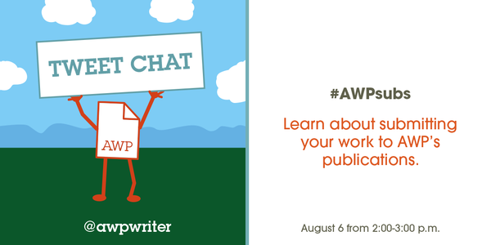
AWP ‏@awpwriter
Thank you for joining us for AWP's 6th tweet chat! Today we'll be chatting live for an hour about AWP's publications. #AWPsubs
AWP ‏@awpwriter
If you have a question about submitting to AWP publications like the Chronicle and Career Advice articles, ask it any time using #AWPsubs.

AWP ‏@awpwriter
Joining us today is Jason Gray @jasonmgray, our associate editor. #AWPsubs
Jason Gray ‏@jasonmgray
Hi! We’re here to answer any questions about submitting to the AWP suite of publications. #AWPsubs
Jason Gray ‏@jasonmgray
This includes the Writer’s Chronicle, our Writer’s Notebook blog, and advice articles in the Careers section of our site. #AWPsubs
Jason Gray ‏@jasonmgray
Tweet your questions to us! We’re going to share some advice and some of our favorite articles from the past. #AWPsubs
Jason Gray ‏@jasonmgray
Take a peek at our guidelines while we chat: https://www.awpwriter.org/magazine_media/submission_guidelines #AWPsubs

Supriya Bhatnagar ‏@sbhatnag
This year we have extended our reading period by a month! It now ends on September 30. #AWPsubs
AWP ‏@awpwriter
Question: what kinds of articles are you most looking for right now? #AWPsubs
Jason Gray ‏@jasonmgray
@awpwriter We get fewer articles about fiction and nonfiction than poetry. So hint hint. And always high quality craft essays! #AWPsubs

Jason Gray ‏@jasonmgray
We’re pleased to announce that we are now accepting submissions via Submittable! http://awp.submittable.com . #AWPsubs
Jason Gray ‏@jasonmgray
We will still take paper submissions through the post as well. Don’t forget your SASE! #AWPsubs
Supriya Bhatnagar ‏@sbhatnag
No personal essays please! Though I love to read them! #AWPsubs
Rebecca Gummere ‏@rgummere
@jasonmgray for Craft Essays do you prefer a query or is it okay to submit a completed essay?
Jason Gray ‏@jasonmgray
No need to query--just go ahead and submit. #AWPsubs

Jason Gray ‏@jasonmgray
Don’t try to be funny in your cover letter—unless you’re REALLY funny. Like Amy Schumer level of funniness. #AWPsubs
Mariecor Agravante ‏@WriterMariecor
@jasonmgray Hi, Jason! I understand AWP offers writing contests. When are they, and what are the guidelines as well? Thanks :) #AWPsubs
Jason Gray ‏@jasonmgray 2h2 hours ago
@WriterMariecor Hi, yes, we have the annual awards series, for full-length books. Find out more here: https://www.awpwriter.org/contests/overview …
AWP ‏@awpwriter
You can find out about all of AWP's contests & awards on our website: https://www.awpwriter.org/contests/overview … #AWPsubs

Jason Gray ‏@jasonmgray
Submit as clean and well-prepared a manuscript as possible. Please! #AWPsubs
Mariecor Agravante ‏@WriterMariecor
@jasonmgray Also, what grants are offered by AWP? Thanks again :)
Jason Gray ‏@jasonmgray
@WriterMariecor We don't have any grants per se, though we provide a list of awards and grants that others provide on our calendar.

Jason Gray ‏@jasonmgray
We pay! Good money. $18/100 words for Chronicle and Career Advice articles. $100 for a blog post. #AWPsubs
Jason Gray ‏@jasonmgray
Writers of color: We don’t hear from you enough! We want to read your work. #AWPsubs
Black Yoda Yogi ‏@BlackYodaYogi
@jasonmgray @awpwriter I can't speak for all writers of color. But, I am tired of having my voice rejected.

Jason Gray ‏@jasonmgray
@BlackYodaYogi @awpwriter Yes, I'm sure that is frustrating. We certainly want to be open to everyone here. I hope you'll give us a try.
Black Yoda Yogi ‏@BlackYodaYogi
@jasonmgray @awpwriter As people of color and writers I believe the only thing we can do is keep writing, submitting, and hoping.

Siyanda-Panda ‏@SiyandaWrites
@jasonmgray I'm not sure if I'm a "writer of color" but I am a African writer in Finland, interested in writing about Buchi Emecheta
Jason Gray ‏@jasonmgray
@SiyandaWrites We'd be happy to read it! #AWPsubs
Bottom of Form
Top of Form
Bottom of Form
Siyanda-Panda ‏@SiyandaWrites
@jasonmgray great!

Burning Bush Press ‏@BurningBushPrss
@jasonmgray just entered the conversation. Where r the guidelines? Interested in an essay re: a short story by a deceased Mexican writer?
Top of Form
Bottom of Form
Jason Gray ‏@jasonmgray
@BurningBushPrss Hi. Sure, we're interested. Guidelines: https://www.awpwriter.org/magazine_media/submission_guidelines …

Jason Gray ‏@jasonmgray
Have a writerly re-discovery? Please send it our way. A future issue will see an essay on Alberta Turner by A. Loudermilk. #AWPsubs
AWP ‏@awpwriter
Want to see all of our previous Writer's Notebook blog posts? We've got a Pinterest board for that! https://www.pinterest.com/awpwriter/the-writers-notebook/ … #AWPsubs
Rebecca Gummere ‏@rgummere
Yay! Thanks for this link! #awpsubs @awpwriter
Jason Gray ‏@jasonmgray
Our blog is a good spot to discuss issues in contemporary lit. Want to join the discussion? #AWPsubs
Jason Gray ‏@jasonmgray
We love intelligent, generous commentaries on writers, like Natasha Trethewey’s essay on Robert Penn Warren: http://tinyurl.com/omd64vt #AWPsubs
Jason Gray ‏@jasonmgray
And well-crafted craft essays, e.g., Douglas Bauer on James’ Portrait of a Lady. https://www.awpwriter.org/magazine_media/writers_chronicle_view/3682/the_master_craftsman_function_follows_form_in_henry_jamess_the_portrait_of_a_lady … #AWPsubs
Supriya Bhatnagar ‏@sbhatnag
The September 15 issue of the Writer's Chronicle is hot off the presses! Watch for it in your mailbox. #AWPsubs
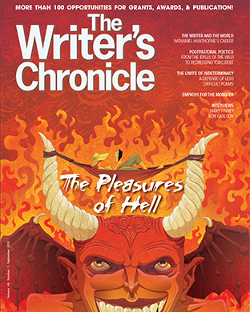
AWP ‏@awpwriter
This tweet chat was perfectly timed. We just got delivery of the September 2015 Writer's Chronicle issue at our office an hour ago. #AWPsubs
AWP ‏@awpwriter
The September 2015 Writer's Chronicle issue will be hitting mailboxes and newsstands shortly #AWPsubs
AWP ‏@awpwriter
Question: What career advice article topics is AWP looking for? #AWPsubs
Jason Gray ‏@jasonmgray
@awpwriter @awpwriter Certainly advice on getting into and advancing in academia, but ... (1/2) #AWPsubs
Jason Gray ‏@jasonmgray
@awpwriter we also want advice for outside academia--let us know what experience you've had using writing in another field. (2/2) #AWPsubs

Rachael Hanel ‏@rachael18
@jasonmgray Footnotes or endnotes for researched articles? MLA style? #awpsubs
Jason Gray ‏@jasonmgray
@rachael18 @awpwriter Endnotes, please! We use Chicago Manual of Style. #AWPsubs
Rachael Hanel ‏@rachael18
@jasonmgray @awpwriter Thank you!

Jason Gray ‏@jasonmgray
We get a lot of personal essays—but we don’t publish them. Nope. #AWPsubs
Jason Gray ‏@jasonmgray
Take a look at our Writer’s Calendar and send those personal essays out to all of those great magazines… https://www.awpwriter.org/community_calendar/writers_calendar … #AWPsubs
Erendira ‏@BelovedEro
@jasonmgray the calls for submissions filter is locked.
AWP ‏@awpwriter
@BelovedEro Which are you attempting to submit to when you receive this error?
Erendira ‏@BelovedEro
@awpwriter on the writer's calendar here : https://www.awpwriter.org/community_calendar/writers_calendar …
AWP ‏@awpwriter
@BelovedEro Oh! Thanks for the clarification. Yes, those are available to members only, so you'd need to be an AWP member & logged in.
Erendira ‏@BelovedEro
@awpwriter OK thanks. I suspected but wanted to be sure.
Cameron Steele ‏@steelecs
@j_bacaj fyi “@jasonmgray: send those personal essays out to all of those great magazines… https://www.awpwriter.org/community_calendar/writers_calendar … #AWPsubs”

Jason Gray ‏@jasonmgray
Also, no pats on the back. Let others write about your work; you tell us what you like about someone else. #AWPsubs
Supriya Bhatnagar ‏@sbhatnag
Sneak Peek inside the Sept issue! #AWPsubs
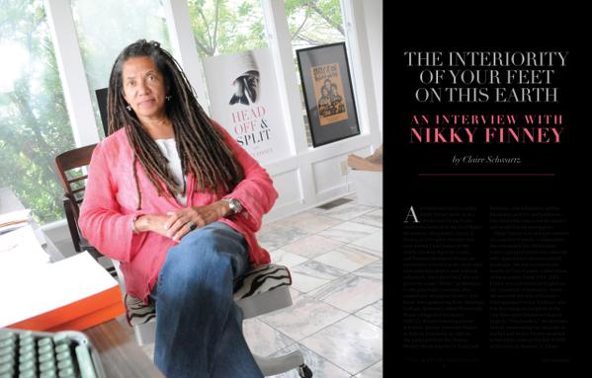
Jason Gray ‏@jasonmgray
If you’re coming to #AWP16 in LA (you are, right?), stop by the info booth and see us. #AWPsubs

AWP ‏@awpwriter
Did you know the Writer's Chronicle is put together by a team of just 5 people? Our entire publications department works on it! #AWPsubs
Jason Gray ‏@jasonmgray
Here’s a sample of what’s coming this year from the Chronicle: An interview with Vijay Seshadri… #AWPsubs
Jason Gray ‏@jasonmgray
… The Pulp Fiction of Jennifer Egan; Karen Russell’s amazing keynote from #AWP15… #AWPsubs
Jason Gray ‏@jasonmgray
D.R. James on Adrienne Rich and Audre Lorde and political poetry #AWPsubs
Jason Gray ‏@jasonmgray
... and “How to Give a Killer Reading” by Christine Vines #AWPsubs
Jason Gray ‏@jasonmgray
And check out our Facebook page. We post a new article from the archive every week day. https://www.facebook.com/WritersChronicle … #AWPsubs

Jason Gray ‏@jasonmgray
Thanks everyone for reading, retweeting, and asking great questions! Hope this has been helpful. We're happy readers, so do submit. #AWPsubs
AWP ‏@awpwriter
Thank you for joining us for today's tweet chat! Chat with us next month about the AWP program survey. #AWPsubs #AWPsurvey

