AWP’s Twenty-second Tweet Chat: #AskAWP17
January 30, 2017 from 3:00-4:00 p.m. ET

AWP ‏@awpwriter
In just one hour, we'll be chatting with you about the #AWP17 Conference & Bookfair. Please ask questions & share advice using #AskAWP17. 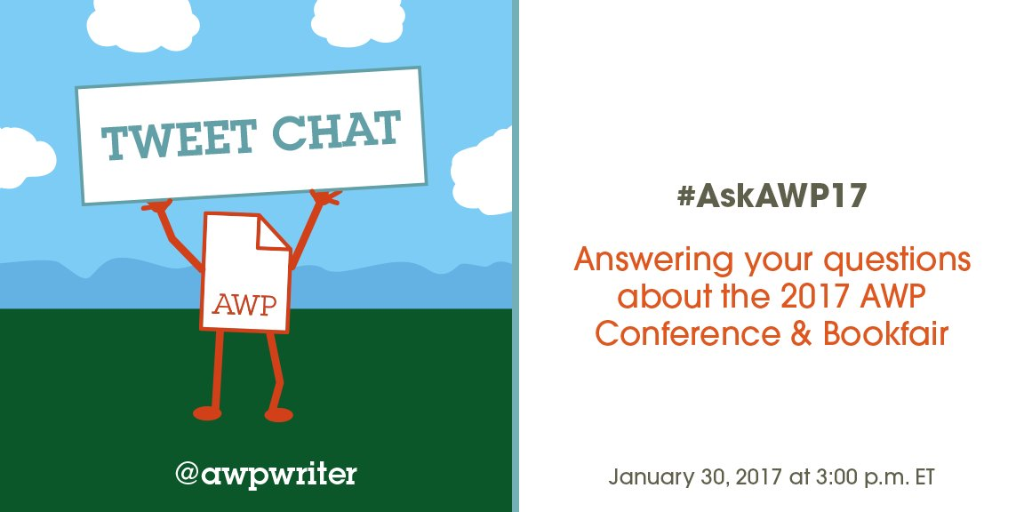
Assay ‏@AssayJournal
Write up an #AWP17 conference report for @AssayJournal! Cover a reading, a talk! #AskAWP17 @awpwriter Sat into: https://assayjournal.wordpress.com/2017/01/26/assayawp17-call-for-saturday-bloggers/ …
Joe Betz ‏@Joe_Betz_
Will you encourage conference attendees to use @lyft or public transportation around DC? #AskAWP17

AWP‏@awpwriter
@Joe_Betz_ Absolutely. See the "Washington, DC Public Transportation" section of our Hotel & Travel page: https://www.awpwriter.org/awp_conference/hotel_travel_overview …

AWP ‏@awpwriter
Welcome to the #AskAWP17 tweet chat about the 2017 Conference & Bookfair in Washington, DC.
AWP ‏@awpwriter
The conference staff is live for the next hour to answer all of your #AskAWP17 questions.
AWP ‏@awpwriter
With us are AWP's Director of Conferences @ChristianTeresi and Director of Exhibits @cshermanva. #AskAWP17
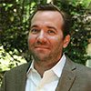

AWP ‏@awpwriter
Also here are Registration Coordinator @AWPsTiffany and Events Coordinator Colleen Cable @colleen_cable. #AskAWP17
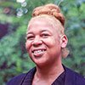

AWP ‏@awpwriter
Have you been to an AWP conference? Got tips, advice, regrets? Please share your wisdom during the chat using #AskAWP17
AWP ‏@awpwriter
Feel free to ask Conference & Bookfair questions any time during the #AskAWP17 chat.
Leanna J Blackwell ‏@baypathmfaCNF
@awpwriter Thanks! I'm wondering if AWP is formally involved in/ helping organize the candlelight vigil on Saturday night #askAWP17
Christian Teresi‏@ChristianTeresi
@baypathmfaCNF We have a small staff, and they are unfortunately going to have their hands full with the conference itself. @awpwriter
Christian Teresi‏@ChristianTeresi
@baypathmfaCNF We plan on posting information about the event to social media today. We want to get the word out. @awpwriter
Bottom of Form
Christian Teresi‏@ChristianTeresi
@baypathmfaCNF AWP is not involved but we applaud those efforts to support and defend freedom of expression. #askawp17 @awpwriter
Leanna J Blackwell‏@baypathmfaCNF
@ChristianTeresi @awpwriter Understood, thanks.#askawp17
Tiffany ‏@AWPsTiffany
Have questions about which type of registration to purchase? Ask me now or email me at registration@awpwriter.org! #AskAWP17
rebecca fisseha ‏@rebsee
@awpwriter thanks! was wondering if general public can buy single ticket to a talk #askawp17
Tiffany‏@AWPsTiffany
@rebsee In order to attend an event, you would need to register for the entire conference. We offer great low student/senior rates #AskAWP17
rebecca fisseha‏@rebsee
@AWPsTiffany thanks, am already registered. asking for someone interested in chimamanda/ta-nehsi event only. can i share my pass? #AskAWP17
Christian Teresi‏@ChristianTeresi
@rebsee Sorry, no. The registrations are specific to the individual, and are not meant to be shared. @AWPsTiffany
Christian Teresi ‏@ChristianTeresi
@rebsee There are no tickets to single events. Though we do have Sat day passes to attend all Sat. events for only $45. @awpwriter #askawp17
rebecca fisseha‏@rebsee
thanks @ChristianTeresi 2nd q: been wanting to add delegate to my pass. is possible after purchase?
Christian Teresi ‏@ChristianTeresi
@rebsee You mean affiliation? Yes, you can add an institutional affiliation by signing into your AWP user account. #askawp17

Cynthia Sherman ‏@cshermanva
Hello! Cynthia Sherman here, happy to answer your #AWP17 bookfair questions. Tweet or email bookfair@awpwriter.org #AskAWP17
Cynthia Sherman ‏@cshermanva
#AWP17 Parking Information http://www.dcconvention.com/Venues/ConventionCenter/DirectionsAndParking.aspx … #AskAWP17
Cathy Baker ‏@charliebravo88
Is it a good idea for a writer to bring business cards? copies of stories? anything else? #AskAWP17
Colleen Cable‏@colleen_cable
@charliebravo88 The conference provides a lot of opportunity to meet and network - bring those business cards! #AskAWP17
Cathy Baker‏@charliebravo88
@colleen_cable Thanks. See you there!

The W's MFA in CW‏@TheW_MFACW
@charliebravo88 Yes, bring some cards, if you have them. Probably not copies of stories. But something with your email and links is good.

The W's MFA in CW‏@TheW_MFACW
@charliebravo88 Also, practice your elevator pitch — if someone asks what you're writing and you have 30 seconds, what do you tell them!

AWP ‏@awpwriter
Did you know your AWP badge will get you discounts at museums, restaurants, and more? Check out: https://washington.org/syb #AskAWP17

Cynthia Sherman ‏@cshermanva
For the most current information download the #AWP17 Mobile App at https://guidebook.com/app/awp #AskAWP17
AWP ‏@awpwriter
Be sure the name on your badge is spelled correctly! If your badge is linked to your account, check here: https://www.awpwriter.org/user/registration_management … #AskAWP17

The W's MFA in CW‏@TheW_MFACW
@awpwriter I see that Will Call registration is still available, right? What’s the difference between that and regular registration?
AWP‏@awpwriter
@TheW_MFACW Yes. Will-call registration is just regular registration purchased online after pre-registration & before conference. #AskAWP17
AWP ‏@awpwriter
@TheW_MFACW The only difference is that, by purchasing online, you save time when picking up your badge at the kiosks. #AskAWP17
Tiffany ‏@AWPsTiffany
@TheW_MFACW Will Call will provide you with the same access to the conference as regular registration. #AskAWP17 https://www.awpwriter.org/awp_conference/registration_overview …

Cynthia Sherman ‏@cshermanva
Check out Exhibitor Spotlights on the AWP-BF FB Page https://www.facebook.com/pages/AWP-Bookfair/536254749775315 … #AskAWP17

Tiffany ‏@AWPsTiffany
Onsite registration is going to be located inside Salon ABC of the Convention Centr #askawp17. https://www.awpwriter.org/awp_conference/registration_overview …
Ponder Review ‏@PonderReview
Best advice for navigating registration? I say get there early and have your confirmation email printed. #AskAWP17
AWP ‏@awpwriter
@PonderReview Great advice! Bring that unique registration code we emailed you and picking up your badge will only take seconds! #AskAWP17

Tom Cho 曹勵善 ‏@tom_cho
.@awpwriter Do you have a sense of how US Govt's new travel bans might affect AWP? E.g. Will any ppl be unable to attend? #AskAWP17
Christian Teresi‏@ChristianTeresi
@tom_cho We have not yet been contacted by anyone who is affected by the ban, but we are monitoring the situation. @awpwriter #AskAWP17
Tom Cho 曹勵善‏@tom_cho
@ChristianTeresi Is @awpwriter proactively investigating if anyone is being prevented from attending the conference?
Christian Teresi‏@ChristianTeresi
@tom_cho We are not aware (either through our own efforts or from outside AWP) of any registered attendee or presenter affected. @awpwriter
Tom Cho 曹勵善‏@tom_cho
@christianteresi @awpwriter OK, thanks for letting me know.

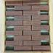Kevin McKelvey‏@KevinMcKelvey
So we're going to ask @awpwriter why the book fair isn't open to the public on Saturday?
Christian Teresi‏@ChristianTeresi
@KevinMcKelvey & of course, it's open to the public, just not for free. There is the discounted Sat. pass for $45. @awpwriter #AskAWP17

Cynthia Sherman ‏@cshermanva
Check out all of the awesome bookfair exhibitors! https://www.awpwriter.org/awp_conference/bookfair_exhibitors_list … #askawp17
The W's MFA in CW ‏@TheW_MFACW
@awpwriter Are there still volunteer opportunities available? #AskAWP17
Tiffany ‏@AWPsTiffany
@TheW_MFACW I'm sorry the opportunity to volunteer has passed. #AskAWP17

AWP ‏@awpwriter
If you're in town on Wednesday afternoon, pick up your badge at registration then so you're all set for Thursday events #AskAWP17
Ponder Review ‏@PonderReview
Save time for the Book Fair! And save room for all the books & things you’ll bring home! We’ll be at #841T #AskAWP17
The W's MFA in CW ‏@TheW_MFACW
#askawp17 Scope out a couple of sessions (near each other, if possible) so that if one is packed, you know where you want to go instead.

Tiffany ‏@AWPsTiffany
We will be offering a one-day pass for Saturday, Feb 11th, of the conference this badge will only be sold onsite on that day. #askawp17
Cynthia Sherman ‏@cshermanva
Attendees make a list of the bookfair exhibitors you would like to see & then be open to the fun of discovering new organizations! #AskAWP17
Tess Duck ‏@TessDuck
#AskAWP17 some members of my student org didn't receive their email confirmations. Will they still be able to pick up their badges with IDs
AWP‏@awpwriter
@TessDuck They should check with registration@awpwriter.org in case we have the wrong email addresses on their badges.

Christian Teresi ‏@ChristianTeresi
@TessDuck The should check their spam folder, and contact @AWPsTiffany at registration@awpwriter.org. #askawp17

Tess Duck‏@TessDuck
@ChristianTeresi thanks, I'll have them email registration
Christian Teresi ‏@ChristianTeresi
@TessDuck They can still pick up badges, but it will take longer. They definitely want to get the confirmation with the code ASAP #askawp17
Cynthia Sherman ‏@cshermanva
Exhibitors make friends with your bookfair neighbors to spot each other for breaks! #AskAWP17
The W's MFA in CW ‏@TheW_MFACW 32m32 minutes ago
#askawp17 We have students in a low-res MFA attending on student registrations. They have IDs, but not w/ Spring 2017. Is this a problem?
Tiffany‏@AWPsTiffany
@TheW_MFACW No problem, they can also provide a class schedule, acceptance email/letter, email/letter from a dean or professor #AskAWP
The W's MFA in CW‏@TheW_MFACW
@awpstiffany Thank you! I’ll let them know.

Cynthia Sherman ‏@cshermanva
Wi-fi is free throughout the convention center! #askawp17
Christian Teresi ‏@ChristianTeresi
WiFi is for email & moderate web browsing, but signal is not strong enough for more complicated uses like streaming video. #askawp17
Tiffany ‏@AWPsTiffany
Get an email saying someone purchased you a badge? Make sure to confirm your registration by "linking" it to your AWP user account #askawp17
AWP ‏@awpwriter
Heading to #AWP17 on the Metro? Remember to stand to the right or walk on the left when using the escalators! #AskAWP17
AWP ‏@awpwriter
The Mt Vernon Sq/Convention Center stop is on the green & yellow lines. Check for delays or announcements: https://www.wmata.com/service/status/ #AskAWP17

Poetry South ‏@poetry_south
#AskAWP17 Look for some great swag at the Book Fair, esp. calls for submissions. Talk to editors. Buy sample copies (or get free ones).
Cynthia Sherman ‏@cshermanva
Cell phone connectivity in the BF is good & a square can be used to run CC transactions w/exception of peak times #AskAWP17
Cynthia Sherman ‏@cshermanva
To guarantee internet access, Smart City offers an exhibitors special, call them directly at 202.249.3800 #AskAWP17
Tiffany ‏@AWPsTiffany
If you have questions about the DC Convention Center, check out the Attendee FAQ page. https://www.awpwriter.org/awp_conference/faqs#AttendeeFAQ …… #AskAWP17
Adam Clay ‏@adam__clay
self-care tip: buy a bag of lemons when you arrive. drink a big glass of lemon water each night and one first thing each morning #AskAWP17

Tess Duck‏@TessDuck
#AskAWP17 any good places to eat on a student budget? We were thinking Daikaya, but it's out of our price range.
Christian Teresi ‏@ChristianTeresi
@TessDuck There are a ton of options, & taking a look at zagat or another food app is the best way to find inexpensive venues. #AskAWP17
Christian Teresi ‏@ChristianTeresi
@TessDuck You might have to walk a few blocks, but this is probably be the most options our attendees have had in a while. #AskAWP17

Adam Clay ‏@adam__clay
Don't buy books on the first day. Do bring a second suitcase (pack your suitcase inside another suitcase) for books. #AskAWP17
Adam Clay ‏@adam__clay
Or bring a flat rate USPS box that's self-addressed to ship books and journals back #AskAwp17

Tiffany ‏@AWPsTiffany
To view and manage your conference badge information, visit https://www.awpwriter.org/user/registration_management … #AskAWP17
Cynthia Sherman ‏@cshermanva
AWP provides 24 hr security, still a good idea to bring a cloth to cover your exhibit table nightly & take small valuables w/ you! #AskAWP17
Cynthia Sherman ‏@cshermanva
@adam__clay Thank you for the great tips, Adam, feel free to keep posting them! #askAWP17
AWP ‏@awpwriter
Need some vegetarian/vegan dining options? We've got a list of some AWP staff favorites: https://docs.google.com/document/d/1fvX-jNaqL7W1iFUTvNmSS0GbleisJ1X8LumlFIOMxMw/edit?usp=sharing … #askawp17
Adam Clay ‏@adam__clay
subscribe to a few journals--rates will be VERY low. be a good literary citizen! #AskAWP17
The W's MFA in CW ‏@TheW_MFACW
#askawp17 Don't miss out on the many off-site events. It's impossible to do everything, but you should see what's happening.
Cynthia Sherman ‏@cshermanva
For exhibitors, the handy carry rule is no charge for one load per person carried into exhibit hall #AskAWP17
Adam Clay ‏@adam__clay
Text a few editor friends before you show up each morning--ask them if they need coffee and bring some caffeine for your pals #AskAwp17
Cynthia Sherman ‏@cshermanva
Have more than 1 trip of hand carry items? Brede charges $90 rate per flat cart load of boxes from your car at the loading dock #AskAWP17
Cynthia Sherman ‏@cshermanva
You can still assign EABs on your exhibit space management page! #AskAWP17
AWP ‏@awpwriter
Right! You'll need EABs in order to set up your exhibit space, so be sure you've got them assigned to the right people! #AskAWP17

Adam Clay ‏@adam__clay
If you want to blend in at the bookfair, grow a beard and wear a flannel shirt #AskAWP17
Cynthia Sherman ‏@cshermanva
@adam__clay Or a sock monkey hat! #askawp17

The W's MFA in CW ‏@TheW_MFACW
#askawp17 Have fun, make friends, go to readings, find new magazines, wear comfortable shoes/clothes, prepare to be exhausted/energized.
AWP ‏@awpwriter
Thank you for joining us for our #AskAWP17 chat! Keep sharing your best advice using #AWPTips
AWP ‏@awpwriter
Please join us on Feb 23 for #TellAWP17, a tweet chat for you to share your conference feedback with us. #AskAWP17

