AWP’s Ninth Tweet Chat: #MFAChat
November 2 from 2:00-3:00 p.m. ET

AWP ‏@awpwriter
Today at 2 p.m. ET, use #MFAchat to join the discussion about writing programs.
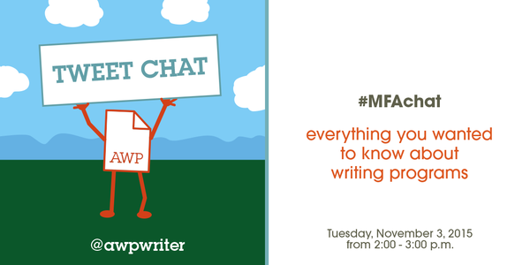
AWP ‏@awpwriter
Welcome to AWP's 9th Twitter chat! Today we'll be discussing writing programs. #MFAchat
AWP ‏@awpwriter
With us today is Director of Membership, Diane Zinna, @DianeZinna. #MFAchat

AWP ‏@awpwriter
Also from the Membership department is Membership Associate Kenny Lakes, @usyboroda. #MFAchat
AWP ‏@awpwriter
And from the Publications department, we are joined by Jason Gray, @jasonmgray. #MFAchat
AWP ‏@awpwriter
We are also joined by many writing programs across the world & a recent MFA graduate, Elizabeth Deanna Morris Lakes, @exclamate_. #MFAchat
EDML ‏@exclamate_
About me: I have an MFA in poetry from @Mason_MFA. I currently work at #FINRA as a test development editor. Yes, I got a real job! #MFAChat
AWP ‏@awpwriter
How do you choose a program that's right for you? Find out now! #MFAchat
AWP ‏@awpwriter
To ask a question at any time and to follow the discussion, use hashtag #MFAchat.
Diane Zinna ‏@DianeZinna
Welcome! I'm Diane Zinna, AWP's Membership Director, and I'll be your host for the next hour as we discuss MFA programs. #MFAChat
Diane Zinna ‏@DianeZinna
Like many of the staff here at AWP (breathlessly standing by to answer your questions), I attended an MFA Program. #MFAChat
Diane Zinna ‏@DianeZinna
We also invited directors of many different creative writing programs to join us today to share their perspectives. #MFAChat
EDML ‏@exclamate_
Over two years, I ended up applying to 30 different MA and MFA programs in poetry. I got into 6, but I only got into 1 fully funded #MFAChat
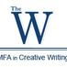The W's MFA in CW ‏@TheW_MFACW
See our Guide for Applicants for ideas on writing samples, statements of purpose, recommendations, etc. #MFAChat http://tinyurl.com/ozbsbtx
IAIALowRez ‏@LowRezMFA
The Institute of American Indian Arts' low residency MFA is unique. Check out our faculty here: http://www.iaia.edu/MFA #MFAchat
Marie-Helene Bertino ‏@mhbertino
I teach here alongside some of the most brilliant minds I know. Check it out and apply, ye MFA seekers!

Jenna Sauers ‏@jennasauers
Are you considering an MFA? I'll be participating in @awpwriter's #MFAchat today at 1 pm CST. Ask me anything about Iowa.
red starbucks cup ‏@helenbholmes
@jennasauers @awpwriter do you feel Iowa's been essential to your development as a writer? would I miss NYC too much to get stuff done?

Jenna Sauers ‏@jennasauers
@helenbholmes "essential" is hard to define, but I have developed during my MFA in ways I wouldn't have had I remained a freelancer #MFAchat
Jenna Sauers ‏@jennasauers
@helenbholmes missing NYC is tough though. It is a HUGE change and I vastly underestimated how disruptive the adjustment would be #MFAchat
red starbucks cup ‏@helenbholmes
@jennasauers could you tell me about what's been hardest for you besides the writing? #MFAchat
Jenna Sauers ‏@jennasauers
@helenbholmes but I am much happier now. In grad school I also have amazing shit I never had before as a freelancer, like health insurance
Joshua Bohnsack ‏@josiahbohnsack
What are some points I should consider and avoid using on my SOP? #MFAchat
Julie Sheehan ‏@thebarbook
@josiahbohnsack avoid opening with "ever since I can remember I wanted to write." So has everyone else.
Carla Caglioti ‏@SouthMFA
@josiahbohnsack @thebarbook We @southampwriters recommend to be yourself -- which is very difficult to do. You're looking for the right fit
The W's MFA in CW ‏@TheW_MFACW
@josiahbohnsack I just tweeted a link to our Guide for Applicants. I wrote it with our program in mind, but also for anyone MFA applicant: http://www.muw.edu/images/colleges/as/llp/MFAGuideForApplicants.pdf
AWP ‏@awpwriter
Any advice for writing a good Statement of Purpose essay? #MFAChat
SMC MFA Program ‏@smcmfa
@awpwriter be specific and honest. spill your guts & let it all hang out. it's your time to put it all out on the table. be brave. #MFAChat
EDML ‏@exclamate_
@awpwriter Here's what NOT to put in: "I've been literally writing since I came out of the womb." Focus on what you're doing now! #MFAchat

Alyse Bensel ‏@leaseandleaves
@awpwriter Know the programs you're applying to and truthfully discuss your goals--explain how you're well-matched for each other! #MFAchat
David Schuman ‏@d_schuman
@awpwriter I always tell students asking for advice about SOP--straightforward and honest is best. Smart alecky, not so much.
Daniel A. Hoyt ‏@dan_hoyt
Consider your personal statement a writing sample. Get specific and real. Don't say you've always been a reader or a writer! #MFAchat
Julie Sheehan ‏@thebarbook
@dan_hoyt we now ask applicants to describe their current reading interests. #MFAchat
Daniel A. Hoyt ‏@dan_hoyt
@thebarbook Great idea. #MFAchat and no Chuck Palahniuk!
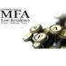Converse College MFA ‏@ConverseMFA
In the personal statement we look for serious readers and as well as serious writers. Be specific. Let us know why you want this. #MFAchat

The W's MFA in CW ‏@TheW_MFACW
Mississippi University for Women has a new MFA that is flexible, affordable, professional and personal. #MFAChat http://www.muw.edu/mfacreativewriting …
The W's MFA in CW ‏@TheW_MFACW
Mississippi University for Women has been coed since 1984. Our MFA is open to all. #MFAChat http://www.muw.edu/disclosures/non-discrimination …
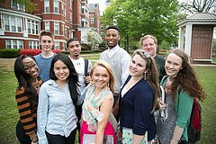
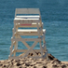SBShampton MFAWriter ‏@SouthampWriters
The good news: no tracking by genre. The bad news: bring your own artistic focus. #MFAChat
David Schuman ‏@d_schuman
Hello #MFAchat If anyone has a question about the MFA at @WUSTL feel free to ask. Our website is currently down, tho...bummer.

UCRLowResMFA ‏@UCRPDLRMFA
#MFAchat is on! So, first thing: Yes, we hold our residencies at a spa. This is our campus: http://www.omnihotels.com/hotels/palm-springs-rancho-las-palmas …
UCR Palm Desert ‏@UCRPalmDesert
See why students love our MFA program! #MFAchat
Diane Zinna ‏@DianeZinna
@UCRPDLRMFA Wait...what? This is amazing! #MFAChat
Daniel A. Hoyt ‏@dan_hoyt
I suggest that undergrads consider applying to an MA program or two along with MFA programs. #MFAchat
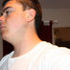Stephen J Furlong ‏@BeenASon24
Stephen J Furlong Retweeted Daniel A. Hoyt
I applied to four of five MAs and am currently in an MA program now. Having those as options really helped. #MFAchat
Daniel A. Hoyt ‏@dan_hoyt
I'm not just saying that because I direct the creative writing program at #KState's MA program. #MFAchat
Daniel A. Hoyt ‏@dan_hoyt
I recommend Kansas State (of course, the University of Missouri (where I got my MA two decades ago), and Mississippi State. #MFAchat
SBShampton MFAWriter ‏@SouthampWriters
The good news: we’re in the Hamptons. The bad news: they don’t let you sleep on the beach. #MFAChat
Diane Zinna ‏@DianeZinna
Let's get started! Alumni and current students, what made you ultimately choose the program you attended? #MFAChat
Michael Nye ‏@mpnye
.@DianeZinna I did my MFA at @umsl - I wanted to live in a city and be in the Midwest #MFAchat
Daniel A. Hoyt ‏@dan_hoyt
.@mpnye @DianeZinna @umsl UMSL has a great magazine and faculty. Good city too: Just ignore those Cardinals fans.
Michael Nye ‏@mpnye
@dan_hoyt @DianeZinna @umsl Spend $ on MLB app for your favorite team! $20 a year! #unpaidendorsement
Lisa Romeo ‏@LisaRomeo
@DianeZinna I chose my program almost entirely on faculty. Also, on location (low res), reputation, strength in my track. #MFAchat
Jason Gray ‏@jasonmgray
I'll start with this: “Don’t go in debt to be a poet.” Best advice I ever received about grad school. #MFAchat
Daniel A. Hoyt ‏@dan_hoyt
Here's some general advice and words of caution that we give to students applying to grad school in CW. http://k-statecreativewriting.tumblr.com/post/33706859670/on-applying-to-mfa-programs … #MFAchat
Diane Zinna ‏@DianeZinna
1/4 Joining us: University of California Riverside's Low-Res Program, St Mary's College of California, Stony Brook Southampton #MFAChat
Diane Zinna ‏@DianeZinna
2/4 Western State Colorado University, Virginia Tech, Sierra Nevada College, Rosemont College, Kansas State, Converse College...#MFAChat

Diane Zinna ‏@DianeZinna
3/4 The Institute of American Indian Arts, Mississippi University for Women, Washington University in St. Louis... #MFAChat
Diane Zinna ‏@DianeZinna
4/4...and Cardiff Metropolitan University in the UK. Whew! That is a lot. But there are hundreds. How to start? #MFAChat
David Schuman ‏@d_schuman
Also excited to let everyone know, if you don't that @WUSTL_English MFA now has a CNF track, starting its second year in Fall 2016 #MFAchat
Lisa Romeo ‏@LisaRomeo
I teach in all online, all CNF program @Bay_Path U. Happy to answer any Qs. Graduate of Stonecoast low res program (U So Maine). #MFAchat
EDML ‏@exclamate_
I applied to 13 schools while finishing my BA in creative writing from @SUWriters. I got into 13 schools, all unfunded. I waited. #MFAChat
EDML ‏@exclamate_
It was an important and good decision. I got out of school with minimal debt, & teaching and editing experience. #MFAChat
EDML ‏@exclamate_
Unless you have an inheritance, live at home, work full time, or some combination thereof, do NOT go to grad school unfunded #MFAChat
UsyBoroda ‏@usyboroda
I am Kenny Lakes, Membership Associate @awpwriter I did not attend an MFA program, but am happy to point out the resources we have #MFAChat
Diane Zinna ‏@DianeZinna
Our Guide to Writing Programs lists over 950 creative writing programs http://bit.ly/1FTizy7 #MFAChat
Diane Zinna ‏@DianeZinna
We recently renovated the Guide to make it a better resource for prospective students #MFAChat
Diane Zinna ‏@DianeZinna
Clicking on the school’s name will bring you to their full listing, where you can learn more about the program #MFAChat
Diane Zinna ‏@DianeZinna
You can sort the Guide by different regions or by a specific state #MFAChat
Diane Zinna ‏@DianeZinna
We have about 50 low-res and online-only programs listed #MFAChat
Diane Zinna ‏@DianeZinna
You can also narrow your search by genre and type of degree. We don’t just list MFA programs, but all undergrad and grad degrees. #MFAChat
UsyBoroda ‏@usyboroda
@DianeZinna Here is what that looks like on our site! #MFAChat
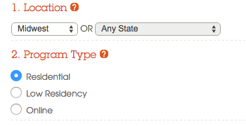
Diane Zinna ‏@DianeZinna
When looking at the list of programs, you can easily see what degrees are offered and what genres are covered. #MFAChat

UsyBoroda ‏@usyboroda
@DianeZinna So many genres to choose from! #MFAChat
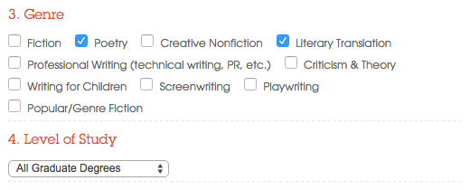
Diane Zinna ‏@DianeZinna
You can also see a list of faculty that teaches at the school as well as where the program is located #MFAChat
UsyBoroda ‏@usyboroda
@DianeZinna Some faculty members' names will link to their AWP bio #MFAChat
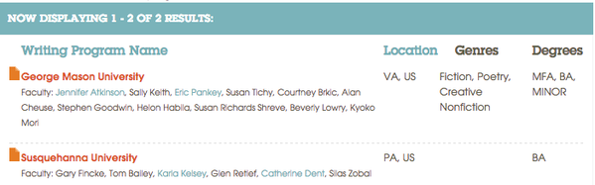
VT Creative Writing ‏@VirginiaTechCW
#MFAChat VirginiaTech: small 3 yr program + diverse student body + vibrant college town in bucolic setting + campus looks like Hogwarts
The W's MFA in CW ‏@TheW_MFACW
I tweeted a link to our Guide for Applicants—that's my advice. What other programs have advice like this? #MFAChat http://www.muw.edu/images/colleges/as/llp/MFAGuideForApplicants.pdf …
Frances Cannon ‏@honeyhog
Where but in Iowa City can a writing grad student spend 10 weeks with so many international scholars? #MFAchat
Leanna J Blackwell ‏@baypathmfaCNF
I direct the MFA in creative nonfiction at Bay Path. The first fully online MFA in CNF. Ask me anything! #MFAchat
English@CardiffMet ‏@English_CMet
Check out our graduate Creative Writing program here: http://www.cardiffmet.ac.uk/education/courses/Pages/Creative-Writing---MA.aspx … #MFAchat

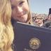Meagan Arthur ‏@meaganearthur
Program directors & panel members, what are common mistakes/general turn offs that you often find in writing samples? #MFAchat @awpwriter
UCRLowResMFA ‏@UCRPDLRMFA
@meaganearthur @awpwriter And typos and cliches within the first sentence -- we want originality and attention to detail #MFAChat
UCRLowResMFA ‏@UCRPDLRMFA
@meaganearthur @awpwriter Your entrance essays don't need to be the worst lifetime movie of your life! Tell us something good! #MFAchat
Converse College MFA ‏@ConverseMFA
@meaganearthur @awpwriter Biggest mistake is when the guidelines aren't followed. If uncertain, be sure to ask. #MFAchat
The W's MFA in CW ‏@TheW_MFACW
@meaganearthur @awpwriter #mfachat Just send your best writing and make it as perfect as you can. Write with passion. Be yourself.

The W's MFA in CW ‏@TheW_MFACW
@meaganearthur @awpwriter Obvious ones: spelling/grammar errors, less obvious, poor poem or story structure,, sending too much. #MFAChat
Michael Nye ‏@mpnye
Broadly, I tell prospective writers 1. Fully funded programs only 2. Three years rather than two 3. work on a #litmag #MFAchat
Brittany Borghi ‏@brittany_borghi
This is so spot on. Conveniently, the #NonfictionWritingProgram @uiowa gives you the chance to do all 3+ #MFAchat
Julie Sheehan ‏@thebarbook
@mpnye Although if you're mid-career, a part-time program could be the way to go. #MFAchat
Michael Nye ‏@mpnye
@thebarbook Definitely, though I wonder, in that situation, if community programs like @GrubWriters are then better than a program.
Lisa Romeo ‏@LisaRomeo
@thebarbook @mpnye Indeed. PT, online, low res - all good choices if you can't move, have a family, are in midlife. That was me. #MFAchat
Michael Nye ‏@mpnye
@LisaRomeo @thebarbook Low-res, though, can be shockingly expensive.
Julie Sheehan ‏@thebarbook
@mpnye @LisaRomeo State schools to the rescue! #MFAchat
Lisa Romeo ‏@LisaRomeo
@mpnye @thebarbook Yep. Choose where to apply wisely. I just crossed out the low res ones I knew I couldn't pay off in 2 years. #MFAchat
Julie Sheehan ‏@thebarbook
@mpnye And part-timers generally don't get funding. #MFAchat
Michael Nye ‏@mpnye
Very true, and people should know this #MFAchat

The W's MFA in CW ‏@TheW_MFACW
@thebarbook @mpnye #mfachat We have partial scholarships for part-time at 6 hours, which is also required for federal loans.
Lydia Pudzianowski ‏@DoritosHangover
Yes, yes, and yes. I took loans out and really wish someone had emphatically told me not to. #MFAchat
Jon Chaiim McConnell ‏@JonMcConn
@mpnye Still don't really conceive of what my massive debt means for my life 3 years later, so I don't even know how dumb I am yet #MFAchat
Jon Chaiim McConnell ‏@JonMcConn
@mpnye that is, it's an amount of money so large that it's not worth worrying about day to day #MFAchat
jen! ‏@JenniferMWolff
@JonMcConn @mpnye Same boat for me now, due to undergrad alone! My student loan debt gets bigger daily, no matter how much I pay into it.

The W's MFA in CW ‏@TheW_MFACW
Affordable: The W offers low in-state tuition & waives non-resident fees for all graduate students. #MFAChat http://www.muw.edu/as/llp/english/graduate/mfacwcosts …
Converse College MFA ‏@ConverseMFA
@converseMFA is a low res MFA that provides partial scholarships, opportunities of TA spots & other options http://www.converse.edu/mfa #MFAchat
Diane Zinna ‏@DianeZinna
QUESTION: What are the factors you’d rank highly when considering creative writing programs? #MFAChat
Alyse Bensel ‏@leaseandleaves 2h2 hours ago
@DianeZinna FUNDING, faculty, coursework options, lit journal, reading series, location, camaraderie, professionalization. #MFAchat
Diane Zinna ‏@DianeZinna
@leaseandleaves YES! Funding has got to be #1!
SMC MFA Program ‏@smcmfa
@DianeZinna faculty #1; curriculum #2. visit campus if you can. connect w alums & current students #MFAChat
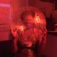Jasmine Evans ‏@JasmineKEvans
@DianeZinna @awpwriter faculty, location, professional development, scholarships, and to a lesser extent alumni involvement #MFAChat
David Schuman ‏@d_schuman
@DianeZinna Who you'd like to work with, location, funding, aesthetics of the program. But getting too hung up on any of those can limit you
Jason Gray ‏@jasonmgray
What opportunities are available? Teaching? Lit mag? Reading series? Chance to study second genre? #MFAchat
SMC MFA Program ‏@smcmfa
@jasonmgray @smcmfa offers a 3rd yr in a second genre. i (@CandaceErosDiaz) am an alumna w a dual concentration in CNF & fiction. #MFAChat

Chelsea H Bryan ‏@chelseahbryan
UCDavis #MFAchat: it's funded, it's got Yiyun Li, Pam Houston and Lucy Corin, and it's got SF commuters. Not a #frenemy environment. Apply.
SBShampton MFAWriter ‏@SouthampWriters
The good news: Meg Wolitzer, Roger Rosenblatt, Billy Collins, Patty Marx. The bad news: premature laugh lines. #MFAChat
Michael Nye ‏@mpnye
Worry 99.9% about your writing sample, and the other .1% about GRE and statement of purpose #MFAchat
Daniel A. Hoyt ‏@dan_hoyt
I'd tweak @mpnye's numbers a little: 90 writing sample, 9.9 SOP, and .1 GRE! #MFAchat

Diane Zinna ‏@DianeZinna 6m6 minutes ago
QUESTION: What would matter more to you? Location or faculty? #MFAChat
Ana ‏@write2recite 20m20 minutes ago
Faculty is important when looking into MFA programs. Because a quality education counts more than location. #MFAChat @DianeZinna

Leanna J Blackwell ‏@baypathmfaCNF
Faculty, faculty, faculty. By far the most important: http://bit.ly/1iB1zBy #mfachat
Leanna J Blackwell ‏@baypathmfaCNF
And when I say "faculty," I mean both distinguished writers and gifted, dedicated teachers. Happy to say we have both. #mfachat
Julie Sheehan ‏@thebarbook
I think the community of students matters in an MFA program. A lot. #MFAchat
Leanna J Blackwell ‏@baypathmfaCNF
@thebarbook Completely agree. I had that. Want my students to have the same. As director,I make sure faculty foster that community #mfachat
Converse College MFA ‏@ConverseMFA
@DianeZinna Depends on the individual, but I think faculty is very important. #MFAchat
EDML ‏@exclamate_
I never looked at schools based on who taught there. Amazing writers can be really bad teachers. (No offense, amazing writers.) #MFAChat
Julie Sheehan ‏@thebarbook
Oh, wow, but when you get both...#MFAchat
SMC MFA Program ‏@smcmfa
@exclamate_ very true. good then to speak w faculty & ask about their teaching philosophy/experience. don't be afraid to dig in #MFAChat
Chelsea H Bryan ‏@chelseahbryan
@exclamate_ true! Can be awesome, ex.: @pam_houston. I believe in going somewhere where you can relate on big stuff your work gets at
EDML ‏@exclamate_
@chelseahbryan @pam_houston Yes! It's good to get a feel for the faculty as a whole, not just yr fav writer.
EDML ‏@exclamate_
Or, maybe your dream writer will end up being so busy you'll never see them! My point: going for one person is risky. #MFAChat
Diane Zinna ‏@DianeZinna
@exclamate_ Yes, and sometimes the greatest writers are not the greatest teachers. #MFAChat
David Schuman ‏@d_schuman
@DianeZinna @exclamate_ And just because you haven't heard of a writer on faculty, doesn't mean they aren't a great writer/teacher #MFAchat
Lydia Pudzianowski ‏@DoritosHangover
@d_schuman @DianeZinna @exclamate_ The big names will likely be swamped and unable to work with you as closely as you'd like. #MFAchat
Julie Sheehan ‏@thebarbook
@DoritosHangover @d_schuman @DianeZinna @exclamate_ Not so! Not so! They don't have to teach, after all. #MFAchat
Lydia Pudzianowski ‏@DoritosHangover
@thebarbook @d_schuman @DianeZinna @exclamate_ True, but they often have a ton of their own deadlines to meet. Not always!
Lisa Romeo ‏@LisaRomeo
@DoritosHangover @d_schuman @DianeZinna @exclamate_ Exactly. ask if those marque names do more than an occasional lecture. #MFAchat
Carla Spataro ‏@cjspataro
@d_schuman @DianeZinna @exclamate_ This is so true. Too much emphasis on what teachers have pub and not enough on who've they helped get pub
EDML ‏@exclamate_
@d_schuman @DianeZinna Jennifer Atkinson is my motherpoet/beacon/role model now. I had never heard of her before!
Aaron Burch ‏@Aaron__Burch
@exclamate_ or maybe, once you get in, or while you're there, they get a job somewhere else!
EDML ‏@exclamate_
@Aaron__Burch We just had Alan Cheuse die at GMU (RIP.) Faculty changes for so many reasons.
UCRLowResMFA ‏@UCRPDLRMFA
What you need to know: We're looking for writers who want to publish their books and make their movies/tv shows. Not hobbyists. #MFAchat

Ray Shea ‏@rayjshea
@mpnye Are there fully-funded programs that are good fits for non-traditional (i.e. really fucking old) students? #MFAchat
EDML ‏@exclamate_
@rayjshea @awpwriter @mpnye So many of my peers were "really fucking old." The MFA isn't like getting a BA degree later in life at all.
Michael Nye ‏@mpnye
@exclamate_ @rayjshea @awpwriter Feel like I'm missing a step or two here.
Ray Shea ‏@rayjshea
@mpnye @exclamate_ @awpwriter I always hear low-res is often a better fit for older writers, & it sounds appealing. But low-res = no funding
Michael Nye ‏@mpnye
@rayjshea @exclamate_ @awpwriter Right. When you see the prices, you'll have some serious sticker shock, good as the programs are.
Ray Shea ‏@rayjshea
@mpnye @exclamate_ @awpwriter My tattoos are creeping up into that range $$-wise. Will an MFA make me look good with my shirt off? ;)
EDML ‏@exclamate_
@rayjshea @mpnye @awpwriter Low-res is great if you have other obligations/own a house or don't want to move/ have a job, etc.
Ray Shea ‏@rayjshea
@exclamate_ @mpnye @awpwriter Yeah. Have a great job, and cities I want to live in don't necessarily have MFA programs I like.
Ray Shea ‏@rayjshea
@exclamate_ @mpnye @awpwriter Plus I like the one-on-one mentorship aspect. Just trying to decide if $30-40K is worth it.
Ray Shea ‏@rayjshea
@exclamate_ @mpnye @awpwriter Plus I like the one-on-one mentorship aspect. Just trying to decide if $30-40K is worth it.
EDML ‏@exclamate_
@rayjshea @mpnye @awpwriter Do you want a new writing support group? Do you feel like you've exhausted your current resources? If so, it is.
Michael Nye ‏@mpnye
@rayjshea Hard to say w/o knowing you better. Community matters, such as small town vs. big city, and so forth.
Michael Nye ‏@mpnye
@rayjshea @exclamate_ @awpwriter In short, I'd say No. A library card and daily writing will do you much better.
Ray Shea ‏@rayjshea
@mpnye @exclamate_ @awpwriter Brother Mouzone agrees.
Leanna J Blackwell ‏@baypathmfaCNF
We offer courses in food&travel writing, writing the personal profile, women's spiritual stories, health&wellness writing, more #mfachat
Michael Nye ‏@mpnye
And MFA programs are still really hard on writers of color. Look for diversity among the students and faculty. #MFAchat
Tola Rotimi ‏@Teri_choco
Cant stress this enough.#MFAchat
Amy Arce ‏@HippieFresa
@mpnye what about Latinos? #MFAchat
Michael Nye ‏@mpnye
@HippieFresa peep @LowRezMFA and similar programs.
IAIALowRez ‏@LowRezMFA
@mpnye White faculty and students are the minority at the Institute of American Indian Arts' MFA. #MFAchat
IAIALowRez ‏@LowRezMFA
@mpnye Which makes for some interesting discussions.
Michael Nye ‏@mpnye
@LowRezMFA I'd love to hear more about this.
IAIALowRez ‏@LowRezMFA
@mpnye A lot to say in 140 characters, but there will be essays for sure. Follow the action here: https://vimeo.com/138799424
Michael Nye ‏@mpnye
Worth watching, #MFAchat
Diane Zinna ‏@DianeZinna
Yes!
Erika Dreifus ‏@erikadreifus
@DianeZinna @mpnye And bear in mind that diversity goes beyond skin color. #MFAchat
English@CardiffMet ‏@English_CMet
@erikadreifus @DianeZinna @mpnye age, culture and life experience all important too
Diane Zinna ‏@DianeZinna
@erikadreifus @mpnye Absolutely. I would want to see diversity in types of writing produced, age, experience, publishing avenues #MFAChat
English@CardiffMet ‏@English_CMet
We offer competitive fees for a WRITING program in one of the UK's capital cities #MFAchat
Online Writing Lab ‏@stedwardsOWL
An #MFAchat is happening right now, English majors @SEUhumanities @SEUCareer
Jane Friedman ‏@JaneFriedman
Wondering about MFA programs—whether to go or which to choose? Check out conversation right now at #MFAchat
Diane Zinna ‏@DianeZinna
@Pam_Houston talked about the importance of program location in her article for us: http://tinyurl.com/nnqvjkb . #MFAChat
Diane Zinna ‏@DianeZinna
@Pam_Houston said, “...it is worth trying to set yourself up to succeed, whatever that means to you.” #MFAChat
Diane Zinna ‏@DianeZinna
@Pam_Houston: “Will you write more if you are happy, lonely, isolated, across the country from your parents..." #MFAChat
Diane Zinna ‏@DianeZinna
2/2 @pam_houston: "...in a foreign country, car-less, able to make ends meet, or abjectly poor?" #MFAChat
Diane Zinna ‏@DianeZinna
What I personally wish I had considered: #12 of @Pam_Houston’s piece: http://tinyurl.com/nnqvjkb . This rang very true for me. #MFAChat

The W's MFA in CW ‏@TheW_MFACW
Personal: small online classes using discussions and a/v chat, plus face-to-face residencies. #MFAChat
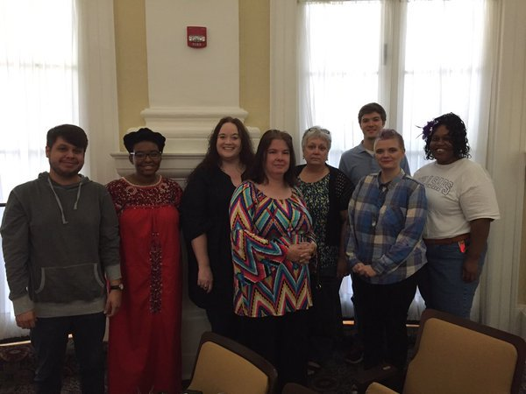
The W's MFA in CW ‏@TheW_MFACW
Flexible & Affordable: Part-time students encouraged. Most are taking 6-9 hours/semester and finish in 2-4 years. #MFAChat

Jenna Sauers ‏@jennasauers
I would advise against going into debt for an M.F.A. I actually got into Iowa in 2012 but didn't get funding. I deferred admission. #MFAchat
UCRLowResMFA ‏@UCRPDLRMFA
We really like it when applicants come and visit residency for a day -- it's good to meet you and it's good for you to meet us #MFAchat
Brittany Borghi ‏@brittany_borghi 3m3 minutes ago
I'm a 1st year Nonfiction MFAer @uiowa. Can't stress enough the close faculty relationships, vibrant lit community, and FUNDS here #MFAchat
SBShampton MFAWriter ‏@SouthampWriters
The good news: The Southampton Review is a world-class lit mag. The bad news: our students roll up their sleeves to help publish it #MFAChat
Jessica Smith ‏@looktouch
@awpwriter I went to SUNY Buffalo b/c Creeley, Howe, Bernstein were there (late 90s). No MFA program -- best decision I ever made #MFAchat
Jenna Sauers ‏@jennasauers
I reapplied for aid the next year, which I got. Waiting that extra year significantly softened the financial blow of grad school. #MFAchat
Max Rubin ‏@SoupRubin
Check out the many fine pubs on our alumni book shelf at Iowa. Is that the new memoir by @LucasWMann ?Yes! #MFAchat
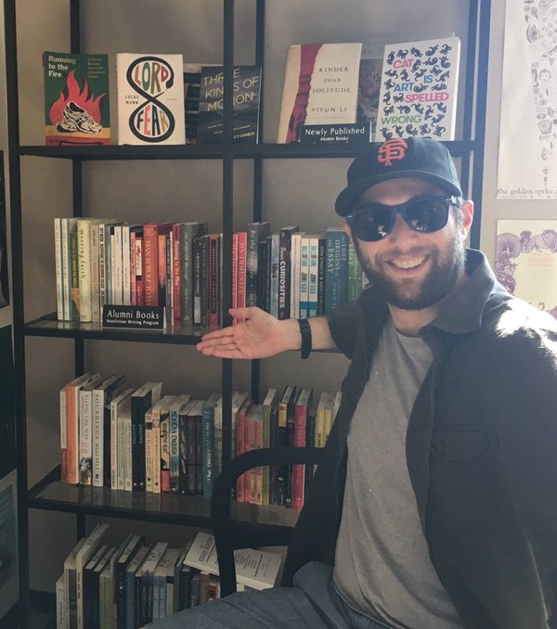
Brittany Borghi ‏@brittany_borghi
It's so great to see you in our sun-lit lounge @uiowa, @SoupRubin! Did I mention we get buddies? This guy is mine!
Joshua Bohnsack ‏@josiahbohnsack
What are the usual sources of funding? #MFAchat
Michael Nye ‏@mpnye
@josiahbohnsack A handful of full fellowships, but usually from TA or other dept work.
Silas Hansen ‏@silas_hansen
@josiahbohnsack 1. Teaching assistantship, 2. Administrative work (lit mag, office, etc.), 3. Fellowships/scholarships, 4. Loans.
Silas Hansen ‏@silas_hansen
@josiahbohnsack Avoid the loans at all costs. The first three (1) are things you can put on a resume/CV and (2) don't ruin your credit.
colette arrand ‏@gh0stplanet
@silas_hansen @josiahbohnsack This is sound. My MFA didn't pay a bunch so I had to take loans anyhow
jen! ‏@JenniferMWolff
I made this mistake on undergrad. @EmersonCollege was a great experience but cost me dearly. #MFAchat
Jenna Sauers ‏@jennasauers
@josiahbohnsack scholarships/aid offered by the program (free $$) & teaching assistantships or research assistantships (p/t work for $$)
Stephen J Furlong ‏@BeenASon24
@josiahbohnsack It really depends on the program and variances of fellowships. As @silas_hansen mentioned, lit mag work is great #MFAChat
The W's MFA in CW ‏@TheW_MFACW
@josiahbohnsack #MFAchat Graduate assistantships, scholarships, and student loans (keep low). Also employers and private scholarships.
Diane Zinna ‏@DianeZinna
A small class size isn’t always optimal. I was 1 of 5 in my year, but the only female & with all male teachers. #MFAChat
Julie Sheehan ‏@thebarbook
@DianeZinna Ouch! #MFAchat
Erika Dreifus ‏@erikadreifus
This & other worthy nuggets if you're considering an MFA program in #creativewriting, via #MFAchat happening now.
Erika Dreifus ‏@erikadreifus
@DianeZinna Not to mention damage even 1 not-so-constructive participant can do in a workshop of 4, esp if fac don't intervene. #MFAChat
Diane Zinna ‏@DianeZinna
@erikadreifus Yes, I learned a lot, but it took me a while to remember who I was after I graduated. #MFAChat

Alyse Bensel ‏@leaseandleaves
Not quite sure about KU? Lawrence is a completely different town from what you may expect. Many reading series + active journals. #MFAchat
Converse College MFA ‏@ConverseMFA
@ConverseMFA faculty are excellent writers & teach regularly. If you apply to work with a specific writer, you will have opportunity #MFAchat
Leslie Pietrzyk ‏@lesliepwriter
@ConverseMFA I love the low-res model...I've seen students make amazing leaps with focused attention. #MFAchat

SBShampton MFAWriter ‏@SouthampWriters
The good news: our campus in Manhattan. The bad news: finding a seat at your new favorite writing cafe #MFAChat
English@CardiffMet ‏@English_CMet
We also offer flexible part time tuition, in the home of Dr Who! #MFAchat
The W's MFA in CW ‏@TheW_MFACW
Flexible: Cross-genre and mixed genre writing is encouraged in classes such as Writing for New Media. #MFAChat http://www.muw.edu/as/llp/english/graduate/mfa-creative-writing-courses …
Michael Nye ‏@mpnye
Your fellow grad students are a tremendous influence ... but you can't research your future cohort like you can research faculty #MFAchat
New School Writing ‏@NewSchoolWrites
In 2014, 36 of our alumni and 11 faculty members published full-length collections. See for yourself: http://newschoolwriting.org/bookshelf/ #MFAchat
EDML ‏@exclamate_
Want to teach post-MFA? Make sure you can get teaching experience. Also understand now that this is a v. difficult goal to achieve. #MFAChat
Nat'l Endow f/t Arts Verified account ‏@NEAarts
Are you in an MFA writing program or thinking of applying for one? Check out the #MFAchat going on now hosted by @awpwriter.
Brittany Borghi ‏@brittany_borghi
.@CityOfIowaCity is a @UNESCO City of Lit & a community of writers, for writers. The NWP @uiowa opens doors locally & globally. #MFAchat
UCRLowResMFA ‏@UCRPDLRMFA
Our faculty write books, write TV shows, write movies & win awards. They're also super nice, which is good. #MFAchat http://palmdesertmfa.ucr.edu/faculty/
Meagan Arthur ‏@meaganearthur
What are the most important factors when considering which applicants get funding? #MFAchat @awpwriter
SMC MFA Program ‏@smcmfa
@meaganearthur @awpwriter the quality of the manuscript #1 #MFAChat
Julie Sheehan ‏@thebarbook
@meaganearthur @awpwriter Writing sample, writing sample, Statement of Purpose, writing sample, letters of rec. #MFAchat
Silas Hansen ‏@silas_hansen
Getting an MFA was the best thing I ever did, but it's not the right choice for everyone. What do you want out of it? #MFAchat
Silas Hansen ‏@silas_hansen
If you can't answer that question yet, it's worth waiting until you can. It's rare to go straight from undergrad. #MFAchat
Top of Form
Bottom of Form
Silas Hansen ‏@silas_hansen
An MFA is NOT going to: (1) guarantee you publications, (2) guarantee you a teaching job, (3) guarantee you a job of any kind. #MFAchat
colette arrand ‏@gh0stplanet
@silas_hansen I wish I could take back my scant MFA publication record, ha.
Silas Hansen ‏@silas_hansen
What an MFA *will* give you: (1) 2-3 years to focus on your writing and (2) classmates and profs to read your work. #MFAchat
Daniel A. Hoyt ‏@dan_hoyt
Yep, @silas_hansen is right on. I wish more applicants would slow down, take a year or two off, think about what they really want. #MFAchat
Julie Sheehan ‏@thebarbook
Totally agree. Doesn't hurt to have something to say. #MFAchat
Leslie Pietrzyk ‏@lesliepwriter
My MFA regret...that I went right out of undergrad. #MFAchat @ConverseMFA
Silas Hansen ‏@silas_hansen
For the record, I did do my MFA straight from undergrad & it worked out--but it's also fine to wait a few years. It depends on YOU. #MFAchat

JohnCabot University ‏@JohnCabotRome
We're offering 4 graduate-level CW courses this summer. Trust us, the Eternal City is good inspiration! http://ow.ly/UcDef #MFAchat
The W's MFA in CW ‏@TheW_MFACW
Professional: Our program has the annual Eudora Welty Writers' Symposium with a dozen Southern writers. #MFAChat http://www.muw.edu/welty

Lisa Romeo ‏@LisaRomeo
Many high school teachers who want to pursue MFA, school district might (help) fund, esp if choosing public institution in state, #MFAchat
Julie Sheehan ‏@thebarbook
@LisaRomeo #MFAChat Yes, and check out lo-rez kid lit program at SUNY school http://www.stonybrook.edu/southampton/mfa/childrens_lit/index.html …

EDML ‏@exclamate_
Otherwise, figure out a way to diversify your experience. I got internships that taught me copy editing, proposal writing, and more #MFAChat
Michael Nye ‏@mpnye
If there is any chance you want to teach in academia, apply to @uiowa - having the Writers Workshop on your CV opens a LOT of doors #MFAchat
English@CardiffMet ‏@English_CMet
If you want to ask a student who has studied with us about our program then @Durre_Shahwar is happy to help #MFAchat
Daniel A. Hoyt ‏@dan_hoyt
I got my PhD at KU: Lawrence is a terrific college town: great live music, good restaurants, super-popular adult kickball. #MFAchat
UCRLowResMFA ‏@UCRPDLRMFA
We like genre writing! Because, you see, we live in the 21st century, and that's what people actually read. What an idea. #MFAchat
Adam Lee Price ‏@Pawriter80
Putting the finishing touches on my application! Get ready @Columbia 'cause here I come! #MFAchat #screenwriting #horrorFilm @JamesGunn
David Leach ‏@LeachWriter
At #UVic, we have a grad course in teaching creative writing for MFA students. WRIT509: Instructional SKills Preparation. #MFAChat
The W's MFA in CW ‏@TheW_MFACW
Flexible: In our low-residency MFA, residencies are separate classes. You take 4 that fit your schedule. #MFAChat http://www.muw.edu/mfacreativewriting …
Diane Zinna ‏@DianeZinna
Creative writing faculty, what is the most important advice you would give to a prospective student who wants to apply? #MFAChat

Lisa Romeo ‏@LisaRomeo
@DianeZinna Be sure you want to LEARN. Be teachable. Be more interested in developing craft than getting affirmation, impressing. #MFAchat
Leslie Pietrzyk ‏@lesliepwriter
@DianeZinna Strong sample. Think low-res v. res. Research faculty and READ THEIR WORK (sounds obv, but not!). Research location. #MFAchat
The W's MFA in CW ‏@TheW_MFACW
@dianezinna #mfachat #bestadvice Know why you want an MFA and where you want to be when finished. Know why you want to do it with us.
David Leach ‏@LeachWriter
.@DianeZinna Identify a potential supervisor that suits your project; submit best portfolio — the first line/page must grab. #MFAChat
The W's MFA in CW ‏@TheW_MFACW
@dianezinna #mfachat #bestadvice Also, know how you'll pay for it without excessive debt. Work your way through or get aid. Have a plan.

Alyse Bensel ‏@leaseandleaves
Attend a fully funded program! Usually with that funding comes teaching experience, which is essential for the academic market. #MFAchat

The W's MFA in CW ‏@TheW_MFACW
Professional: We want to graduate professional writers who are skilled at their craft and able to work in writing related fields #MFAChat
South Carolina MFA ‏@scMFA
If you are interested in applying to MFA programs, or deciding whether or not that's right for you: #MFAchat.
Chelsea H Bryan ‏@chelseahbryan
Have heard great things from multiple sources about IAIA. Any #MFAchat takers on IAIA thoughts? #diversity #race
Michael Nye ‏@mpnye
It's behind their paywall, but @poetswritersinc published a good essay by Steve Almond about reading submissions for programs #MFAchat
EDML ‏@exclamate_
If you can visit the school before you go, oh do it! Chat up current students. See how the profs interact with them. Visit a class! #MFAChat
SBShampton MFAWriter ‏@SouthampWriters
The good news: Amazing writers visit campus for Writer’s Speak Wednesdays. The bad news: what to do the other six days of the week #MFAChat
UCRLowResMFA ‏@UCRPDLRMFA
Program director @todgoldberg talks about genre writing and why MFA programs are scared of it #MFAchat : http://palmdesertmfa.ucr.edu/blog/wanted-the-greatest-criminal-minds-of-our-time/ …
Silas Hansen ‏@silas_hansen
More advice: if you're applying straight from undergrad & want to maximize time, consider funded MA programs to prep for MFA. #MFAchat
Silas Hansen ‏@silas_hansen
It's a different degree--not terminal--but gives you time to hone your craft, experiment with different kinds of writing, read, &c. #MFAchat
Silas Hansen ‏@silas_hansen
Funded MAs also usually require/include more lit classes, rhet comp, etc. than MFAs--helps you succeed in those classes during MFA. #MFAchat
Daniel A. Hoyt ‏@dan_hoyt
For example, two of our recent MA grads, went on to strong MFAs, and entered PhD programs just this year. #MFAchat

Diane Zinna ‏@DianeZinna
If you can, talk to students who attend a program! Check out our Campus Visit Video Series http://bit.ly/1RKTK89 #MFAChat
Diane Zinna ‏@DianeZinna
In these videos, students discuss life at their creative writing programs. http://bit.ly/1RKTK89 #MFAChat
Diane Zinna ‏@DianeZinna
There are videos featuring residential and low-residency programs, as well as an immersive semester program #MFAChat
Jason Gray ‏@jasonmgray
.@awpwriter Don’t be afraid to ask current students questions about life in the program. #MFAchat

Converse College MFA ‏@ConverseMFA
Be sure to talk to current students and graduates of a program. Also, ask to speak to various faculty. #MFAchat
Rhonda BrowningWhite ‏@RBrowningWhite
I vetted programs for two years before applying @ConverseMFA, and I couldn't have made a better choice! #MFAchat
Gabrielle Freeman ‏@TheLadyRandom
Completing the #mfa through @ConverseMFA was the best thing I've ever done for myself. Ask away! #mfachat
Leslie Pietrzyk ‏@lesliepwriter
#mfachat Yes, always ask to speak to students in the program & recent grads before deciding.
Lisa Romeo ‏@LisaRomeo
@lesliepwriter @TheLadyRandom @ConverseMFA Yes, yes, yes. Talk to current students & alumni & faculty, by PHONE if possible. #MFAchat
David Schuman ‏@d_schuman
And see if you can hang out and even stay with them when you visit--get to know the place #MFAchat
Julie Sheehan ‏@thebarbook
@d_schuman @awpwriter @SouthampWriters does a visiting day for admitted students. Very helpful for them to make a good choice. #MFAchat

South Carolina MFA ‏@scMFA
Application tips from us: Writing sample is most important. Statement of purpose is also a writing sample. #MFAchat (1/3)
South Carolina MFA ‏@scMFA
Ref letters with knowledge, specifics>letters from famous writers you met once. Most letters glow; we do look for red flags. #MFAchat (2/3)
South Carolina MFA ‏@scMFA
Don't care tons about grades, but our dept. cares some. Don't care about GRE scores (can waive low ones), but must have them. #MFAchat (3/3)

Joshua Bohnsack ‏@josiahbohnsack
How effective is interfolio? As in ease for me and my references. #MFAchat
Michael Nye ‏@mpnye
@josiahbohnsack It's an awesome service: kudos to any program that uses it.
Diane Zinna ‏@DianeZinna
@josiahbohnsack Super easy! We actually transitioned away from dossier svcs because they were leaders in the market--for a reason. #AWPChat
Diane Zinna ‏@DianeZinna
WHEN did you decide that you wanted to attend an MFA program? #MFAChat
SMC MFA Program ‏@smcmfa
@DianeZinna i (@CandaceErosDiaz) made other ppls dreams come true instead of mine for 10 yrs after UG. i couldn't w8 any longer #MFAChat
Michael Nye ‏@mpnye
@DianeZinna As an undergrad. But I also decided I wanted to be out of school for three years before I attended. #MFAchat
Emily Lundgren ‏@emslun
I'm a 1st yr @NEOMFA'er - cannot stress how welcoming the wrkshp environment is! My research for a constructive wrkshp checked out. #MFAchat
The W's MFA in CW ‏@TheW_MFACW
Flexible: Our program combines workshops with forms and literature classes. You do not have to specify a genre when you apply. #MFAChat
EDML ‏@exclamate_
Also keep in mind your resources. My stipend went a lot less far in NOVA than my friends' similar stipends did in AZ. #MFAChat
Daniel A. Hoyt ‏@dan_hoyt
I think my best advice is just listen to @silas_hansen! #mfachat
Shannon H. Polson ‏@ABorderLife
If I were applying now I'd talk to more students who came from the program to get specifics abt their experiences. #MFAChat
Shannon H. Polson ‏@ABorderLife
As well as what the residency focus covers/where it focuses, i.e. Craft v lit review etc #MFAChat
Blake Kimzey ‏@BlakeKimzey
Get an MFA to become a better writer (all that time!) not so you can be an adjunct after you graduate. Focus on your writing. #MFAchat
The W's MFA in CW ‏@TheW_MFACW
“@BlakeKimzey: Get an MFA to become a better writer " Yes, but also to become a more professional writer and develop job skills. #MFAchat

Michael Nye ‏@mpnye
Have an outlet that has nothing to do with writing. You'll become emotionally and mentally exhausted during the program. #MFAchat
EDML ‏@exclamate_
Consider location! At GMU, my peers were spread out. I have friends on smaller campuses that are physically closer to their peers. #MFAChat
Shannon H. Polson ‏@ABorderLife
Specifically the amount and quality of interaction between residencies (for low red) and amy and quality of feedback on writing #MFAChat

Michael Nye ‏@mpnye
I'm biased, but I working on a #litmag was one of the most beneficial things about my MFA program. #MFAchat
Carla Spataro ‏@cjspataro
@mpnye #MFAchat this is so helpful for students. Let's them see how submissions really work and why work doesn't get published.
Jeannette Ronson ‏@jeannetteronson
Working on @PYJournal - my MFA's literary magazine - has opened up new doors for me. Work in yours! #MFAchat

David Schuman ‏@d_schuman
Don't think your sample needs to be perfect/publishable, just representative of your voice. Faculty want writers they can teach #MFAchat
Alyse Bensel ‏@leaseandleaves
It's important to figure out YOUR priorities before applying to MFA programs. Then see which programs best match your interests. #MFAchat

UCRLowResMFA ‏@UCRPDLRMFA
Writing genre fiction and getting rejected? It's probably because of this #MFAchat:
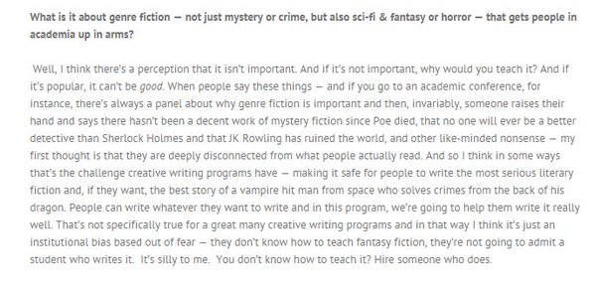
UsyBoroda ‏@usyboroda
What are your thoughts on a two-year vs. three-year MFA? #MFAChat
David Schuman ‏@d_schuman
@usyboroda I thought, back then, I'd want a quick return to "real life" so I chose two. But I'm still here! Depends on funding, family, etc.
EDML ‏@exclamate_
@usyboroda KENNY, I'm SO GLAD YOU ASKED.
EDML ‏@exclamate_
I had some friends at 2-year programs who wished they had more time. But 2 years might be enough for you! #MFAChat
EDML ‏@exclamate_
GMU is a 3-year program, and I definitely appreciated the time. I spent my whole third year writing a MS. #MFAChat
Julie Sheehan ‏@thebarbook
Time is on your side. Take it! #MFAchat
Jason Gray ‏@jasonmgray
Jason Gray Retweeted UsyBoroda
When I was at Ohio St, at the start, three years seemed long, at the end, not long enough. Take the time. #MFAchat
Katie Schmid ‏@kt_schmid
Really know your goals: the studio degree is VERY different than an MFA that functions as a lit degree with a creative thesis #MFAchat

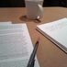Writer's Cramp ‏@WritersCramp1
While you figure out your MFA plans, take a look at @LitReactor and its classes. Affordable, targeted writing help. #MFAchat
Tammie Rice ‏@tlrice2
@TheW_MFACW And an established literary event - The Welty Symposium #MFAChat #TheW #lowresmfa
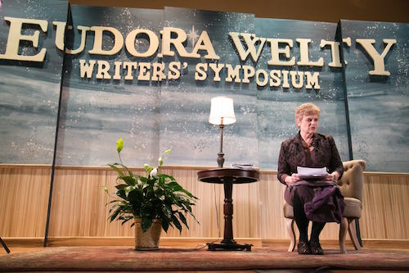
EDML ‏@exclamate_
I used the old @awpwriter Guide to Writing Programs to look for places. I hear it's improved since 2010/2011. ;) #MFAChat

EDML ‏@exclamate_
I looked at every program in the states I was willing to live in, looked at funding & other resources, and went from there. #MFAChat
Katie Schmid ‏@kt_schmid
inquire about support/job opportunities during the summer. it's NOT WORTH taking out loans to support yourself. #MFAchat
David Schuman ‏@d_schuman
@kt_schmid MFA at @WUSTL has provided summer funding between first and second years. Other programs may as well and you can ask #MFAchat
Nick Mamatas ‏@NMamatas
NB: lots of MFA programs aren't very competitive. If all your classmates are Great! Writers! maybe you're not a good reader. #MFAchat
Meagan Arthur ‏@meaganearthur
If you are participating in #MFAchat and are representing a fully funded program, give a shout! @awpwriter
VT Creative Writing ‏@VirginiaTechCW
@meaganearthur @awpwriter VT is fully funded! 16k per year for all students!
SBShampton MFAWriter ‏@SouthampWriters
The good news: we’re a family. The bad news: you can never leave. Even after you graduate. #MFAChat
Long Day Press ‏@longdaypress
A lot of great advice is coming from @awpwriter's #MFAchat discussion.
Carla Spataro ‏@cjspataro
@Rosemont_MFA #MFAchat Our program is designed for adults who want to go part time but are also very serious about their work.
South Carolina MFA ‏@scMFA
Also: *sometimes* high grades and/or high GRE scores allow us to locate additional funding for you, on top of our regular package. #MFAchat
Diane Zinna ‏@DianeZinna
We asked @JaneFriedman what BFA programs could be doing to prepare students for MFA life and after. #MFAChat http://tinyurl.com/lk2nql9
Diane Zinna ‏@DianeZinna
1/2 @janeFriedman: [They should help] students better understand the economics of the writing life... #MFAChat
Diane Zinna ‏@DianeZinna
2/2 @JaneFriedman: ...and how authors or artists do manage to put together a full-time living from doing what they love. #MFAChat
Chelsea H Bryan ‏@chelseahbryan
#MFAchat thought: don't go into an MA or MFA until you have a project that interests you so much you are not afraid to write the whole thing
Lydia Pudzianowski ‏@DoritosHangover
@chelseahbryan This is excellent advice. #MFAchat
Chelsea H Bryan ‏@chelseahbryan
@DoritosHangover thank you! Given as question since, maybe, sometimes one can see no other way forward in life but MFA!
Lydia Pudzianowski ‏@DoritosHangover
@chelseahbryan A good point. Going into an MFA with a book idea vs. without is a "Good for you, not for me" thing (thank you, Amy Poehler).
Lydia Pudzianowski ‏@DoritosHangover
@chelseahbryan Essentially, do what you need to do. #MFAchat
Tammie Rice ‏@tlrice2
@chelseahbryan Perfect advice! #MFAChat @TheW_MFACW #TheW #lowresmfa

UCRLowResMFA ‏@UCRPDLRMFA
We give our students a competitive advantage in the real world -- everyone who graduates is read by top agents/publishers/studios #MFAchat
UCRLowResMFA ‏@UCRPDLRMFA
Not some of the students. Not a couple select people. No, all of our students get read by the agents/publishers/studios. #MFAchat
Chelsea H Bryan ‏@chelseahbryan
LT #MFAchat program as exploration V program as acceleration. Or is that an MFA v NYC question? *wink*
David Schuman ‏@d_schuman
@chelseahbryan An ideal program might allow both sorts of students to flourish #MFAchat

Chelsea H Bryan ‏@chelseahbryan
@d_schuman 2nd that: one may switch from one mode to the other mid-program. Stylistic, artistic emotional risks:
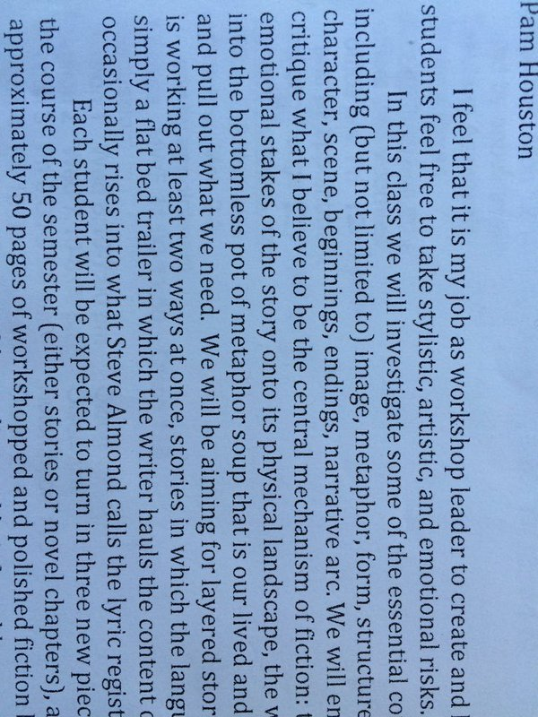
The W's MFA in CW ‏@TheW_MFACW
#mfachat @awpwriter I tell undergrads, before an MFA program, try summer/weekend workshops and develop as a writer. MFA when you're ready.
David Leach ‏@LeachWriter
Do other MFA programs have a teaching training component & emphasis? I'd like to swap course notes & thoughts. Pros/cons. #MFAChat #UVic
SMC MFA Program ‏@smcmfa
@LeachWriter we do. you can find out a bit more here: http://www.stmarys-ca.edu/mfa-in-creative-writing/prospective-students/funding/teaching-fellowships … #MFAChat
David Leach ‏@LeachWriter
@smcmfa Thanks!
Leanna J Blackwell ‏@baypathmfaCNF
@LeachWriter We do. Emphasis on teaching outside of academia.Students do internships in prisons,shelters,senior centers, hospitals #mfachat
David Leach ‏@LeachWriter
@baypathmfaCNF That sounds like great community engagement. #mfachat
Carla Spataro ‏@cjspataro
@baypathmfaCNF @LeachWriter @Rosemont_MFA we offer Workshopping the Workshop pedgog class on running wksps in and out of academe. #MFAchat
Steph Vanderslice ‏@wordamour
@LeachWriter ours @ARWritersMFA does.
David Leach ‏@LeachWriter
@wordamour @ARWritersMFA Thanks! WIll follow up....
Carla Spataro ‏@cjspataro
@LeachWriter @Rosemont_MFA offers a Rhet/Comp pedog class and we do a 1 day conf on how to get adjunct work, write a CV, etc. #MFAchat
Carla Spataro ‏@cjspataro
@LeachWriter @Rosemont_MFA we also bring in 1st year writing dir who do hiring so students know what to expect. Our alums work all over!
David Leach ‏@LeachWriter
@cjspataro @Rosemont_MFA Thanks! I like the conference idea....
Julie Sheehan ‏@thebarbook
Yep, Stony Brook Southampton has grueling teaching practicum. I know b/c I teach it. #MFAchat
kimWICKedwitch ‏@kimannjosouth
Anyone interested in applying to a CW PhD program post MFA[/MA] this year, let me know! I love mine. #MFAchat
Joshua Bohnsack ‏@josiahbohnsack
I was considering an MPhil degree from European programs. Is this degree much less prestigious than an MFA? #MFAchat
John O'Donoghue ‏@JOD45
@josiahbohnsack Although publication is still seen as being a good equivalent to MFA, MA, MPhil, PhD.... /3
Joshua Bohnsack ‏@josiahbohnsack
@JOD45 I really like the programs and faculty at Trinity and Cork, but I didn't know how they translated on the American Market.
John O'Donoghue ‏@JOD45
@josiahbohnsack Me neither - but I should think there'd be Irish-friendly Am universities - round Boston, Chicago, New York? - which would -
John O'Donoghue ‏@JOD45
@josiahbohnsack MPhils are - you probably know - one down from DPhils or PhDs. TCD (Dublin) run a program, as do other unis. A good degree/1
John O'Donoghue ‏@JOD45
@josiahbohnsack ... rate TCD in particular? Check out also Limerick - Joe O'Connor is running the MA there and he is tip top.
John O'Donoghue ‏@JOD45
@josiahbohnsack I think Europeans might look down slightly on the MFA. The MA and PhD are often the terminal degrees that matter... /2
Steph Vanderslice ‏@wordamour
@josiahbohnsack Just different. Message me what programs you're considering, some are quite helpful esp if you're interested in publishing.
EDML ‏@exclamate_
If you have a partner coming with you, the location can also dictate their ability to get a job. #MFAChat
EDML ‏@exclamate_
I was lucky that my husband (@usyboroda) ended up getting a job at @awpwriter! #fulldisclosure #MFAChat
Diane Zinna ‏@DianeZinna
1/2: @LauraKasischke: “I couldn’t have become a writer if I hadn’t studied with X, met X...been encouraged by __.” #MFAChat
Diane Zinna ‏@DianeZinna
2/2: @LauraKasischke: “The blanks, I’m sure, could be filled with anything as long as they do not remain blank.” #MFAChat
Daniel A. Hoyt ‏@dan_hoyt
At K-State, almost all of our MA students get funding, teaching experience, and teaching training, along with health insurance. #MFAchat
Nick Mamatas ‏@NMamatas
Rather than denouncing genre fiction (SF, crime etc.) instructors should just acknowledge they're not competent to teach it. #MFAchat
Carla Spataro ‏@cjspataro
@NMamatas #MFAchat Profs need to be open to all genres. Not my business to tell you what to be passionate about, just help you write better.
The W's MFA in CW ‏@TheW_MFACW
@nmamatas re: genre fiction #mfachat We've had some good discussions in our new program about genre writing. We're open if also literary.
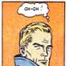Lincoln Michel ‏@TheLincoln
@NMamatas I think I really lucked out here. My program was one of few with lots of experimental and genre/"genre bending" teachers #MFAchat
SpookySamhainSpectre ‏@jlikesbooks
@TheLincoln which one did you attend, by the by?
Nick Mamatas ‏@NMamatas
@jlikesbooks @TheLincoln Yes, which did you attend? I bet that's the info people following #MFAchat would like to know.
Lincoln Michel ‏@TheLincoln
.@NMamatas @jlikesbooks Columbia. At time, we had Kelly Link, Ben Marcus, Victor LaValle, etc. Still leaned "lit fic", but was very open
Lincoln Michel ‏@TheLincoln
@NMamatas @jlikesbooks And glancing at the current faculty, it's still that way.

Diane Zinna ‏@DianeZinna
@NMamatas AWP's Mentorship Program, Writer to Writer: http://tinyurl.com/pjtpcrt #MFAChat

davidbishop ‏@davidbishop
On the Creative Writing MA @EdinburghNapier in Scotland we specialise in genre fiction, @NMamatas - SF, fantasy, mystery, horror #MFAchat
Daniel A. Hoyt ‏@dan_hoyt
Or get with the program and the reading public, @NMamatas. I read a lot more literary genre work because of students' interest. #MFAchat
Nick Mamatas ‏@NMamatas
@dan_hoyt Yeah, get competent. But it can take a while—a few cohorts can march through a program by the time teachers are up to speed.
Elissa Field ‏@elissafield
@dan_hoyt @awpwriter @NMamatas successful 21st c fiction is often crossover btwn lit & genre. Any programs better for this? #MFAchat Nick Mamatas ‏@NMamatas
@elissafield @dan_hoyt @awpwriter Always check the faculty. Them that does, may teach.

Leslie Pietrzyk ‏@lesliepwriter
@elissafield @dan_hoyt @awpwriter @NMamatas Well, @ConverseMFA has a new YA track.And this is why I recommend reading faculty books.
TP ‏@thranduilion
Liking this #MFAchat trajectories so far. Keep them coming, people!
SBShampton MFAWriter ‏@SouthampWriters
The good news: visiting professors of poetry like Mark Doty, Martin Espada, Matthea Harvey. The bad news: letting go. #MFAChat
UCRLowResMFA ‏@UCRPDLRMFA
An important thing when considering a low residency: is there a day where there's all you can eat ice cream? We have that. #MFAchat
The W's MFA in CW ‏@TheW_MFACW
#MFAchat We're getting requests from international students. Would love to hear from other low-res programs about visa regulations.
Converse College MFA ‏@ConverseMFA
Work w/faculty,agents,book& journal editors,visiting writers. Plus internships, TA spots.Our low res focuses on professional writer #MFAchat
David Leach ‏@LeachWriter
How much does institutional location shape MFA experience? #UVic is in Fine Arts Faculty vs. English Dept/Humanities Faculty. #MFAChat
Julie Sheehan ‏@thebarbook
@LeachWriter A little esoteric for applicants, but this matters. #MFAChat

Alyse Bensel ‏@leaseandleaves
Creative writing PhDs are very different beasts from MFAs. It's best to get an MFA first. You'll be far more prepared. #MFAchat
Katie Schmid ‏@kt_schmid
the MFA makes u look like a strange bird outside of academia. think abt how u can spin yr skills to future non-academic employers #MFAchat
UCRLowResMFA ‏@UCRPDLRMFA
@kt_schmid This is super important. We try to teach a bit of life skills, too -- so that people know how to get a real job, too. #MFAChat

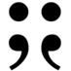gigantic sequins ‏@GIGANTICsequins
We are following along with the #MFAchat right now! How many GS eds have an MFA? 3! 2 w/ MAs.
SBShampton MFAWriter ‏@SouthampWriters
The good news: fiction faculty Ursula Hegi, Susan Scarf Merrell, Melissa Bank. The bad news: a surfeit of attention. #MFAChat
New School Writing ‏@NewSchoolWrites
Our courses meet on weeknights from 8:00-10:00pm, with optional weekend courses. We train working writers. #MFAchat
jen! ‏@JenniferMWolff
#MFAchat is making my heart ache with its loveliness & my own sense of longing to do an MFA in writing. You're all wonderful.
Leslie Pietrzyk ‏@lesliepwriter
@JenniferMWolff I can tell that you will excel wherever you land with such an open attitude!

jen! ‏@JenniferMWolff
@lesliepwriter Thank you! Not sure an MFA is in the cards due to finances/location, but it's still my dream. #MFAchat
The W's MFA in CW ‏@TheW_MFACW
@jennifermwolff #mfachat Try part time low-res. Location less relevant, though it helps if travel costs are low. (We're in MS). Low tuition.
jen! ‏@JenniferMWolff
@TheW_MFACW Thank you! I've definitely looked into such options, but undergrad debt & chronic illness have limited my options. #MFAchat
The W's MFA in CW ‏@TheW_MFACW
@jennifermwolff I understand. Best of luck to you! Also consider non-degree options like workshops and conferences. Many have scholarships.
jen! ‏@JenniferMWolff
@TheW_MFACW Definitely! I've only recently reignited my original passion for the craft, so am exploring furtively at this point. Thank you!

jen! ‏@JenniferMWolff
@TheW_MFACW Had resigned myself to a life of professional & tech writing (& very successful/pleasant career), but I want to do more.
The W's MFA in CW ‏@TheW_MFACW
@jennifermwolff Nothing wrong with professional and tech writing, but it's great to combine with your passion for literature.
jen! ‏@JenniferMWolff
@TheW_MFACW Absolutely. I love my career & that it opened so many doors for me, & can now freelance. Now I want to stoke the creative fire!
The W's MFA in CW ‏@TheW_MFACW
@jennifermwolff Our program can be done part-time with as few as 3 hours per semester (takes 6 years). Look for one that fits your needs.
The W's MFA in CW ‏@TheW_MFACW
@jennifermwolff Or look for a writing community outside of academia if you don't need the degree. There are other ways to be a writer.

jen! ‏@JenniferMWolff
@TheW_MFACW I'll definitely explore your program more. At this point, 6yrs is nothing to finish, ha. & Agree completely w/other communities!
The W's MFA in CW ‏@TheW_MFACW
@jennifermwolff Yes, and if you find something nearer to home, you should go for it. I've discussed our program because it's what I know.
jen! ‏@JenniferMWolff
@TheW_MFACW Your input has been very helpful, and much appreciated. Not everyone takes the time to give such thoughtful advice.
The W's MFA in CW ‏@TheW_MFACW
@jennifermwolff Thanks. I try… Did you see our Guide for Applicants? http://www.muw.edu/images/colleges/as/llp/MFAGuideForApplicants.pdf … I put it together using some blog posts.
jen! ‏@JenniferMWolff
@TheW_MFACW Brilliant! Thank you! You & #MFAchat have done so much for me today. A bounty of wonderful resources.

Emily Lundgren ‏@emslun
Also @NEOMFA (especially the YSU gateway with @Cbarzak) has shown to be a welcoming space for sci-fi/fantasy/genre writers! #MFAchat
Annie Frazier ‏@BijouAnnie
Low Res is a great option for those who can't relocate. Loving @spalding_mfa to bits so far! #MFAchat
The W's MFA in CW ‏@TheW_MFACW
“@BijouAnnie: Low Res is a great option for those who can't relocate." #MFAchat I advise if you can relocate, do; if not, the low-res.
Leanna J Blackwell ‏@baypathmfaCNF
@TheW_MFACW @BijouAnnie Low- and no-res an excellent option if you can't relocate.We are online with a summer intensive in Ireland. #mfachat
Tammie Rice ‏@tlrice2
@baypathmfaCNF @TheW_MFACW @BijouAnnie Can I do this and Rome?! #MFAChat #TheW
The W's MFA in CW ‏@TheW_MFACW
@tlrice2 @baypathmfacnf @bijouannie Are you asking me? We accept 6 hours of transfer credit. Let's look into it, if you want to.
Tammie Rice ‏@tlrice2
@TheW_MFACW @baypathmfaCNF @BijouAnnie You know me - it's the experience not the credit that I care about! Now, where to find the money...

Brittany Borghi ‏@brittany_borghi
Fun fact: for .5 time teaching appointment @uiowa we get paid ~$18K for 10 months, == ~$1800 a month. How does yr funding compare? #MFAchat
TP ‏@thranduilion
@brittany_borghi @uiowa roughly similar to how it is here at UMD.
Brittany Borghi ‏@brittany_borghi
@thranduilion Interesting! I did my BA @merrillcollege, and loved UMD. Cost of living is roughly 14% higher in College Park, tho #MFAchat
Brittany Borghi ‏@brittany_borghi
@thranduilion (For reference: http://www.bestplaces.net/cost-of-living/iowa-city-ia/college-park-md/18000 …) #MFAchat

TP ‏@thranduilion
@brittany_borghi why, yes. The rent in CP is nuts, and it's even crazier when you commute from DC like I do. Probs the only downfall. ):
Brittany Borghi ‏@brittany_borghi
@thranduilion Blergh. DC is fun, though. How do you like CP? How's the program? #MFAchat
TP ‏@thranduilion
@brittany_borghi and there's always reading here, there, & everywhere, even one tailored for students
TP ‏@thranduilion
@brittany_borghi yep, the city is fun. It's just the rent that is not. The MFA life's great here, supportive profs & quirky classmates & all
Merrill College @UMD ‏@merrillcollege
@brittany_borghi @thranduilion Great to count you as a @merrillcollege grad, Brittany!

UCRLowResMFA ‏@UCRPDLRMFA
Other important questions about low res MFAs: Do you have to share a bathroom? Are the beds gross? What's the situation with tics? #MFAchat
IAIALowRez ‏@LowRezMFA
@UCRPDLRMFA And ticks.
UCRLowResMFA ‏@UCRPDLRMFA
@LowRezMFA See? We don't even know how to spell ticks, that's how few we get.
IAIALowRez ‏@LowRezMFA
@UCRPDLRMFA If you spell it, they will come.
UCRLowResMFA ‏@UCRPDLRMFA
To answer: No! You're staying at a resort! No! You're staying at a resort! No! You need to worry about sunburn. #MFAchat
Jenna Sauers ‏@jennasauers
The whole "go to an M.F.A. program only when you have a book you want to write" thing has never made much sense to me either. #MFAchat
Jenna Sauers ‏@jennasauers
1. The book I would've started when I began my M.F.A. is very different (read: worse) than the one I'm writing now. #MFAchat
Jenna Sauers ‏@jennasauers
2. If you already have a book idea, why not...just...write...it? #MFAchat
Leslie Pietrzyk ‏@lesliepwriter
@jennasauers A good teacher/program will shortcut you through the learning process, will teach what you don't know you don't know. #MFAchat
Matt Matros ‏@Matt_Matros
@jennasauers @awpwriter MFAs are much more about craft than about generating ideas. But of course anyone who wants to write a book should!
Jenna Sauers ‏@jennasauers
3. Imagining you need to have a ride-or-die, capital-I Idea in order to deserve a shot at an M.F.A. may mean you never even apply. #MFAchat
Jenna Sauers ‏@jennasauers
4. You'll learn in ways you can't foresee. My work got better when I started trusting that process. And letting myself fuck up, too #MFAchat
Chelsea H Bryan ‏@chelseahbryan
@jennasauers I don't think most people do, yet I frequ. encountered this advice. Maybe "go only if" advice should not be so black&white.
Jenna Sauers ‏@jennasauers
@chelseahbryan this — "go only ifs" are nonsense. Except where funding is concerned. That's the one "go only if" I whole-heartedly believe.
Lisa Romeo ‏@LisaRomeo
@jennasauers Esp if (as happens), once in program, your book idea evaporates; you find other form, genre, project more compelling. #MFAchat
Michael Nye ‏@mpnye
@jennasauers I've actually heard this argument more and more lately. It's an interesting response to what the programs are for.
IAIALowRez ‏@LowRezMFA
@jennasauers Like saying learn to play the guitar only when you have a song to write. #MFAchat

Johannes Hoffmann ‏@Jo_Hoff
@jennasauers that's right only study architecture if you know what building you want to design, makes no sense
Carmen Maria Machado ‏@carmenmmachado
THIS. I didn't figure out what kind of writer I wanted to be (/was) until halfway through my MFA. #MFAchat
Dahlia Seroussi ‏@DahliaSeroussi
@carmenmmachado TOTALLY. Went into my MFA with one vision, came out with another. Grateful for change, growth, and possibility. #MFAchat

Lincoln Michel ‏@TheLincoln
What happened to that MFA ranking based on graduate placement in BASS/Pushcart/etc.? #MFAchat
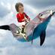Brandi Wells ‏@brandimwells
shout out to Alabama (tuscaloosa) where i got my mfa and was funded four years. #MFAchat
TP ‏@thranduilion
Most likely will do a third year here. I applied to work with a writer I look up to, not just to graduate with another degree. #MFAchat
The W's MFA in CW ‏@TheW_MFACW
#mfachat One of our New Media projects was a GeoPoem started on Google Maps and written on Twitter. http://kendalldunkelberg.com/2015/10/16/a-geopoem-project-in-columbus-ms/ …
David Schuman ‏@d_schuman
Often students stay on in STL a few years after the MFA. Think about if the place you're going might be a place you might stay #MFAchat
UsyBoroda ‏@usyboroda
AWP’s annual conference is a great place to learn more about creative writing programs! #MFAChat
UsyBoroda ‏@usyboroda
There are several panels at our #AWP16 that discuss MFA programs #MFAChat
Julie Sheehan ‏@thebarbook
@usyboroda Patricia McCormick, @SouthampWriters faculty doing panel on innovations in kid lit at #AWP. #MFAchat

Julie Sheehan ‏@thebarbook
@usyboroda @SouthampWriters Also check out current student @AHBonenberger on war memoir at #AWP #MFAchat
UsyBoroda ‏@usyboroda
“The Meaning of Every(MFA)thing: Program Directors Tell All” http://bit.ly/1Sk6JyA #MFAChat #AWP16
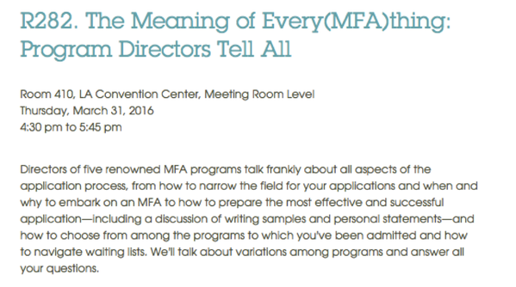

UsyBoroda ‏@usyboroda
“Full-Residency, Low-Residency, Online: The MFA Student and Faculty Experience” http://bit.ly/1Q6WYEM #MFAChat
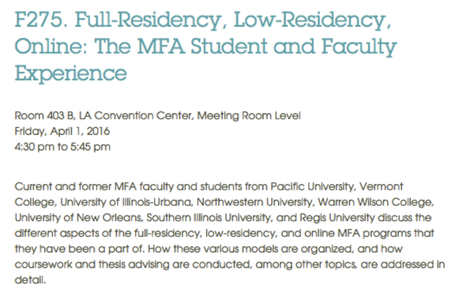
UsyBoroda ‏@usyboroda
Our annual conference is also an opportunity to meet faculty, students, and alumni from schools you are interested in. #MFAChat

Amy Stuart ‏@AmyfStuart
The @ubccrwr optional residency MFA produces a huge # of published writers. Distinguished faculty, rigorous courses @UBC @awpwriter #MFAchat
Annie Frazier ‏@BijouAnnie
VISIT before applying. Ask students as many detailed questions as possible. Talk to faculty (but, you know, be cool about it). #MFAchat
SMC MFA Program ‏@smcmfa
we recently partnered w @kearnystreet & @writehedgebrook to offer new community sponsored scholarships #MFAChat @awpwriter
SMC MFA Program ‏@smcmfa
@kearnystreet @writehedgebrook @awpwriter more details here: http://www.stmarys-ca.edu/mfa-in-creative-writing/prospective-students/funding/scholarships-0 … #MFAChat

Silas Hansen ‏@silas_hansen
I have lots of thoughts re: #MFAchat. When deciding btwn offers, look for relatively equal funding among students--positive community.
Silas Hansen ‏@silas_hansen
You want readers/classmates who will be supportive of your accomplishments--not ones who see you as competition for better funding. #MFAchat

Holly Vanderhaar ‏@HollyVanderhaar
@silas_hansen CO-SIGNED. It makes a huge difference in morale when you're not fighting over basic funding. #MFAchat

Brittany Borghi ‏@brittany_borghi 3m3 minutes ago
Brittany Borghi Retweeted Iowa Admissions
PLUS, LOOK AT IT. #beauty #midwestisbest #IowaBrag #midwest #MFAchat #nonficnov @awpwriter @uiowa @UIowaCLAS
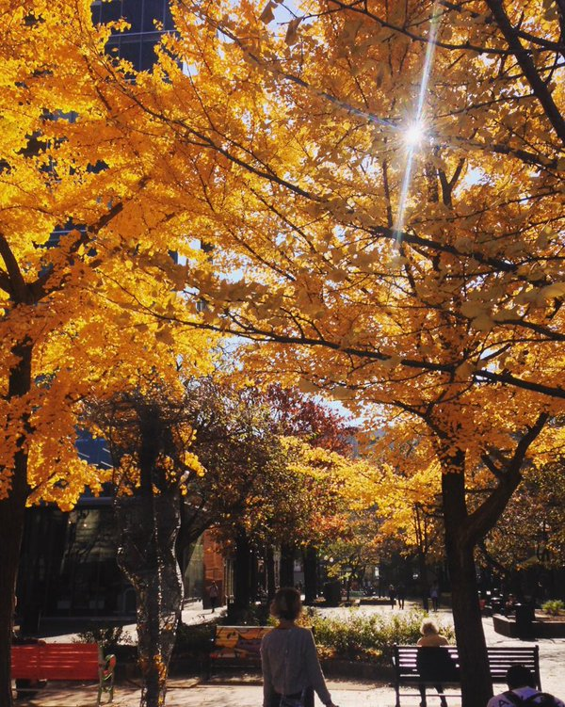
Iowa Admissions @IowaAdmissions
Hope everyone is enjoying this perfect fall day in downtown Iowa City!

David Leach ‏@LeachWriter
Are there #MFA programs that teach / integrate digital impact on creative writing, interactive writing, hyperlit, etc.? #MFAChat
The W's MFA in CW ‏@TheW_MFACW
@leachwriter Yes. Ours has a class. Rochester Institute of Technology is proposing one focused on digital lit. I've heard of others.
Tammie Rice ‏@tlrice2
@LeachWriter I am doing that this semester in Writing for New Media! @TheW_MFACW #TheW #lowresmfa #MFAChat

Alyse Bensel ‏@leaseandleaves
Having a supportive community is essential for graduate creative writing programs. See what the community is like before you apply. #MFAchat
Matthew MacFarland ‏@me_macfarland
Do not take on debt to get an MFA. Do not take on debt to get an MFA. Do not take on debt to get an MFA. Sideways-8. #MFAchat

Matt Matros ‏@Matt_Matros
I did, but then I started playing more poker... #MFAchat

Writer's Cramp ‏@WritersCramp1
And @LitReactor has writer/instructors/professionals you can't find at any school, plus peer reviews that trump the avg. MFA class #MFAchat
Peter Kispert ‏@PeterKispert
I know a LOT of writers who openly regret going for their MFA. A lot. #mfachat
Elissa Field ‏@elissafield
@PeterKispert Peter, why? Time lost? Cost? Corrupted focus? Not the outcome they wanted? I'm curious. #MFAchat
EDML ‏@exclamate_
@elissafield @PeterKispert A few of my friends went straight from a BA in CW to an MFA. They're a little burnt out. It's amazing but tiring
Elissa Field ‏@elissafield
@exclamate_ There's something to be said for getting out and living/writing on your own between bach & masters. Find ur next need. #MFAchat
Steph Vanderslice ‏@wordamour
@elissafield @exclamate_ Agree, even though I didn't and it worked out for me. That was 25 years ago though. If I had it to do over though-
Elissa Field ‏@elissafield
@wordamour @exclamate_ All diff right? I wasn't ready ideawise to write strt fr BA. Found voice, pract'd novel, more ready for MFA. #MFAchat

SBShampton MFAWriter ‏@SouthampWriters
The good news: fine-tune your work during our summer conference in the Hamptons. The bad news: you can’t stay all summer #MFAChat
Michael Nye ‏@mpnye
Consider cost of living. $$$ is a huge stress already w/o worrying about being a grad student. #MFAchat
EDML ‏@exclamate_
Talk to students about what it's like at their program. Do they actually have time to write? Do they feel supported? #MFAChat
EDML ‏@exclamate_
I've heard more than one story about writers who end up feeling like they're just by themselves writing. Not the MFA-goal, I’d say. #MFAChat
Julie Sheehan ‏@thebarbook
@exclamate_ This makes me very sad. Nooooooo! #MFAchat
David Schuman ‏@d_schuman
@exclamate_ and also, what is life like on campus, in town. Is there a scene beyond the university. Reading series off campus? #MFAchat
SMC MFA Program ‏@smcmfa
@d_schuman @exclamate_ @awpwriter speaking of reading series-ours is on fire this yr to celebrate our 20th: http://www.stmarys-ca.edu/mfa-in-creative-writing/creative-writing-reading-series … #MFAChat

Peter Kispert ‏@PeterKispert
Guess where else you can find talented peers to help you w your writing? Online. #mfachat

UCRLowResMFA ‏@UCRPDLRMFA
The big thing: get an MFA because you NEED it, not because you want it. You have to need the instruction, need the transformation. #MFAchat
JohnCabot University ‏@JohnCabotRome
If your MFA program accepts transfer credit, try studying abroad in Rome, grad-style. http://ow.ly/UcHGI #MFAChat
Tammie Rice ‏@tlrice2
@JohnCabotRome I can be back there in about 16 hours! #MFAChat @TheW_MFACW #TheW

Alyse Bensel ‏@leaseandleaves
Does the program you're applying to let MFA/MA students teach more than comp? Because they should. #MFAchat
UCRLowResMFA ‏@UCRPDLRMFA
Call and talk to the program director. See if you like them. It's important. That's the person whose philosophy guides the program. #MFAchat
UCRLowResMFA ‏@UCRPDLRMFA
Pro-tip: don't call the program director at home, however, if you find their # online. Just, you know, from experience. #MFAchat
Leanna J Blackwell ‏@baypathmfaCNF
@UCRPDLRMFA Excellent advice.DO call the program director & ask about his/her teaching philosophy. Most are very happy to share it. #mfachat

Christopher R Alonso ‏@ChrisRAlonso
My biggest concern when applying was finding instructors that were receptive to the kind of writing I like. Research your profs. #MFAchat
Daniel A. Hoyt ‏@dan_hoyt
I'd actually talk to them on the phone, if possible, @ChrisRAlonso. #MFAchat
Christopher R Alonso ‏@ChrisRAlonso
@dan_hoyt Definitely! My current instructor actually called me. I'm with the program I''m in now. Took a little while, but I'm here.
Daniel A. Hoyt ‏@dan_hoyt
@ChrisRAlonso That's great, Chris. Hope it's a good fit!
Christopher R Alonso ‏@ChrisRAlonso
@dan_hoyt Thank you! I appreciate the well wishes
Christopher R Alonso ‏@ChrisRAlonso
I'm very happy where I'm at now. I'm happy that my instructor and colleagues are supportive and encouraging and as dorky as me. #MFAchat
Michael Nye ‏@mpnye
A graduate program is only the beginning, not the end all and be all, of a writing life. When it's over you'll ask "Now what?" #MFAchat
Jeannette Ronson ‏@jeannetteronson
#MFAchat The MFA program is only the beginning. You can be totally changed from it IF you put the work into writing.
The W's MFA in CW ‏@TheW_MFACW
“@mpnye: A graduate program is only the beginning" #MFAchat It should be the launchpad for a writing life (or booster rocket), not the end.
Steph Vanderslice ‏@wordamour
Answered by @FairfieldUMFA book of the same name. @mpnye
Michael Nye ‏@mpnye
Noted! @wordamour @FairfieldUMFA #MFAchat http://www.fairfield.edu/academics/schoolscollegescenters/collegeofartssciences/graduateprograms/mfaincreativewriting/lifeafterthemfa/ …

New School Writing ‏@NewSchoolWrites
MFA Dir. @LuisRJaramillo + faculty @easyreeder teach the Writing & Publishing Lab, training students on emerging digital media. #MFAchat
EDML ‏@exclamate_
Once at the MFA, immerse yourself in the writing community. Go to readings! Work for your MFA's lit mag! Don't be apathetic! #MFAChat
Carla Spataro ‏@cjspataro
@exclamate_ #MFAchat excellent advice! To be a part of the community you have to engage--it won't come to you! Network! @Rosemont_MFA
JohnCabot University ‏@JohnCabotRome
Our visiting CW grad students this summer will get to work with our Writer in Residence, Susan Minot. #MFAChat

The W's MFA in CW ‏@TheW_MFACW
#mfachat What do you love most about your MFA? For me, the answer is our students: already doing great work & their interactions are great.
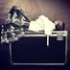Karrie Higgins ‏@karriehiggins
If you have a disability, be aware of accessibility issues & ableism in MFA programs. It's a rampant problem. #MFAchat
Lincoln Michel ‏@TheLincoln
Here's some #MFAchat real talk: don't underestimate the value of location, especially NYC. I'll get flack for that, but it's true.
Lincoln Michel ‏@TheLincoln
.@TheLincoln and not (just) because of "connections," but also being immersed in a writing community outside of the MFA bubble. #MFAchat
Jaime Green ‏@jaimealyse
Agreed. It's a big trade-off against a funded program, but it can be worth it. #MFAchat
Jaime Green ‏@jaimealyse
@TheLincoln on the other hand, an intense program can give you barely time to breathe, let alone get out to readings & events #MFAchat
David Schuman ‏@d_schuman
@jaimealyse @TheLincoln True, true #MFAchat
Alyse Bensel ‏@leaseandleaves
Sometimes it can be difficult to find programs (esp. MFAs) that allow hybrid/cross-genre work. Reach out to faculty and ask! #MFAchat
Alyse Bensel ‏@leaseandleaves
.@leaseandleaves So glad to hear other programs allow hybrid work! At #KU it is definitely permitted, for both the MFA and PhD. #MFAchat
The W's MFA in CW ‏@TheW_MFACW
“@leaseandleaves: Sometimes it can be difficult to find programs that allow hybrid/cross-genre work." #MFAChat We allow cross/mixed theses.
SMC MFA Program ‏@smcmfa
@leaseandleaves @awpwriter true. i (@CandaceErosDiaz) am a cross-genre writer & found a safe, nurturing place @smcmfa. #MFAChat
davidbishop ‏@davidbishop
@leaseandleaves hybrid work shouldn't just be permitted, it should be encouraged! #MFAchat
English@CardiffMet ‏@English_CMet
@davidbishop @leaseandleaves yay! We are just starting a Centre for New and Experimental Writing that will totally encourage it #MFAchat
Alyse Bensel ‏@leaseandleaves
@davidbishop Oh, it is! We have faculty who engage in hybrid forms, and the program offers a mixed forms workshop! #MFAchat #KU
Julie Sheehan ‏@thebarbook
@leaseandleaves same at @SBSouthampton #MFAchat
David Schuman ‏@d_schuman
I also tend to think, the big coastal cities are tough--so much going on, distractions, etc. Not to disparage! Just a thought #MFAchat
Diane Zinna ‏@DianeZinna
On faculty/fellow students: 1/2 @powell_DA says to think of the [MFA] years as barrel years..." #MFAChat
Diane Zinna ‏@DianeZinna
2/2 @powell_DA: …Whatever poets have stained the inside of the barrels will influence whatever else is to come.” #MFAChat #Winereference!
Amy Stuart ‏@AmyfStuart
I began @ubccrwr MFA w a small portfolio & graduated w 2 published stories, a novel draft, an agent & a great community #MFAchat @awpwriter
Lucas Mann ‏@LucasWMann
#MFAchat If you can get funding, then go. If you can get funding for three years somewhere, take the extra year. Try to be nice to yourself.
Adam Clay ‏@adam__clay
My MFA program was ideal because of the students there--profs were great, but the community of students really made the difference. #MFAchat
Adam Clay ‏@adam__clay
I say reach out to current students to find out about experiences in terms of community, post-workshop gatherings, etc. @awpwriter #MFAchat

davidbishop ‏@davidbishop
Creative MA @EdinburghNapier in UK building partnerships with like-minded US MFA programs toward student/credit swaps #MFAchat

Joshua Bohnsack ‏@josiahbohnsack
I had a 3.0 GPA in undergrad, but feel it's not a great representation of my work. Is there hope for me? #MFAchat
Julie Sheehan ‏@thebarbook
@josiahbohnsack Yes. GPA is not a great indicator of your talent as a writer. Your writing sample, however, is. #MFAchat
William L. Domme ‏@Atypeofwriter
@thebarbook @awpwriter @josiahbohnsack So do I need a BA or can I just submit past work in the application?
Steph Vanderslice ‏@wordamour
@thebarbook @josiahbohnsack Although if your GPA is poor in writing courses, that is usually a red flag.
Joshua Bohnsack ‏@josiahbohnsack
@wordamour @thebarbook good to know. It was math that brought me down. It always is.

Alyse Bensel ‏@leaseandleaves
@josiahbohnsack What truly matters when applying to MFA programs is the writing sample. It is THE MOST important thing. #MFAchat
Daniel A. Hoyt ‏@dan_hoyt
If your writing sample shows real promise, I wouldn't worry about a 3.0. @josiahbohnsack #MFAchat
The W's MFA in CW ‏@TheW_MFACW
@josiahbohnsack #mfachat Yes! Our limit is 3.0, but we have provisionally admitted students with lower. Writing and work post-BA help.

EDML ‏@exclamate_
If it all works out, you'll end up a MASTER of the FINE ARTS. (Disclosure: cats can't get MFAs.) #MFAChat
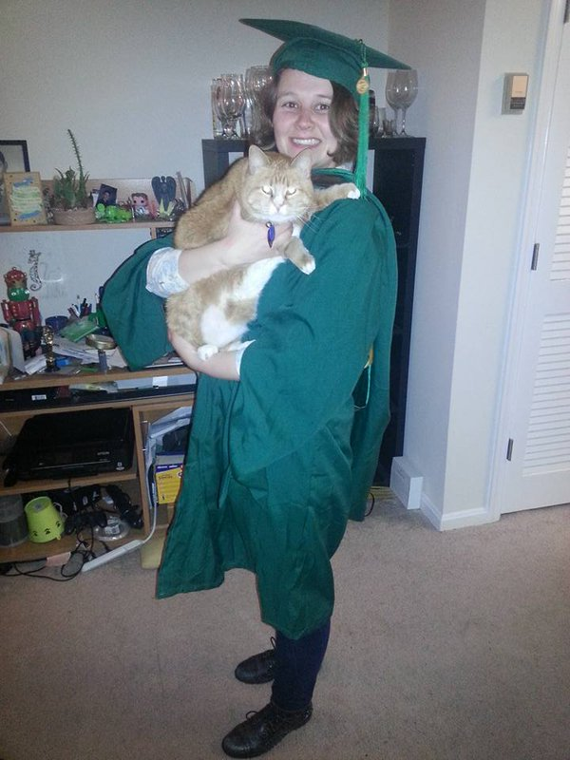
Paige Sullivan ‏@BPaigeSullivan
I def agree that seeking out funding, a teaching position, and chances to work on publications are what make an MFA worthwhile. #MFAchat
Julie Sheehan ‏@thebarbook
@SouthamptonRevi @SouthampWriters we offer lit mag & opportunity to teach undergrad cr wrting @stonybrooku #MFAchat

Danielle Lazarin ‏@d_lazarin
Some good advice coming through #MFAchat. Cosign on fully-funded programs, not straight after undergrad, & life beyond the MFA.
Danielle Lazarin ‏@d_lazarin
Other things to know: you may not want to teach after. Name recognition of faculty is irrelevant. Good teachers may be new to you. #mfachat
Lisa Romeo ‏@LisaRomeo
@d_lazarin When researching faculty, some names were new. I talked to them, read their work, asked students & alum about them #MFAchat
Danielle Lazarin ‏@d_lazarin
@LisaRomeo Yes, talking to students & alum is key. I learned that some faculty whose work I adored weren't accessible to students.

Heather Steadham ‏@hbsteadham
(1) Location may be important, but your commitment to furthering your craft is paramount. #MFAchat
Heather Steadham ‏@hbsteadham
(2) In today's virtual world, you're only limited by your own efforts (or lack thereof). #MFAchat
EDML ‏@exclamate_
You will likely not be making $100ks post-MFA. It's the rewards of active discussion, care, and community that you'll reap. #MFAChat
EDML ‏@exclamate_
I now have dear friends in these states: Washington, Arizona, New Mexico, New Jersey, California, Utah, Minnesota, & even Alaska! #MFAChat
Max Rubin ‏@SoupRubin
Beyond funding, faculty, and programming, I've benefitted from being in a community of writers unparalleled anywhere in the country #MFAchat
Lisa Romeo ‏@LisaRomeo
@SoupRubin Right. Your MFA classmates (and to some degree, faculty) form the bedrock of your post-MFA #writing community. #MFAchat
Max Rubin ‏@SoupRubin
@LisaRomeo definitely. Can't imagine a stronger group of readers.

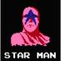Bryan Bliss ‏@brainbliss
If you're looking for a great MFA program, may I suggest Seattle Pacific. I can't even explain the difference it made to my writing #MFAchat
Doug Paul Case ‏@dougpaulcase
Literally the only reasons you need an MFA are time and to have teaching credentials should your book do well enough for a TT job. #mfachat
The W's MFA in CW ‏@TheW_MFACW
@dougpaulcase Reason for MFA: not teaching creds, but writing creds. Time to write; Also learn the profession & careers other than teaching.
The W's MFA in CW ‏@TheW_MFACW
@dougpaulcase Reason for MFA: not teaching creds, but writing creds. Learn the profession & careers other than teaching. #MFAChat

Long Day Press ‏@longdaypress
How important are previous publications when applying? Does it help to declare your publications (if you're not just bragging)? #MFAchat
Adam Clay ‏@adam__clay
Working with profs who write poems/prose completely different from your current style is ideal. An MFA is a chance to experiment #mfachat
UCRLowResMFA ‏@UCRPDLRMFA
Let's do some pimping, shall we? Who is the only member of congress with an MFA in Creative Writing? @RepMarkTakano! #MFAchat
Diane Zinna ‏@DianeZinna
1/2: I often hear people say they want to attend an MFA program to have that “built-in” community for the rest of their lives... #MFAChat
Diane Zinna ‏@DianeZinna
2/2: Finding a lifelong writing community is difficult. Attending an MFA program won't guarantee that. #MFAChat
David Schuman ‏@d_schuman
@DianeZinna but can definitely help #MFAchat

David Schuman ‏@d_schuman
Advice on deciding how many programs to apply to--how bad do you want to go and how bad do you want to go NOW. A lot = more apps #MFAchat
South Carolina MFA ‏@scMFA
Location matters, but not always in the ways you think, and places are often not what you expect if you haven't spent time there. #MFAchat
Dahlia Seroussi ‏@DahliaSeroussi
Agreed; Corvallis didn't seem "exciting" at first, making it the perfect place to write 4 me. Also nature. #MFAchat

Yen Ha ‏@yhaduong
@lesliepwriter @awpwriter I asked NYU MFA in Paris. For privacy would not put me in touch w/ students or grads. That's not normal? #mfachat
Leslie Pietrzyk ‏@lesliepwriter
@yhaduong @awpwriter Honestly, I'd be leery. Our dir asks students if they are willing to talk to prospective students.
Yen Ha ‏@yhaduong
@lesliepwriter @awpwriter Yes. I want to talk to ppl about actual experience, not party line. They said for privacy reasons they couldn't.
Leslie Pietrzyk ‏@lesliepwriter
@yhaduong @awpwriter Ugh. Red flag. I hope you have some other programs you're excited about!
SMC MFA Program ‏@smcmfa
@yhaduong @lesliepwriter @awpwriter they must have a reason why. ask. seems odd tho, yes. #MFAChat
South Carolina MFA ‏@scMFA
Usually recommend applicants apply to a range of programs, not just in terms of tiers but also in program size, other factors. #MFAchat
Morgan Jerkins ‏@MorganJerkins
#MFAchat oooh *rubs hands together*
EDML ‏@exclamate_
Have any specific questions for me? I have opinions. Feel free to ask! #MFAChat
Diane Zinna ‏@DianeZinna
More: “Why the Hell Wouldja Choose an MFA Program Anyways?” @Powell_DA http://bit.ly/1P6s682 #MFAChat
Diane Zinna ‏@DianeZinna
1/2: “Rankings don’t matter if you feel the school’s a good fit.”— @elizmccracken http://bit.ly/20oyWJX #MFAChat
Diane Zinna ‏@DianeZinna
2/2: “Rankings matter even less if you feel it’s a bad one.”— @elizmccracken http://bit.ly/20oyWJX #MFAChat
Adam Clay ‏@adam__clay
a 3 or 4 year program is best for writers just getting their footing, IMO. My first year went by fast. Years 2-3 = wrote a ton #MFAchat
IAIALowRez ‏@LowRezMFA
@DianeZinna You will compile these tweets into a single coherent document? I'm impressed. I'd rather register grasshoppers to vote. #MFAchat
AWP ‏@awpwriter
@LowRezMFA @DianeZinna Already up to 120 pages of tweets!
Diane Zinna ‏@DianeZinna
@LowRezMFA Our poor Webmaster: This is going to be terrible to archive, but I love seeing directors and admins answering questions! #MFAChat

davidbishop ‏@davidbishop
#MFAchat programs should volunteer opportunities for applicants to Skype chat with current students and/or graduates - it's a big commit!
Nandini Balial ‏@nandelabra
#MFAchat Should I apply to a program? Is it worth the student loan? Does it make you a happier person?
Converse College MFA ‏@ConverseMFA
@nandelabra I can say I'm glad I did. It was the best choice I ever made, and not because of jobs, but what I learned/experienced #MFAchat
Gabrielle Freeman ‏@TheLadyRandom
@ConverseMFA @nandelabra I fell in love with poetry all over again. Loans are hefty, but, for me, totally worth it. Love my Converse family.

Nandini Balial ‏@nandelabra
@TheLadyRandom @ConverseMFA I already owe six figures in loans. But apparently there are programs with funding?
Nandini Balial ‏@nandelabra
@ConverseMFA I think I'd only do it if it helped me get a job. It's paramount, for me anyway.
Michalle ‏@Senneteer
@nandelabra omg only go if you get funding/apply to programs with funding
Nandini Balial ‏@nandelabra
@Senneteer Yeah. And I don't know if those exist. I also didn't like college, so I'm thinking it's maybe not the best fit for me.
Michalle ‏@Senneteer
@nandelabra I am very pro mfa we can email about it you want more info
Michalle ‏@Senneteer
@nandelabra lots of those exist!
Karen Backstein ‏@KarenatashaB
@nandelabra For writing?
Brak Lesnar ‏@Moose_Bigelow
@nandelabra There was a big hubbub in @strangerslog about this. http://www.thestranger.com/books/features/2015/02/27/21792750/things-i-can-say-about-mfa-writing-programs-now-that-i-no-longer-teach-in-one …

EverywhereAllTheTime ‏@bani_amor
@MorganJerkins literally all white faces in #MFAchat
Morgan Jerkins ‏@MorganJerkins
@bani_amor *dives in*
SMC MFA Program ‏@smcmfa
@bani_amor @MorganJerkins POC here representing @smcmfa. also an alumna of the program :) #MFAChat #workingondiversity
P.E. Garcia ‏@AvantGarcia
MFA programs are really #cool and #fun. #MFAChat #predominatelywhite
South Carolina MFA ‏@scMFA
Our MFA student-edited lit mag is @YemasseeJournal. Series: The Open Book, Fall Literary Festival, Shark's Parlor. Also town stuff. #MFAchat
SBShampton MFAWriter ‏@SouthampWriters
The good news: Lou Ann Walker, Neal Gabler, and Roger Rosenblatt teach nonfiction. The bad news: those keen eyes on your work #MFAChat
Nicole Byrne ‏@nicolebyrnepoet
Your first semester is going to be a nightmare. Hang in there #MFAchat
Adam Clay ‏@adam__clay
and embrace your time in a grad program. you'll never have as much time in your life to write and read as you do during an MFA. #MFAchat
Carla Spataro ‏@cjspataro
@adam__clay #MFAchat @Rosemont_MFA So true. I also tell students to push themselves outside their comfort zone. Safest place to try is GS
Heather Steadham ‏@hbsteadham
Take advantage of EVERY opportunity available to you. Pick up visiting writers at the airport. No job too small. #MFAchat
Danielle Lazarin ‏@d_lazarin
Last one on #MFAchat, for prose folks: I'd be drawn by a program that makes room to teach the novel. Not done enough.
Morgan Jerkins ‏@MorganJerkins
If you're a POC, there may be a moment when your white colleagues will not understand your characters. #MFAchat
Julie Sheehan ‏@thebarbook
This needs to change. #MFAchat
Morgan Jerkins ‏@MorganJerkins
Take it all in stride. But at the same time, defend your work. Don't shy away from discomfort. It's useful for everyone. #MFAchat
Morgan Jerkins ‏@MorganJerkins
I was the only black person in my incoming class and I was scared. I thought I was just a token. Don't be like me. #MFAchat
Julie Sheehan ‏@thebarbook
@MorganJerkins Oh, traumatic! I'm pushing for the day when we all recognize the individuality of the imagination. #MFAchat
Lauren Wolf ‏@WriteBoldly
@MorganJerkins @awpwriter Critiques and workshops are better with diverse classrooms! Thanks for encouraging others to be brave.
Renee C. ‏@jademoonsun
@MorganJerkins @awpwriter what do you mean? Don't be scared? Don't accept tokenism?
Morgan Jerkins ‏@MorganJerkins
In + out of workshop, make sure you work on finding YOUR voice. You're not a ventriloquist. Your colleagues will be able to tell. #MFAchat
Morgan Jerkins ‏@MorganJerkins
I spent my first year trying to sound like a old white man. My most praised work came from me sounding like me. Imagine that. #MFAchat
Morgan Jerkins ‏@MorganJerkins
Reach out to people. I emailed Junot Díaz for advice and a day later, he responded to me with this: Find your community. #MFAchat
Morgan Jerkins ‏@MorganJerkins
Don't be ashamed if you've never read Didion or Munro. I came from a background of Russian and Japanese lit. You'll be just fine. #MFAchat
Morgan Jerkins ‏@MorganJerkins
If you're a POC, don't be afraid to write in dialect. Force your white colleagues to read it. It needs to stay. #MFAchat
Naomi Hirahara ‏@gasagasagirl
@MorganJerkins I've been told by readers outside my community that I was being disrespectful by using dialect. Forget that!
Morgan Jerkins ‏@MorganJerkins
If a colleague is writing a character who shares your racial identity and something bothers you, speak up. #MFAchat
Christopher R Alonso ‏@ChrisRAlonso
@MorganJerkins Thank you for this whole thread. I'm the only Hispanic in my program right now. Got some comments about some Spanish words.
Christopher R Alonso ‏@ChrisRAlonso
@MorganJerkins Other than that, my favorite colleagues are supportive and ask questions and have been very welcoming.
Naomi Hirahara ‏@gasagasagirl
@ChrisRAlonso @MorganJerkins How do words become mainstream? One way is usage, so I say use them!
EverywhereAllTheTime ‏@bani_amor
@ChrisRAlonso @MorganJerkins can I ask what they said?
Christopher R Alonso ‏@ChrisRAlonso
@bani_amor @MorganJerkins asked if it was necessary since the story is written in English but set historically in a Spn speaking country
EverywhereAllTheTime ‏@bani_amor
@ChrisRAlonso @MorganJerkins that's super basic. Just wow.
Christopher R Alonso ‏@ChrisRAlonso
@bani_amor I kinda expected that. I'm going to keep the Spanish. Ain't nobody else who can roll these Rs like I can
EverywhereAllTheTime ‏@bani_amor
@ChrisRAlonso dude, I've been told repeatedly in *poc only spaces* to change my Spanish words. We end doing what makes sense for the work.
Christopher R Alonso ‏@ChrisRAlonso
@bani_amor Damn! I definitely see where the Spanish doesn't fit, and I see where it does, and that's where I'll put it. You do you!
seelight ‏@seelight
@MorganJerkins Yes! And support fellow writers of color who speak up in class!
Morgan Jerkins ‏@MorganJerkins
Do not just say a white colleague's POC character is "problematic". Lay it out clearly so that he or she can learn. #MFAchat
Just zis guy y'know? ‏@GRIMACHU
@MorganJerkins #MFAchat Despite the borderline racist tone of much of this, that's sound advice. Dismissal is just frustrating as hell.
Morgan Jerkins ‏@MorganJerkins
POCs, gorge yourself on the works of those who look like you. The boldness will rub off on you, trust me. #MFAchat
Morgan Jerkins ‏@MorganJerkins
Dig deep. You think you have your limits but you can go further. It feels like heart surgery but you will thank yourself later. #MFAchat

Stephen J Furlong ‏@BeenASon24
Community is vital when it comes to MFA/MA work. While writing is a soloistic art, it thrives when dedicated people work together #MFAChat
Rachael Warecki ‏@RachaelLaWriter
My MFA program brought me a community of like-minded writers, now some of my best friends. Wouldn't have met them otherwise. #MFAchat
Shannon H. Polson ‏@ABorderLife
Most important thing: it's not about the MFA- it's abt the writing. #MFAchat
Adam Clay ‏@adam__clay
start a magazines with yr fellow students. start a reading series. think literary citizenship. #MFAchat
Daniel A. Hoyt ‏@dan_hoyt
Thanks, @DianeZinna, @awpwriter, and everyone who participated. Great questions and advice. #MFAchat
UCRLowResMFA ‏@UCRPDLRMFA
Don't over estimate how little it matters if you live or work in NY. #MFAchat
David Schuman ‏@d_schuman
You may think you know what kind of writer you are, but understand you might come out the other side completely not that thing #MFAchat
Max Rubin ‏@SoupRubin
@d_schuman and also my writing sample is NOTHING like what I've ended up pursuing in my writing
David Schuman ‏@d_schuman
@SoupRubin And part of that is allowing a faculty member who doesn't share your aesthetic to get under your skin and challenge you #MFAchat

Holly Vanderhaar ‏@HollyVanderhaar
1/2 Speaking as an MFA and now an MFA Prog. Coordinator: Don't go into huge debt. Funding matters. #MFAchat
Holly Vanderhaar ‏@HollyVanderhaar 8m8 minutes ago
2/2 And the big-name faculty who drew u to the program may work with only a few students, or not teach regularly. Research ALL fac. #MFAchat
Paige Sullivan ‏@BPaigeSullivan
I also would research - is the program studio, or studio-academic? No idea that @gsucw was studio-academic, but I love the rigor! #MFAchat
Michael Beeman ‏@MichaelBeeman
Want to keep your day job? Consider a low-residency MFA program. #MFAchat
Nick Mamatas ‏@NMamatas
Don't write stories about the person in workshop you want to have sex with. #MFAchat
Diane Zinna ‏@DianeZinna
Let's end with this: Alumni and current students, what do you wish you knew when you were looking for programs to apply to? #MFAChat
Lisa Romeo ‏@LisaRomeo
@DianeZinna Say yes to the optional and or tough stuff. Get in the DIScomfort zone. That's where good things happen to yr writing. #MFAchat
Michael Nye ‏@mpnye
@DianeZinna Nothing. Whatever missteps I made ultimately got me to a good spot, and my program, whatever its flaws, helped me do that.
IAIALowRez ‏@LowRezMFA
@DianeZinna As an alum (University of Montana) long ago, I wish I'd known how fast the two (in my case) years would pass. #MFAchat
IAIALowRez ‏@LowRezMFA
@DianeZinna I was in Montana for the first time in 15 years and realized how significant, intense, and magical those years were. #MFAchat
Leanna J Blackwell ‏@baypathmfaCNF
@DianeZinna Easy!Wish I had known how to submit, where, and to whom. My MFA was 100% craft.I had to learn the rest on my own after. #mfachat

Diane Zinna ‏@DianeZinna
@baypathmfaCNF Mine too! They stapled-together photocopies on publishing with the title, "Trade Secrets" in my mailbox grad day. #MFACHAT
Leanna J Blackwell ‏@baypathmfaCNF
@DianeZinna Oh no! Awful! That's one reason I'm so gung-ho about helping students understand publishing before they graduate.#mfachat

Joshua Bohnsack ‏@josiahbohnsack
Despite each program's preference, generally, does one long story or two shorter stories provide a better sample? #MFAchat
Tasha Cotter ‏@TashCotter
I'd highly recommend taking a class in a different genre. It could be a turning point for you! #MFAchat
Lisa Romeo ‏@LisaRomeo
Great advice. I am a CNF writer, but some of my best aha moments came in a poetry or fiction seminar. #MFAchat

UsyBoroda ‏@usyboroda
Article by @jpoch discusses MA vs. MFA http://bit.ly/1LMES7P #MFAChat
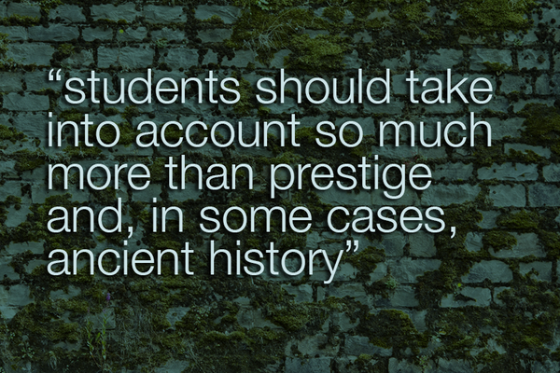
Danielle Lazarin ‏@d_lazarin
Okay wait, one more for #MFAchat! I clicked my way through the math section of my GRE. Single digit score. Still got into good programs.
Leanna J Blackwell ‏@baypathmfaCNF
@d_lazarin Me, too! #mfachat
The W's MFA in CW ‏@TheW_MFACW
“@d_lazarin: #MFAchat! [Low] math .. score. Still got into good programs.” Yep. We don't require GRE. Many MFA's don't either.

Nicole Byrne ‏@nicolebyrnepoet
There's a lot of opportunities available to you in grad school that aren't directly related to your MFA. Take advantage of those. #MFAchat
UCRLowResMFA ‏@UCRPDLRMFA
Other random thoughts: make sure you're in a program that lets you write what you want to write, not what they want to read #MFAchat
IAIALowRez ‏@LowRezMFA
After the tweets settle, questions for the Institute of American Indian Arts' low residency MFA can be addressed to jdavis@iaia.edu #MFAchat
davidbishop ‏@davidbishop
#MFAchat working at a UK university, I'm still amazed many US universities charge people to apply! Volume/admin nightmare I know, but still.

Paige Sullivan ‏@BPaigeSullivan
I will also say that teaching a full load and juggling your writing can be a feat -- let alone finding time to submit! #MFAchat
Carla Spataro ‏@cjspataro
@BPaigeSullivan #MFAchat Yes! @Rosemont_MFA offers a class called surviving as a writer that helps students get ready for that challenge!
Michael Nye ‏@mpnye
Be humble going into a grad program. If you knew everything, you wouldn't need to go. #MFAchat
Tasha Cotter ‏@TashCotter
At the @BGWritersStudio I took courses in fiction and poetry. Loved that the faculty were so encouraging & supportive. #MFAchat
Michael Nye ‏@mpnye
Ultimately, the person responsible for your writing is you. Programs and communities help, but, face it, writing is a solitary art. #MFAchat
David Schuman ‏@d_schuman
@mpnye and often it's solitary and very much not art...#MFAchat
Heather Steadham ‏@hbsteadham
Dedicate yourself to increasing the diversity in your program. DO WHAT IT TAKES. #MFAchat @AvantGarcia
Michael Nye ‏@mpnye
Broadly I'd say a graduate program will make you a better writer and, if you can, you should go to one. #MFAchat
Shannon H. Polson ‏@ABorderLife
.@mpnye for those unable to attend for whatever reason so many other ways to learn craft and grow community #MFAchat
Shannon H. Polson ‏@ABorderLife
.@mpnye places like Seattle's @HugoHouse and Boston's @grubstreet, great online options and conferences #MFAchat
Michael Nye ‏@mpnye
@ABorderLife @HugoHouse @grubstreet Agreed: Sackett too, and it seems like most large cities now have communities like these.

Shannon H. Polson ‏@ABorderLife
Sorry, should have been @mpnye @HugoHouse @GrubWriters #MFAchat
GrubStreet ‏@GrubWriters
Thanks @ABorderLife! Our Novel & Memoir Incubators are also a good option for finishing book-length work with supportive community #MFAchat

Lincoln Michel ‏@TheLincoln
I'd also avoid going to a program for a SINGLE teacher you love, but definitely go to program with a diverse set of great teachers #MFAchat
Alyse Bensel ‏@leaseandleaves
Research, research, research programs! Don't be afraid to reach out to faculty and students! Only apply to fully-funded programs! #MFAchat
AWP ‏@awpwriter
So many great tweets, we can't keep up with retweeting them! #MFAChat

Nick Mamatas ‏@NMamatas
The ego is always the enemy: writers who want their work "torn apart" are just as narcissistic as those who only want praise. #MFAchat
G.M. Palmer ‏@gm_palmer
Put a novelist on your poetry thesis panel. Put a poet on your novel thesis panel. Learn from the other. #MFAchat
Chad Rhoad ‏@c_rhoad
Knowing why you want a MFA program is crucial to choosing the right one for you. What do you want from your time there? #MFAchat
Doug Paul Case ‏@dougpaulcase
OMG guys an MFA is not going to make you a writer. You are or you're not, will be or won't. #MFAchat
Nova Ren Suma ‏@novaren
Watching #MFAchat with interest, now that I've joined the faculty of an MFA program for the first time (@VCFA)! So interesting.
UCRLowResMFA ‏@UCRPDLRMFA
We're happy to have #MFAchat any time! Feel free to email with questions: palmdesertmfa@ucr.edu or just send us questions here.
Catapult ‏@CatapultStory
Make sure to check out the lively conversation happening in #MFAchat right now
The W's MFA in CW ‏@TheW_MFACW
Thanks @awpwriter #mfachat has been intense. Now let me look back over the hashtag to see what I missed!
Evelyn Lauer ‏@evelynalauer
I write more now with a career and two kids than I did during my MFA years. #MFAchat
Dahlia Seroussi ‏@DahliaSeroussi
@evelynalauer this is incredibly comforting! #MFAchat

Jenna Sauers ‏@jennasauers
Best things about getting an M.F.A., to me: 1. Health insurance 2. Access to academic library 3. Great teachers 4. Great colleagues #MFAchat
Jenna Sauers ‏@jennasauers
Most important, of course, is workshop. I didn't move to fucking Iowa to go to cool parties. What happens in that room is it. #MFAchat
Jenna Sauers ‏@jennasauers
When you're checking out a program, visit campus. Go to workshop. Do you like what you see and hear? That's really the only thing. #MFAchat
Max Rubin ‏@SoupRubin
@jennasauers are you implying that 5 cheeseburger/week at George's is not as culturally fulfilling as the entire offerings of NYC?
Jenna Sauers ‏@jennasauers
@SoupRubin why did you have to bring cheeseburgers into this
AWP ‏@awpwriter
Thank you for joining us today for this #MFAchat! It's been amazing! Feel free to keep the great discussions going
AWP ‏@awpwriter
Our next tweet chat will be in January. We'll chat about the #AWP16 bookfair. #MFAChat
Diane Zinna ‏@DianeZinna
Thank you, everyone! That was exhausting and fun! More questions? Check out advice articles here: http://bit.ly/1l4nhzN #MFAChat
Lilliam Rivera ‏@lilliamr
Will have to check out the #MFAchat hashtag. Lot's of good advice.
Diane Josefowicz ‏@dianegreco
Don't neglect courses in literary translation #mfachat
Michael Nye ‏@mpnye
"Do it or don't. But I got some place I gotta be" - Marlo Stanfield on MFA programs #MFAchat #TheWire
davidbishop ‏@davidbishop
#MFAchat interested in genre-fiction MA in UK? Here's the skinny on Creative Writing @EdinburghNapier http://macreativewriting.blogspot.co.uk/2015/05/updated-admissions-process-for-ma.html … #shamelessplug
UCRLowResMFA ‏@UCRPDLRMFA
And if you want #MFAChat in real life: our fall residency Dec. 4-13th. Come visit. Email palmdesertmfa@ucr.edu for details/schedule
SMC MFA Program ‏@smcmfa
happy to answer more questions re: @smcmfa or MFA's in general @ cd8@stmarys-ca.edu. Thanks so much @awpwriter & @DianeZinna #MFAChat
Scott Anderson ‏@SMAnderson575
@awpwriter Too many young writers in MFA programs hardly/don't read much fiction. READ READ READ and then read some more #MFAchat
Kate North ‏@katetnorth
I really enjoy teaching Novel Writing on the @English_CMet grad program, feel free to ask any questions #MFAchat
Marian Womack ‏@beekeepermadrid
@Cambridge_Uni Master is low-residence & very well structured for full-time working students. I'm very happy in my 2nd year there. #MFAchat
Alyse Bensel ‏@leaseandleaves
I'd love to chat more about #KU and Lawrence! We've got a lot going on in the graduate creative writing program #MFAchat
Heather Steadham ‏@hbsteadham
When the "lit mag" you can work on in your program is the Oxford American . . . (Arkansas Writers MFA Workshop) #MFAchat @ARWritersMFA
Adam Clay ‏@adam__clay
if you're lucky enough to only teach CW in your MFA program, ask to teach comp for at least a semester. You'll thank me later. #MFAchat
Annie Frazier ‏@BijouAnnie
Want a mentor to read 175-250 pages of your fiction per semester? Check out @spalding_mfa. #MFAchat
Carla Spataro ‏@cjspataro
#MFAchat happy to answer any questions about @Rosemont_MFA. Thanks to @awpwriter & @DianeZinna!
jen! ‏@JenniferMWolff
@DianeZinna @awpwriter Thank you for sparking such an awesome & inspiring discussion! #MFAchat
UCRLowResMFA ‏@UCRPDLRMFA
Follow some of our faculty #MFAchat folks: @Elizabeth_Crane, @encurtido, @Ginafrangello, @todgoldberg, @JAEssbaum, @RobergeRob, @davidulin
UCRLowResMFA ‏@UCRPDLRMFA
Follow even more of our faculty and alums #MFAchat people: @SGJ72, @NatashiaDeon, @Nicolucci1899, @ShadesShadows, @DeanneStillman2
David Schuman ‏@d_schuman 2m2 minutes ago
A whirlwind and I forgot to tag #MFAchat like a thousand times but thanks @awpwriter! And feel free to get in touch with any questions.
South Carolina MFA ‏@scMFA
Because we're small, we bring in visiting writers to read and give master classes. *Some* are listed here: http://tinyurl.com/pmlf4gz #MFAchat
Annie Frazier ‏@BijouAnnie
Try to find out what the workshop atmosphere is like before applying. #MFAchat
Marian Womack ‏@beekeepermadrid
If you want to feel part of a community attend the @ClarionUCSD writers workshop #MFAchat
UCRLowResMFA ‏@UCRPDLRMFA
And for all your information #MFAchat folks: http://palmdesertmfa.ucr.edu
Chelsea H Bryan ‏@chelseahbryan
The biggest part of the experience besides teachers are peers: do go to visiting day to see if it's the right environment. #MFAchat
Leslie Pietrzyk ‏@lesliepwriter
Thinking about an MFA or in the m idst of apps? Check out #MFAchat hosted by @awpwriter for smart advice. #amwriting
Lisa Romeo ‏@LisaRomeo
Online MFA @Bay_Path I have far more 1:1 w/my students than I had w/faculty in my low res. Not disparaging, just program design. #MFAchat
Rachael Warecki ‏@RachaelLaWriter
Also: went to a low-res MFA program, @AntiochLA. Allowed me to work full-time while also learning & writing. #MFAchat
English@CardiffMet ‏@English_CMet
@RachaelLaWriter yes, lots of our low res students work #MFAchat

Carmen Maria Machado ‏@carmenmmachado 4m4 minutes ago
A few #MFAchat thoughts:
Carmen Maria Machado ‏@carmenmmachado
1.) I'm very glad I didn't go to my MFA directly out of college, but I'm also glad that I didn't wait much longer than I did. #MFAchat
EDML ‏@exclamate_
@carmenmmachado Yeah, you gotta wait until you've got the burn for school again.
Carmen Maria Machado ‏@carmenmmachado
@exclamate_ Exactly! If I'd gone right out of college I would have been hella exhausted.
Char Wars ‏@cpburkejr
This is fantastic advice. Be sure to check out the whole detailed thread. #MFAchat
Carmen Maria Machado ‏@carmenmmachado
2.) I had NO IDEA what sort of writer I was going in. My style happened b/c smarter writers than me sensed what I was trying to do. #MFAchat
Carmen Maria Machado ‏@carmenmmachado
3.) Part of the reason I applied for MFAs when I did was because the economy sucked & I hated my job. I needed to Get Out. #MFAchat
Carmen Maria Machado ‏@carmenmmachado
4.) I am really grateful that I went to a program in a city with a low cost of living. (Almost went to Austin; so glad I didn't.) #MFAchat

Carmen Maria Machado ‏@carmenmmachado
5.) I'm very grateful I didn't take on debt for my MFA. Everyone's needs are different, but I think I made the right choice. #MFAchat
Carmen Maria Machado ‏@carmenmmachado
6.) There are more funded programs than you think. I could have spent $$$, but I waited an extra year & applied again & I'm glad. #MFAchat
Carmen Maria Machado ‏@carmenmmachado
7.) When you're looking at programs, don't necessarily shoot for big name faculty; fame can't predict how good a teacher is. #MFAchat
Leah Zufall ‏@lkz25
@carmenmmachado thanks for sharing Carmen Maria Machado, have a great Tuesday :) (insight by http://commun.it )
Carmen Maria Machado ‏@carmenmmachado
8.) Good teachers don't necessarily have to write in your genre/style; they have to be smart, well-read, and open-minded. #MFAchat

Carmen Maria Machado ‏@carmenmmachado
(This is true of fellow students, too. My best readers are themselves writers in a variety of genres, including realism.) #MFAchat
Christopher R Alonso ‏@ChrisRAlonso
@carmenmmachado I agree! Had a big workshop two weeks ago and saw how receptive and thoughtful colleagues were, esp the realists. Realest.
Carmen Maria Machado ‏@carmenmmachado
But I loved getting my MFA. I had time to write & health insurance. I found my voice. I read a ton. I met amazing people. #MFAchat
Carmen Maria Machado ‏@carmenmmachado
Oh, another thing: don't rely on "chatter" about programs. Go straight to the source. Talk to current & recent students. #MFAchat
Carmen Maria Machado ‏@carmenmmachado
Wondering about a program's competitiveness? Genre-friendliness? Ability to help you during & after your program? Ask the students #MFAchat

Carmen Maria Machado ‏@carmenmmachado
Oh, and don't apply with samples that artificially cater to your perception of a program's tastes. Apply with your best work. #MFAchat
Carmen Maria Machado ‏@carmenmmachado
Don't be afraid to re-apply a second (or third) year! Readers change, luck changes. And in between, keep improving your writing! #MFAchat
Char Wars ‏@cpburkejr
@carmenmmachado I did exactly this and was literally multiple times more successful at round two. You get better with time.
Carmen Maria Machado ‏@carmenmmachado
Also: MFAs are not about "teaching writing." They're about giving writers time, space, advice, education, resources, community. #MFAchat
Carmen Maria Machado ‏@carmenmmachado
"Can writing be taught?" is not the right question here. It's "What could this writer do if she had the resources she needed?" #MFAchat

Carmen Maria Machado ‏@carmenmmachado
Like, my MFA program was the right set of resources for me at the right time in my life & career & writerly arc. #MFAchat
Carmen Maria Machado ‏@carmenmmachado
Also, the MFA is just the beginning. Plenty of people get them & stop writing. It's really about what you do afterwards. #MFAchat
Carmen Maria Machado ‏@carmenmmachado
Also, there are always more talented writers than there are slots in MFA programs. (This is true of magazines & residencies, too.) #MFAchat
Carmen Maria Machado ‏@carmenmmachado
There isn't infinite money for every writer with potential. So apply widely, don't get discouraged, and keep reading & writing. #MFAchat
Carmen Maria Machado ‏@carmenmmachado
Make sure you know WHY you're applying for an MFA. Do you want or need what it offers? #MFAchat

Carmen Maria Machado ‏@carmenmmachado
For example, if you want an MFA, you should love reading. If you don't, you're in the wrong field. #MFAchat
Carmen Maria Machado ‏@carmenmmachado
You also should have thoughts and feelings about literature as an art form--about aesthetic--however that looks. #MFAchat
Carmen Maria Machado ‏@carmenmmachado
And... I think that's it? Whew. But I can answer questions about MFAs, if you have them. I have A Lot of Feelings, obviously. #MFAchat
Libby ‏@libbywebster
@carmenmmachado I am glad I follow you on Twitter. I am in the process of my first time applying to MFAs & love reading your thoughts! 0:)

Dahlia Seroussi ‏@DahliaSeroussi
Getting 2/3 years to read&write is one of the best things you'll do. Don't blow it by being an asshole. #MFAchat

Leslie Pietrzyk ‏@lesliepwriter
@awpwriter Shouldn't have stopped...#MFAchat just started trending! :)
IAIALowRez ‏@LowRezMFA
@lesliepwriter @awpwriter Jon Stewart was in our sights! We had him. #MFAchat
Diane Zinna ‏@DianeZinna
Yes! Another dream come true for me! (The first was getting my MFA, of course!) #MFAChat
UCRLowResMFA ‏@UCRPDLRMFA
Write something that makes you happy. Don't be miserable doing this job. Be miserable in a cubicle. Be happy writing. #MFAchat
GrubStreet ‏@GrubWriters
Yes! Though don't be miserable in a cubicle if you can help it #MFAchat

IAIALowRez ‏@LowRezMFA
One thing that has surprised me about low residency programs is the intensity of the bonds between students. #MFAchat
Rachael Warecki ‏@RachaelLaWriter
True. I have strong friendships with @ArtsCollide, @LimelightWendy, @K_Imani, etc. due to @AntiochLA. #MFAchat
Ashley Perez ‏@ArtsCollide
@RachaelLaWriter @LimelightWendy @K_Imani @AntiochLA @LowRezMFA one of the best parts of the MFA experience
Rachael Warecki ‏@RachaelLaWriter
#MFAchat Also true!

Heather Steadham ‏@hbsteadham
Don't be afraid to apply for fellowships--if you don't get them, maybe you'll still get noticed. #MFAchat
Joshua Bohnsack ‏@josiahbohnsack 2m2 minutes ago
So much great advice with #MFAchat. Thanks all!
Anita Laydon Miller ‏@AnitaLaydonMill
@jendellazanna Did you notice the #MFAchat discussion?
South Carolina MFA ‏@scMFA
Thanks @awpwriter for hosting #MFAchat. We have to sign off now, but there's lots of info on our website: http://artsandsciences.sc.edu/engl/mfa-program-carolina …
Ashley Strosnider ‏@bravenewlady
Does everyone in #MFAchat already have a MFA? Is it "a MFA" or "an MFA?" So many questions.
The W's MFA in CW ‏@TheW_MFACW
@bravenewlady #MFAchat It's an MFA. I think many using this hashtag direct programs or are in them, but it's also for those looking at them.

Laura Villareal ‏@earthandstars
Funding & diversity were concerns when applying. Luckily, I ended up at @NewarkMFA which has both. #MFAchat
IAIALowRez ‏@LowRezMFA
I skipped a meeting with the Dean to be here, so I better justify my time: http://www.iaia.edu/mfa will take you to our faculty. #MFAchat

Hope Jordan ‏@hopejordannh
Going to writing conferences, then back to my normal life felt like starting an MFA and stopping it after a week, year after year #MFAchat
Blake Kimzey ‏@BlakeKimzey
An MFA is not the destination. It can be a starting point (or way station). You don't deserve anything just because you enroll. #MFAchat
Carla Spataro ‏@cjspataro
Just finished participating in my first twitter chat. Felt a little like being a puck in a hockey game, but really informative! #MFAchat
James Tate Hill ‏@JamesTateHill
The #MFA is barely the beginning of your writing education, not the completion. #MFAchat
Amanda Miska ‏@akmiska
#MFAchat just makes me feel bitter that there wasn't an active Twitter lit community in 2005 to tell me I was making a huge mistake
Vincent Scarpa ‏@vincentscarpa
If you're on the wrong meds, your first year barely counts. #MFAchat
Jenna Sauers ‏@jennasauers
This #MFAchat was fun. And, I hope, useful! Thanks @awpwriter
Emma Hutson ‏@Emma_S_Hutson
Did my MA at @English_CMet - the lecturers really make a difference - interaction, support and innovation. #MFAchat
English@CardiffMet ‏@English_CMet
@Emma_S_Hutson great to hear, so glad to provide a place for you to study before your next step onto a PhD! #mfachat
Emma Hutson ‏@Emma_S_Hutson
@English_CMet I miss doing creative writing with you guys though! #MFAchat
HumanitiesCardiffMet ‏@English_CMet
@Emma_S_Hutson the feeling is mutual!
Durre Shahwar ‏@Durre_Shahwar
.@Emma_S_Hutson @English_CMet Not to mention that they really know their stuff & are approachable, always make the time. #nostalgia
Emma Hutson ‏@Emma_S_Hutson
@Durre_Shahwar @English_CMet Yep! Creative writing workshops were brilliant. Don't get quite the same experience anywhere else. #MFAchat

jen! ‏@JenniferMWolff
I just found a wealth of interesting people to follow thanks to #MFAchat. I love how the Internet makes creative connections more viable.
jen! ‏@JenniferMWolff
@BeenASon24 Thanks to you too! Really enjoyed your input on #MFAchat.
Heather Steadham ‏@hbsteadham
And, of course, SUBMIT SUBMIT SUBMIT. #MFAchat
Jenna Sauers ‏@jennasauers
This #MFAchat was fun. And, I hope, useful! Thanks @awpwriter
Create ॐ Shanti ✑ ‏@CreateShanti
@akmiska oh dear I just looked up the #MFAchat and confused myself all over again.
Ben Hoffman ‏@benrhoffman
There are like 8 MFAs where agents will come sign you (or sign your friend, not you). You'll find an agent later when you're ready #MFAchat
Danielle Lazarin ‏@d_lazarin
.@benrhoffman also was in a program that brought agents in but wasn't in a rush for us to sign. Was told: write book first! #MFAchat
Ben Hoffman ‏@benrhoffman
.@d_lazarin yes, even if your program brings in agents, agent is 99% gonna say, cool, keep going, get in touch when you have a book #MFAchat
The W's MFA in CW ‏@TheW_MFACW
#mfachat Applicants do you know about the MFA Draft '16 on Facebook? I've had students who thought it helped. https://www.facebook.com/groups/228419750615188/ …
Kelly Luce ‏@lucekel
Don't expect a program to 'make you a writer.' Do the work you need to do to identify as a writer before you apply to grad school. #MFAchat
Warren Buchanan ‏@warrenbuchanan
An MFA doesn't measure talent or skill. It measures whether or not you have the drive to devote your life, your being, to writing. #MFAchat
Literary Disco ‏@LiteraryDisco
Some of you are likely MFA bound writers...Tod answered questions today during #MFAchat via @UCRPDLRMFA.
Emma Smith-Stevens ‏@ESmithStevens
#MFAchat
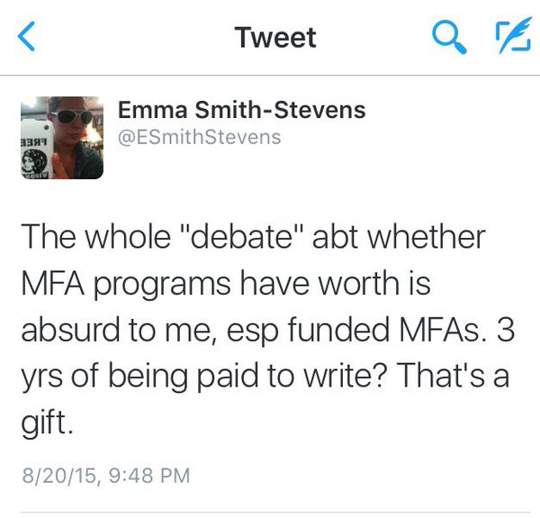
Amal El-Mohtar ‏@tithenai
Check out @carmenmmachado's TL right now for #MFAchat thoughts. A lot of fantastic, succinct advice.
Midway Journal ‏@MidwayJournal
If you haven’t, check out the #MFAchat on Twitter.
James Tate Hill ‏@JamesTateHill
Most of what you learn in an #MFA & beyond is a result of your willingness to learn. #MFAchat
Dan Shea ‏@DanielShea1
Unless it's free, don't. #MFAchat
Kristen Leigh ‏@Kris10ly
#MFAchat Don't apply to #gradschool immediately after undergrad. #Travel, #Work, #Fail at something so you have something to write about.
AU Creative Writing ‏@ArcadiaCW
We love seeing the great conversations around #MFAchat. Makes us happy to be a part of this community.
James Tate Hill ‏@JamesTateHill
The less you think about #publishing, the more you can think about #writing. #MFAchat
David J. Rothman ‏@Prosodisto
@realgaymania #MFAchat I encourage students to remember that to publish is to join a community. Focus on that and it will come.

Hunger Mountain ‏@HungerMtn
So busy reading submissions for our next print issue, we hardly noticed the new trend...What is this #MFAchat anyway?
The W's MFA in CW ‏@TheW_MFACW
@hungermtn #mfachat it was a tweetchat by @awpwriter to discuss MFA programs, applications, etc. Official time is over, but continuing.
Hunger Mountain ‏@HungerMtn Nov 3 Montpelier, VT
@TheW_MFACW @awpwriter Thanks! Got our noses buried in stories over here, bummer to miss this Twitter trend though!
The W's MFA in CW ‏@TheW_MFACW
@hungermtn @awpwriter Scroll back through the hashtag #mfachat and you can see the whole conversation. A few people are still using it.

Diane Zinna ‏@DianeZinna
Also, this: #MFAChat trending!
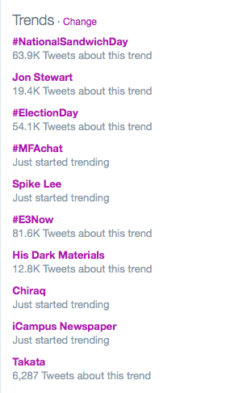
David J. Rothman ‏@Prosodisto
So i think I'm coming late to the party -- but what a great chat. #MFAChat
Nandini Balial ‏@nandelabra
So this article makes me think I'm not qualified. #MFAchat http://www.thestranger.com/books/features/2015/02/27/21792750/things-i-can-say-about-mfa-writing-programs-now-that-i-no-longer-teach-in-one …
David J. Rothman ‏@Prosodisto
@nandelabra That article created quite a firestorm. Take it with a large grain of salt. You can learn a great deal in an MFA! #MFAchat

Andrea Gutierrez ‏@AndreaGtrrz
@carmenmmachado So so true. @chrisabani said this to us in my first quarter in grad school. #MFAchat
Carmen Maria Machado ‏@carmenmmachado
Someone once said that MFAs are like pressure cookers; they speed along a writer's process faster than if they hadn't taken one. #MFAchat
David J. Rothman ‏@Prosodisto
@carmenmmachado #MFAchat ...and it sure beats Ramen...
Carmen Maria Machado ‏@carmenmmachado
For me, that's apt. I think I could have been in my current place artistically eventually, but it would have taken 5+ more years. #MFAchat
Carmen Maria Machado ‏@carmenmmachado
I think that's a useful metaphor. #MFAchat
Carmen Maria Machado ‏@carmenmmachado
Also, SF/F writers: Clarion & Clarion West offer similar, though not identical, benefits to an MFA. #MFAchat
Carmen Maria Machado ‏@carmenmmachado
Clarion can give you similar access to teachers, advice, connections, & community. But w/o the funding & time, which is important. #MFAchat
Carmen Maria Machado ‏@carmenmmachado
You can do both, either, or neither. It just depends what you want/need. I did both & it was a great combination. #MFAchat

David J. Rothman ‏@Prosodisto
My program is at Western State Colorado University -- a low-res in the Rockies; 2-wk. July intensive. http://www.western.edu/academics/graduate/creative-writing …. #MFAChat
Carmen Maria Machado ‏@carmenmmachado
So yeah. Basically, write & read a ton, evaluate your wants & needs, do your research, & don't get discouraged. #MFAchat
Stonecoast Community ‏@StonecoastTweet
#mfachat happy to answer questions about low-residency challenges and benefits
Christine Hennessey ‏@TheNewChrissy
You don't need to go grad school right away! I started my #MFA program when I was 29 and was so glad I waited. #MFAchat
Leslie Jones ‏@lesleslielie
I just read Harold Brodkey expound for 21 pages, mostly on oral sex... And it was awesome! (workshop assignment). #MFAchat
Steve Kistulentz ‏@kistulentz
Advice for possible grad students: ask. Will faculty be on leave? What help can I get outside workshop? Can I visit a class? #MFAchat
Steve Kistulentz ‏@kistulentz
Also ask: is MFA the right degree? MA more flexible, perhaps a better entry into PhD study. (disclaimer: I direct an MA program!) #MFAchat
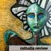Rathalla Review ‏@RathallaReview
Amazing conversations happening at #MFAChat ! Search the hashtag for insights from @awpwriter @carmenmmachado @cjspataro @LisaRomeo
Emily Coon ‏@ehcoon
Check out the #MFAchat thread if you have questions/thoughts about MFAs. Moving across the country to begin mine was a good call.
Brittany Borghi ‏@brittany_borghi
What are nonfiction writers @uiowa up to rn? Some Borges, some Whitney, some snacking, etc. #MFAchat @awpwriter
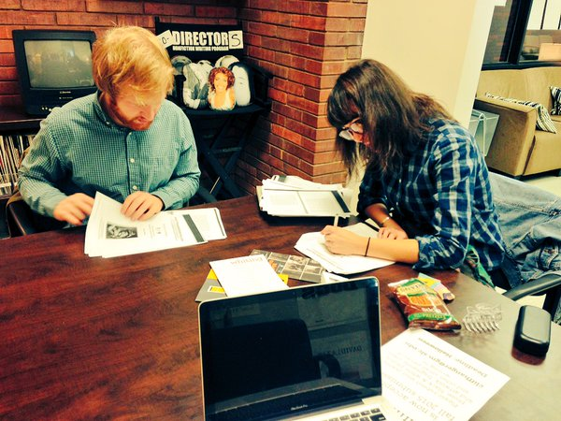
Leslie Jones ‏@lesleslielie
Mostly, we wear sweatpants with our concentration (poetry/fiction) stamped across the butt. #mfachat

dawniewalton ‏@dawniewalton
@MorganJerkins Thank you for your insights in #MFAChat. Am applying to programs this year and found your words super helpful!
Lauren Wolf ‏@WriteBoldly
Hey #MFAchat people, Let's continue this conversation over a drink at #AWP16
todd dillard ‏@toddedillard
how did i miss #MFAchat? I have things to say! And those things are: MFA debt is the worse. Also: Don't go straight to MFAs from undergrad.
Forrest Anderson ‏@OCaptainEnglish
@Mariad_kins good convo about mfa programs happening now on twitter at this hastag: #MFAchat
Eric Shonkwiler ‏@eshonkwiler
#MFAchat Find the biggest person in your program and beat them in a fight.
Eric Shonkwiler ‏@eshonkwiler
Unplug your thesis chair when fully charged to ensure longer battery life. #MFAchat
Martha Holloway ‏@mlhollow
Biggest advice for MFA seekers: Don't go for it if you don't really, truly want it. Also don't take on (more) student loan debt. #MFAchat
Amanda Sledz ‏@transporbation
Don't enroll in any MFA program, ever, that expects you to pay for it with student loans exclusively. Don't do that to your future. #MFAchat
Amanda Sledz ‏@transporbation
the writer you admire the most is not necessarily the best teacher. Famous writers are also humans with issues, obsessions, flaws #MFAchat
Amanda Sledz ‏@transporbation
the best teachers see what you're trying to accomplish, and coax you towards it. You walk away still writing like you, not them. #MFAchat
Amanda Sledz ‏@transporbation
you don't need an MFA. It is a piece of paper that many people have. What you need is to observe, to be inspired, and to dream. #MFAchat
Samantha Lienhard ‏@SamLienhard
Looks like I missed the #MFAchat, but as a genre writer, going to Seton Hill was one of the best decisions I made. #SHUWPF
Tristian Evans ‏@TristEv
I start in January,@SamLienhard. I am really excited about attending the #SHUWPF program. #MFAchat

Laura Hunsberger ‏@lilredradio
My MFA was the launching point into a career I love that uses writing as an essential skill: radio reporter and producer. #MFAchat
jen! ‏@JenniferMWolff
I dream of an MFA that would help me break the chains of fear that hold me back from speaking my truth. Need a community. #MFAchat
Eileen Tomarchio ‏@EileenTomarchio
Looking back, wish I'd pursued a MFA in cw rather than pricier film directing/ screenwriting. Master of Fuzzy Aspirations? #MFAchat
W. P. Johnson ‏@Americantypo
Being taught to write like everyone else is super pricey. Ass in seat is free and you'll probably produce more work. #MFAchat
W. P. Johnson ‏@Americantypo
Most, but not all, end up just treating it like a social club. Writing is lonely work unfortunately. Just gotta sit down and do it. #MFAchat
W. P. Johnson ‏@Americantypo
A thesis, for example, is a book which, if it's your 1st, will probably stink. better to write ur 1st shitty book without debt. #MFAchat
W. P. Johnson ‏@Americantypo
There's also little chance it will lead to a teaching gig. Also, tenure track positions are an endangered species. #MFAchat
W. P. Johnson ‏@Americantypo
In short, I've seen more mfa peeps tinker away endlessly with their terrible thesis while others grinded and eventually published #MFAchat
W. P. Johnson ‏@Americantypo
That said if you can get a free ride, go for it #MFAchat

Pulchritude Press ‏@PulchPress
#MFAchat Our advice (biased but human, from founders who know) is to pursue & invest in only that which assists you in doing what you love
Brittany Borghi ‏@brittany_borghi
Yeah I know #MFAchat is over, but look: even one of @uiowa's writers can fix his computer.
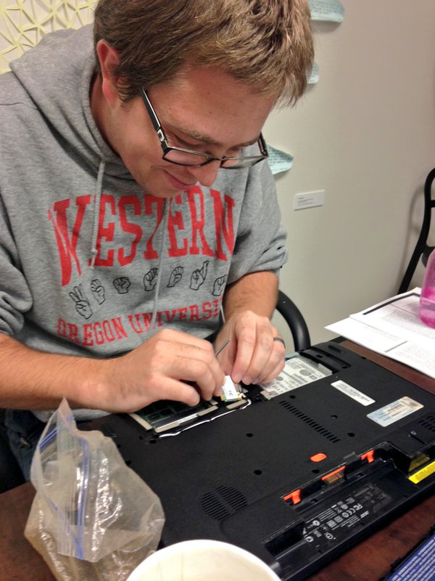
lisa nikolidakis ‏@lisanikol
My equation: (funding) (faculty) size + teaching load = the right school(s) for you #MFAchat
Andrew Wooldridge ‏@AndyCWooldridge
Take time away from academia after your undergrad, live life and discover yourself, and then apply for an MFA. #MFAchat
Kenzie Allen ‏@cerena
Well just so #MFAchat knows, yes, you can write a mass marketed (not as litfic) book while in top MFA programs. http://www.amazon.com/Every-Anxious-Wave-A-Novel/dp/1250067499 …
Anna Cabe ‏@annablabs
Golly, missed #MFAchat! All I have to say is: I am GLAD to have taken time off between undergrad and MFA.
Anna Cabe ‏@annablabs
Taking time off gave me perspective and discipline. It made me hungry and self-starting. My work gained breadth and depth. #MFAchat
Anna Cabe ‏@annablabs
Keep in mind I was a traditional-aged middle-class undergrad so if if you're a different type of person, you might not need to. #MFAchat
Anna Cabe ‏@annablabs
Also: I LOVE being fully funded for 3 years in a quiet town. I'm easily distracted so it's easier for me to focus. Also money. #MFAchat
Anna Cabe ‏@annablabs
As I've told my students, being a writer depends on the practice. If you can't write before or after or without, it's meaningless. #MFAchat
The W's MFA in CW ‏@TheW_MFACW
Many comments on debt in #MFAchat yesterday got me looking. Here's an article about loan forgiveness programs. http://www.usatoday.com/story/money/personalfinance/2013/09/06/student-loan-forgiveness-options/2776545/ …
The W's MFA in CW ‏@TheW_MFACW
@thew_mfacw One resource referenced in this article is http://www.saltmoney.org — you have to sign up, but it appears to be free. #MFAchat
The W's MFA in CW ‏@TheW_MFACW
@thew_mfacw Still probably the most comprehensive place to get info on student loans is https://studentaid.ed.gov/sa/ #MFAChat

