AWP’s First Tweet Chat: Writers’ Conferences & Centers
March 3 from 2:00-3:00 p.m. ET
AWP ‏@awpwriter Mar 3
Want to know more about our writers' conferences, centers, retreats, festivals, & residencies? Join us today at 2pm ET for a WC&C Q&A #WCCQA
A Room Of Her Own ‏@aroomofherown Mar 3
Did you know AROHO's Retreat for Women Writers qualifies for the @awpwriter WC&C Scholarship? http://bit.ly/1i8PgsT due March 30! #WCCQA
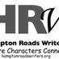HamptonRoads Writers ‏@HRWriters Mar 3 Norfolk, VA
proud to be a part of Association of Writers & Writing Programs. join today's Q&A today from 2-3 PM EST #WCCQA
AWP ‏@awpwriter Mar 3
Welcome to @awpwriter's 1st Tweet Chat! From 2-3pm we'll answer questions about our Writers' Conferences & Centers programs & award #WCCQA
Diane Zinna ‏@DianeZinna Mar 3
Hi, Writers! I’m Diane Zinna, the membership director at @AWPwriter, coordinating memberships for individuals, programs, and WC&C. #WCCQA
AWP ‏@awpwriter Mar 3
To ask a question at any time & to follow the chat, just use #WCCQA
AWP ‏@awpwriter Mar 3
With me today to answer your Qs is AWP's Director of Membership & manager of the WC&C program @Dianeyzp #WCCQA
Diane Zinna ‏@DianeZinna Mar 3
With a staff of 20, everyone at @awpwriter wears a lot of hats. Did you know that AWP is headquartered in a tiny house in VA? #WCCQA
AWP ‏@awpwriter Mar 3
AWP's offices! #WCCQA
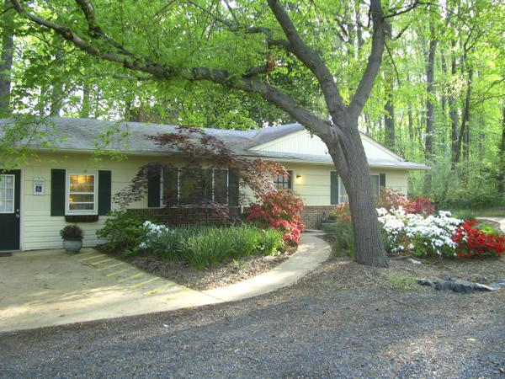

Diane Zinna ‏@DianeZinna Mar 3
We should have a Q&A about our old house next time. I have a photo of a long snakeskin we found in our bathroom sink I could share. #WCCQA
Diane Zinna ‏@DianeZinna Mar 3
WC&C stands for Writers’ Conferences & Centers, but we also help get the word out about festivals, retreats, and residencies. #WCCQA
Diane Zinna ‏@DianeZinna Mar 3
I'm going to be shining the light on as many programs as I can today. You can view them all here: http://bit.ly/1M50A6G #WCCQA
Diane Zinna ‏@DianeZinna Mar 3
That way you can figure out where you want to go when you win our WC&C Scholarship Prize this year. http://bit.ly/1i8PgsT #WCCQA
Diane Zinna ‏@DianeZinna Mar 3
Each year we hold the WC&C scholarship contest. 3 genres. Winners use their $500 scholarships to attend one of 150+ programs. #WCCQA
HamptonRoads Writers ‏@HRWriters Mar 3 Norfolk, VA
@Dianeyzp Is there a fee to apply? #WCCQA
Diane Zinna ‏@DianeZinna Mar 3
Hi friends at @HRWriters! The cost to enter is $10 per submission. #WCCQA
Diane Zinna ‏@DianeZinna Mar 3
Contest closes 3/30. We hope you'll enter: https://wcc.submittable.com/submit #WCCQA
Pamela Winters ‏@PaisleyPam Mar 3
@Dianeyzp @awpwriter If I'm an entrant in another AWP contest, am I still eligible?
Diane Zinna ‏@DianeZinna Mar 3
@PaisleyPam @awpwriter Absolutely, Pam! #WCCQA. We just welcome your best unpublished work! #WCCQA
Diane Zinna ‏@DianeZinna Mar 3
Want some insider information? 62 entries so far in fiction; 33 in poetry; 18 in CNF. #WCCQA
AWP ‏@awpwriter Mar 3
Question: What is the best way to find out about upcoming writers’ conferences & workshops? #WCCQA
Diane Zinna ‏@DianeZinna Mar 3
@awpwriter Find your perfect program using the search tools in our Directory of Conferences & Centers! #WCCQA https://www.awpwriter.org/wcc/directory_conferences_centers …
AWP ‏@awpwriter Mar 3
You can also see WC&C dates in our Writer's Calendar and the Calendar section of the main page of our site #WCCQA http://www.awpwriter.org/community_calendar/writers_calendar …
Diane Zinna ‏@DianeZinna Mar 3
Our fiction judge this year is @MattBell #WCCQA
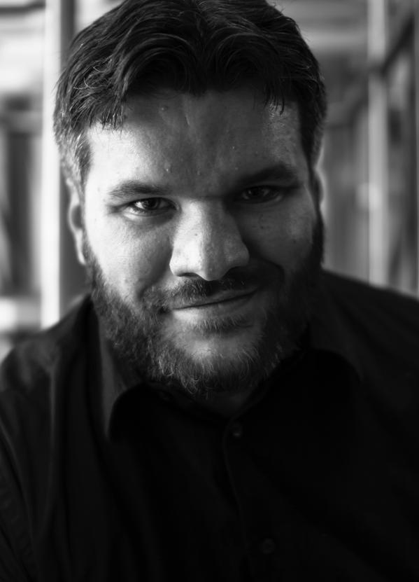
Diane Zinna ‏@DianeZinna Mar 3
Our poetry judge is @sandrabeasley #WCCQA
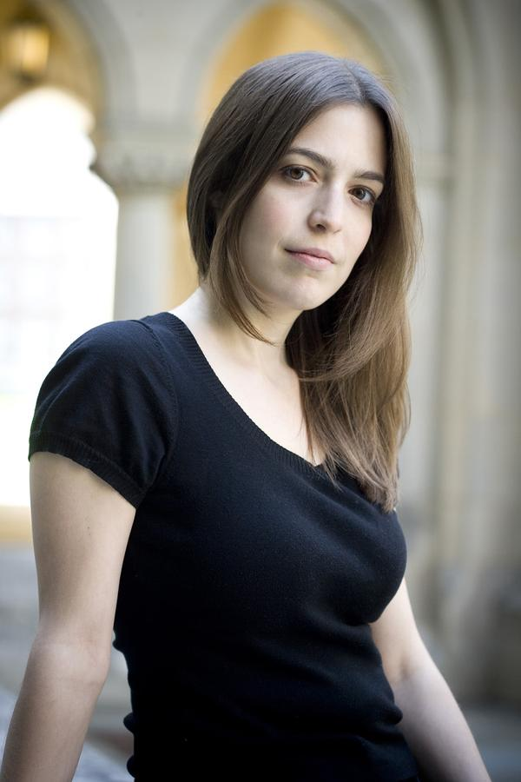

Diane Zinna ‏@DianeZinna Mar 3
We're also offering our first-ever CNF prize judged by @XuXiwriter. #WCCQA
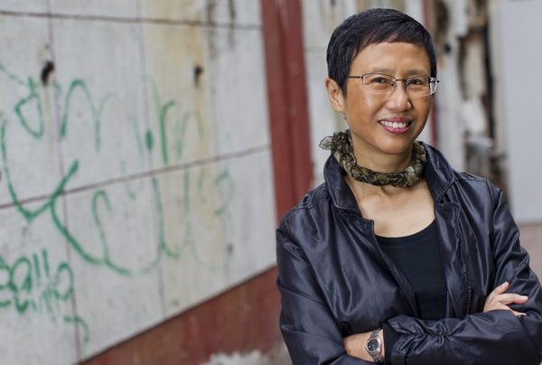

Diane Zinna ‏@DianeZinna Mar 3
So glad to have gotten my first question from @HRWriters! Their 7th annual conf. in VA offers chances to pitch work to agents #WCCQA
AWP ‏@awpwriter Mar 3
Here's a quick link to the WC&C Scholarship Guidelines: https://www.awpwriter.org/application/public/pdf/awards/WCC_Scholarship_Guidelines.pdf … #WCCQA
Diane Zinna ‏@DianeZinna Mar 3
Did you see that great photo of @xuxiwriter? At VCFA’s Postgrad Writers' Conference, novelists can work directly with her. Aug 10-16. #WCCQA
Diane Zinna ‏@DianeZinna Mar 3
Also for post-grads: Brittany Postgrad Workshop for MFA grads in prose. Their early bird deadline is 3-15: http://bit.ly/1EfJIYa #WCCQA
Diane Zinna ‏@DianeZinna Mar 3
Oh, and we love the Woodstock Mayapple Writer's Retreat (also for postgrads) in NY. #WCCQA
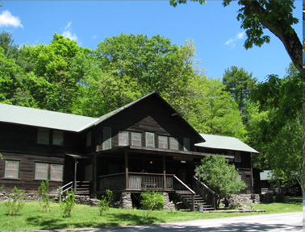
Diane Zinna ‏@DianeZinna Mar 3
SO many provide college credit, including NYU's programs in New York, Paris, and Florence #WCCQA
Diane Zinna ‏@DianeZinna Mar 3
Many offer disc. to AWP members. North Carolina Writers Network gives pre-reg rate ($99) their members get. 4-18, UNC Greensboro. #WCCQA
Diane Zinna ‏@DianeZinna Mar 3
Deadline for Writing Workshops in Greece (@wwigthasos) passed but if members say hey contact them, they promise to read your app. #WCCQA
Diane Zinna ‏@DianeZinna Mar 3
@WWIGthasos...Carolyn Forche, Christopher Bakken, workshops on their patio with a view of 3 beaches, dancing and fresh seafood, ah. #WCCQA
Top of Form
Bottom of Form
lilliamr ‏@lilliamr Mar 3
Was a fiction finalist last yr. GET IT! RT @awpwriter: Here's a link to the WC&C Scholarship Guidelines: http://bit.ly/1DGBEvU #WCCQA
AWP ‏@awpwriter Mar 3
Congrats on being a finalist last year, @lilliamr! And thanks for the retweet about the scholarship program! #WCCQA

AWP ‏@awpwriter Mar 3
Question: Are all the WC&C programs for established writers only, or are there programs for emerging writers also? #WCCQA
Diane Zinna ‏@DianeZinna Mar 3
@awpwriter So many, for all levels of experience! I had really good early experiences at The Writer's Center near me in Bethesda, MD #WCCQA
Diane Zinna ‏@DianeZinna Mar 3
Let's talk programs for young people. #WCCQA
Diane Zinna ‏@DianeZinna Mar 3
A new Gettysburg College Writing Camp for HS'ers. 5 nights long, taught by the sr. creative writing faculty at Gettysburg College. #WCCQA
Diane Zinna ‏@DianeZinna Mar 3
U Mass’s Juniper Institute for Young writers is also for HS students. They are one of the many programs that offer scholarships. #WCCQA
Diane Zinna ‏@DianeZinna Mar 3
Not FOR young people, but writing FOR them: The Highlights Foundation wksps: https://www.awpwriter.org/wcc/wcc_entry_view/677/highlights_foundation_workshops … #WCCQA

Cheat River Review ‏@CheatRiver Mar 3
Hi @awpwriter! What are some conferences or retreats that #WCCQA winners have attended in the past 2 years?
Diane Zinna ‏@DianeZinna Mar 3
@CheatRiver @awpwriter, they often pick the biggies, like @sewaneewriters or Bread Loaf, but not always. #WCCQA
Diane Zinna ‏@DianeZinna Mar 3
@CheatRiver @awpwriter, 1 of last year's winners chose the conf. at Writers' League of Texas and got an extra agent meet to boot. #WCCQA
Betsy WritersRoom ‏@BWritersRoom Mar 3
@awpwriter How can we be sure our Writers in Residence program is included in the WC&C scholarship competition? http://www.betsywritersroom.com/
Diane Zinna ‏@DianeZinna
@BWritersRoom @awpwriter Sorry I missed your question! Winners can choose any program. Be sure to promote the contest in sunny FL! #WCCQA
Betsy WritersRoom ‏@BWritersRoom Mar 3
@Dianeyzp @awpwriter Thanks - we definitely will share the contest info. Who wouldn't want to stay on balmy #SouthBeach? #inspired
Diane Zinna ‏@DianeZinna Mar 3
The Juniper Summer Writing Institute is offering a full tuition scholarship. Their scholarship deadline is approaching: 3/16! #WCCQA
AWP ‏@awpwriter Mar 3
Question: What opportunities are there for WC&C program members to meet each other in person? #WCCQA
Diane Zinna ‏@DianeZinna Mar 3
#WCCQA The Writer's Hotel Master Class in NYC is also now offering scholarships in 3 genres. http://bit.ly/1EKvE9I #WCCQA
Cheyenne Autry ‏@cheyautry Mar 3
Really enjoying the #WCCQA from @awpwriter. Lots of great information coming out of this conversation.
Diane Zinna ‏@DianeZinna Mar 3
The Writer's Hotel works with writers on their writing pre-conference before meeting the agents and editors on site in NYC. #WCCQA.
Diane Zinna ‏@DianeZinna Mar 3
@ARoomofherown has 2 book prizes (poetry & prose), apps due April 1 & the $50K #GiftofFreedom due Nov. 2! http://bit.ly/1dGI2Y3 #WCCQA
Diane Zinna ‏@DianeZinna Mar 3
More industry meet-ups! Tinker Mountain Writers Workshop: editor Sarah Bowlin of Henry Holt and agent Peter Steinberg of Foundry. #WCCQA
Diane Zinna ‏@DianeZinna Mar 3
Here are some upcoming events from our calendar. #WCCQA
Diane Zinna ‏@DianeZinna Mar 3
Colrain Poetry Manuscript Conference, 3/13-16 #WCCQA
AWP ‏@awpwriter Mar 3
.@Dianezp is graciously going to stay until 3:15. So feel free to post if you have a question! #WCCQA
Alisha Ebling ‏@alishakathryn Mar 3 Philadelphia, PA
@awpwriter @dianezp so helpful! #WCCQA

Diane Zinna ‏@DianeZinna Mar 3
Wordcrafters in Eugene, Mar 20-22, specializing in fiction...#WCCQA
Diane Zinna ‏@DianeZinna Mar 3
@KauaiWriConf provides 3 days focused on fiction & memoir in HI with agents, editors, @VDiffenbaugh @moriarty_laura @colsonwhitehead #WCCQA
Diane Zinna ‏@DianeZinna Mar 3
@KauaiWriConf provides 3 days focused on fiction & memoir in HI with agents, editors, @VDiffenbaugh @moriarty_laura @colsonwhitehead #WCCQA
Diane Zinna ‏@DianeZinna Mar 3
One of our new WC&C members, PoetsWest, provides a network for poets through a weekly radio program on @KSERfm #WCCQA
Diane Zinna ‏@DianeZinna Mar 3
@NonfictionAssoc (Nonfiction Authors Assoc.) holds annual virtual conf. and 2x weekly free teleseminars #WCCQA
Diane Zinna ‏@DianeZinna Mar 3
Discount available for AWP members to attend @NonfictionAssoc annual conference. Get the code here: http://bit.ly/17NU4SG #WCCQA
Diane Zinna ‏@DianeZinna Mar 3
A new WC&C member, Writer’s Room at the Betsy @BWritersRoom hosts authors and artists to develop craft and foster community #WCCQA
Diane Zinna ‏@DianeZinna Mar 3
One of our new WC&C members, Writing By Writers @writingxwriters hosts workshops and a manuscript boot camp each year in CA and CO #WCCQA
Diane Zinna ‏@DianeZinna Mar 3
Grin City Collective @GrinCity offers 3 and 6-week residencies throughout the year on their working farm complex in Iowa #WCCQA. IOWA!
AWP ‏@awpwriter Mar 3
If you're a WC&C member going to #AWP15, don't miss the WC&C Council meeting on Friday, April 10 noon-1:15pm: https://www.awpwriter.org/awp_conference/event_detail/4500 … #WCCQA
Diane Zinna ‏@DianeZinna Mar 3
For 20 years, @SarahLawrence has been hosting their Summer Seminar for Writers, a week of writing, readings, and workshops #WCCQA
Diane Zinna ‏@DianeZinna Mar 3
@critshop is hosting its first workshop for LGBT fiction in Berlin. 4 days of classes, one-on-ones, and group activities #WCCQA
Diane Zinna ‏@DianeZinna Mar 3
Djerassi Resident Artists Program is a new WC&C member. @artandsky provides a retreat experience to artists in various disciplines #WCCQA
Diane Zinna ‏@DianeZinna Mar 3
Women Reading Aloud Writers' Retreat in Greece, also new to WC&C, features a workshops, night writing, sailing and more in June #WCCQA
Diane Zinna ‏@DianeZinna Mar 3
WC&C: programs like Bread Loaf, @sewaneewriters, @writehedgebrook, @gemini Ink, @StoryStudio Chicago, but so many others to explore. #WCCQA
AWP ‏@awpwriter Mar 3
.@Dianezp is showcasing a lot of new WC&C members! Find out more about WC&C membership: https://www.awpwriter.org/about/organizational_membership_wcc … #WCCQA
Diane Zinna ‏@DianeZinna Mar 3
Want to know more about the WC&C groups? All welcome to join us at the WC&C reception at #AWP15 on Fri, 4-10 at 6:30pm in Room 203B. #WCCQA
AWP ‏@awpwriter Mar 3
Hope to see everyone there! RT @Dianeyzp All welcome to join us at the WC&C reception at #AWP15 on Fri, 4-10 at 6:30pm in Room 203B. #WCCQA
HamptonRoads Writers ‏@HRWriters Mar 3 Norfolk, VA
@awpwriter @Dianeyzp #WCCQA Representatives from the @HRWriters writers' conference will be there!
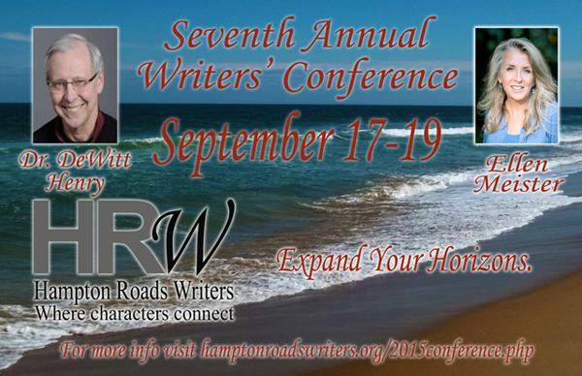

Diane Zinna ‏@DianeZinna Mar 3
Come have a drink, learn more about these programs, and connect with their directors at #AWP15. #WCCQA.
Diane Zinna ‏@DianeZinna Mar 3
WC&C really exists to help connect you with these programs--and connect their directors to each other. #WCCQA
Diane Zinna ‏@DianeZinna Mar 3
We want to see all of these programs thrive and reach the writers who need them. #WCCQA
Diane Zinna ‏@DianeZinna Mar 3
Director of a writing conference, center, festival, retreat, or residency? Large or small? Join us! #WCCQA. https://www.awpwriter.org/about/organizational_membership_wcc …
Diane Zinna ‏@DianeZinna Mar 3
Wait, you want more? University of North Dakota Writers Conference. 3-25 to 3-27. oFree and open literary festival #WCCQA
Diane Zinna ‏@DianeZinna Mar 3
Tennessee Williams New Orleans Literary Festival: Mar 25–Mar 29 #WCCQA
Diane Zinna ‏@DianeZinna Mar 3
BTW, we love Aspen. It's where our exec director @davidfenza formed his friendship with the original WC&C founder, Kurt Brown. #WCCQA
HamptonRoads Writers ‏@HRWriters Mar 3 Norfolk, VA
#WCCQA. Thanks for taking the time to answer questions today, @Dianeyzp
Diane Zinna ‏@DianeZinna Mar 3
Already over the hour! Wish I had more time to talk about more of these programs. Feel free to reach out to me! @dianeyzp #WCCQA.
Diane Zinna ‏@DianeZinna Mar 3
Please join me at the WC&C reception at #AWP15, Fri., 4-10 from 6:30-8pm in Room 203B. #WCCQA
AWP ‏@awpwriter Mar 3
Thank you to everyone who joined us during #WCCQA to watch or ask Qs. We hope to do another Tweet Chat soon about #AWP15!
Diane Zinna ‏@DianeZinna Mar 3
WC&C groups and those interested in learning more about running a program, our WC&C mtg is at #AWP15, Fri., 4-10 at noon, Room 205 C. #WCCQA
Diane Zinna ‏@DianeZinna Mar 3
And don't forget to spread the word about our scholarship contest! #WCCQA http://bit.ly/1i8PgsT
Diane Zinna ‏@DianeZinna Mar 3
Thanks all for joining me for the first Tweet Chat! This was hard! Let me know if you want to see the picture of the snakeskin. :) #WCCQA.
Diem Jones ‏@drhmjoy Mar 3
#WCCQA Writers of Color explode, VONA/Voices Consequence--Generation One. Hear us roar. Saturday 8PM @ The LOFT, 4/11/15
A Room Of Her Own ‏@aroomofherown Mar 3
Accepted 2015 Retreat attendees, check out: http://bit.ly/1i8PgsT . AROHO's Retreat qualifies for the @awpwriter WC&C Scholarship! #WCCQA
The Writer's Hotel ‏@TheWritersHotel Mar 3
#WCCQA We give out writing stipends in the spirit of the @AWP WC&C Scholarships! You're eligible for both if we accept you! Apply by April 1
Juniper Institute ‏@junipersummer Mar 3
Thanks @Dianeyzp for the shout-out. Juniper has a new full-ride scholarship for adults! Deadline 3/16 #WCCQA
Juniper Institute ‏@junipersummer Mar 3
Juniper '15 participants, visit http://bit.ly/1i8PgsT for a scholarship opportunity from @awpwriter WC&C to attend Juniper this June #WCCQA
The Writer's Hotel ‏@TheWritersHotel Mar 3
#WCCQA Each of our accepted writers gets a reading in NYC at @bowerypoetry or @kgbbarlit or @bookculture! To apply: http://tinyurl.com/nzt87bm
The Writer's Hotel ‏@TheWritersHotel Mar 3
Conference held between 3 writer's hotels in NYC: @Bryantparkhotel, @LibraryHotel and @algonquinNYC! 3 Genres: http://tinyurl.com/nzt87bm #WCCQA

Odyssey Workshop ‏@OdysseyWorkshop Mar 4
Odyssey #workshop for #writers of #fantasy , #sf, #horror in NH--app. deadline 4/8. http://odysseyworkshop.org #WCCQA
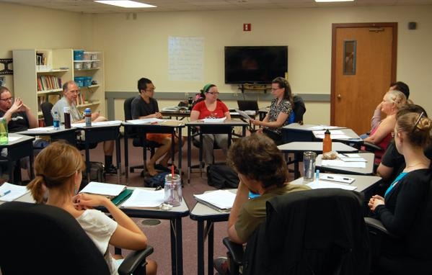
StoryStudio Chicago ‏@StoryStudio Mar 4
Thanks @Dianeyzp for the mention! We're excited to unveil our new online classes in time for #AWP15 . #WCCQA @awp
The Writer's Hotel ‏@TheWritersHotel Mar 14
Three weeks left to apply! Accepting writers of Poetry, Fiction or Nonfiction: http://tinyurl.com/khy58nc #WCCQA

AWP ‏@awpwriter Mar 18
WC&C groups & those who want to learn more about running programs, WC&C mtg is @ #AWP15, Fri., 4/10 @ noon, Room 205C #WCCQA @Dianeyzp
The Writer's Hotel ‏@TheWritersHotel Mar 23
Happy! @LibraryHotel made this video with writers & @TheWritersHotel in mind! 6/10-16! http://tinyurl.com/pnuj8kt #WCCQA #writersconference
The Writer's Hotel ‏@TheWritersHotel Apr 1
You asked, we listened & extended our TWH NYC deadline to April 17. http://tinyurl.com/nzt87bm #writers #WCCQA #AWP15
Bryant Park Hotel

The Writer's Hotel ‏@TheWritersHotel Apr 2
Check out The Writer's Hotel's action-packed writing conference schedule: http://thewritershotel.webs.com/ #WCCQA #writingtips
Empire State Bldg

