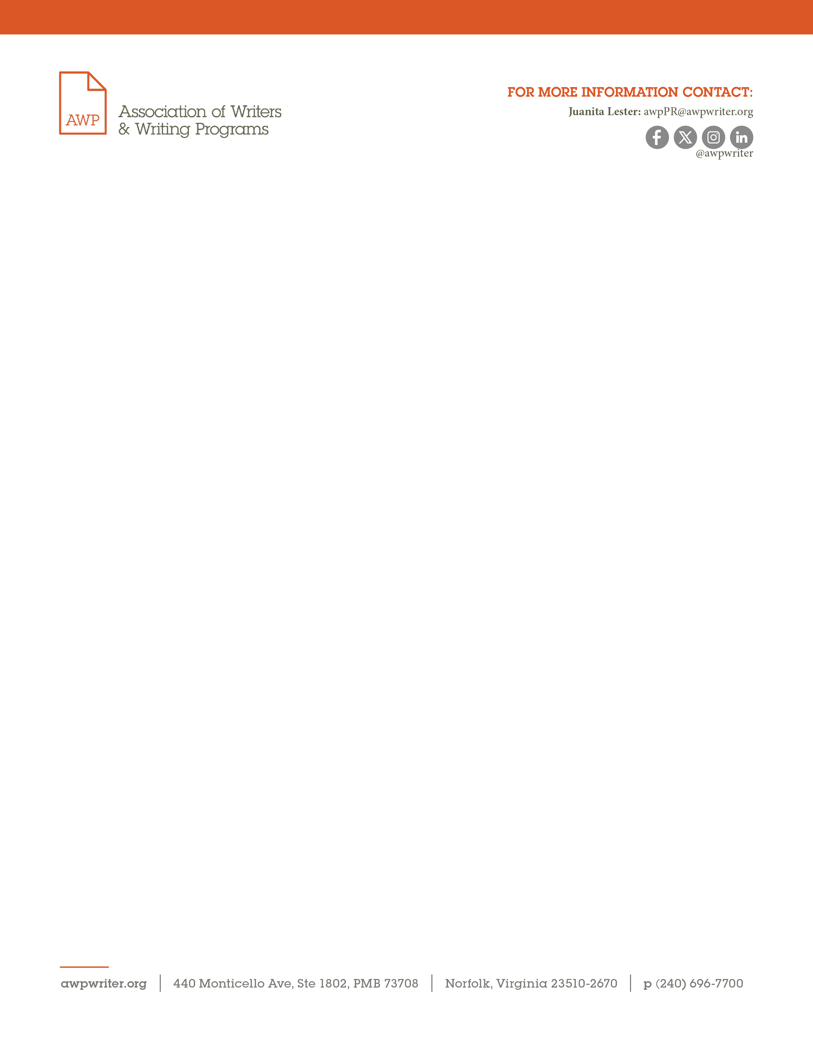
August 19, 2024

FOR IMMEDIATE RELEASE

AWP Awarded Amazon Literary Partnership Grant
Norfolk, VA — Amazon Literary Partnership announced that the Association of Writers & Writing Programs (AWP) received a $5,000 grant to support the AWP Writer to Writer Mentorship Program. AWP is among the list of ninety-three Amazon Literary Partnership grant recipients.

Through annual grants, Amazon Literary Partnership supports literary centers, writing workshops, residencies, fellowships, literary magazines, independent publishers, poetry, and translation programs. Writers supported by these organizations have gone on to become bestselling and award-winning authors and poets. Amazon Literary Partnership is also working with the Academy of American Poets on the Poetry Fund and the Community of Literary Magazines and Presses (CLMP) on the Literary Magazine Fund. Each of these funds will provide fifteen to twenty grants to poetry organizations and literary magazines.

“We deeply appreciate the ongoing support from Amazon Literary Partnership for our Writer to Writer Mentorship Program. This initiative, which connects diverse emerging writers with experienced mentors, embodies AWP’s commitment to nurturing the craft and professional growth of writers while championing diversity and excellence within the literary community,” said January Gill O’Neil, chair of the AWP Board of Directors. “The success and vitality of this program are a testament to the dedication of both mentors and mentees, and we are grateful that Amazon Literary Partnership shares in our mission to empower and uplift writers.”

Ricardo Maldonado, executive director of the Academy of American Poets, said, “We’re grateful for the opportunity to continue championing the vital work of poetry organizations and presses in partnership with the Amazon Literary Partnership, uplifting underrepresented writers and communities of readers all over the nation through the Poetry Fund.”

“Literary magazines have always served as an important record and reflection of our country’s literary landscape, and are so often the first place where countless writers connect with readers,” said CLMP executive director Mary Gannon. “CLMP is incredibly grateful to Amazon Literary Partnership for its ongoing support of these essential publishers through the Literary Magazine Fund.”

About AWP
AWP is a professional association of creative writers and writing programs. AWP provides support, advocacy, resources, and community to nearly 50,000 writers, 550 college and university creative writing programs, and 150 writers’ conferences and centers. The AWP Conference & Bookfair is the annual destination for writers, teachers, students, editors, and publishers of contemporary creative writing. It includes thousands of attendees, hundreds of events and bookfair exhibitors, and four days of essential literary conversation and celebration.

About Amazon Literary Partnership
Since 2009, Amazon Literary Partnership has provided more than $17 million in grant funding to more than 170 literary organizations, assisting many thousands of writers. Among the organizations they have supported over the years include the Academy of American Poets, the Asian American Writers’ Workshop, the National Book Foundation, PEN America, Poets & Writers, Girls Write Now, Lambda Literary, the Loft Literary Center, National Novel Writing Month, Words Without Borders, Yaddo, and many more.

