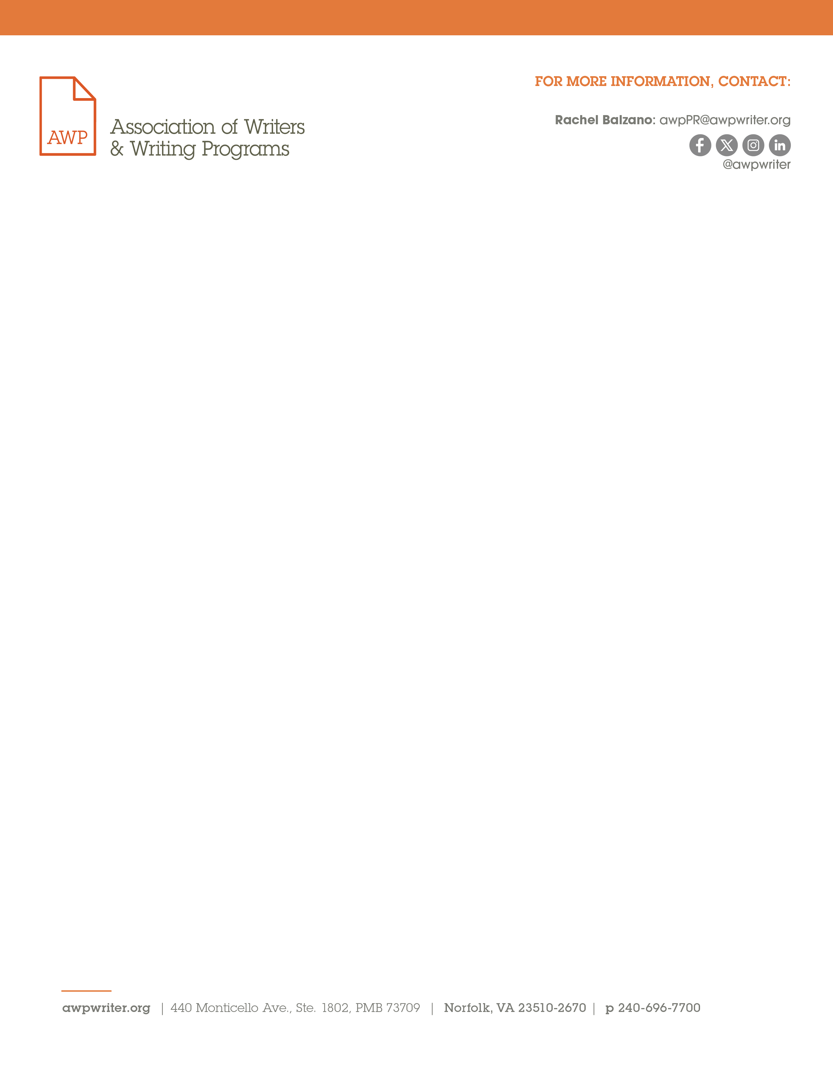
November 6, 2024
FOR IMMEDATE RELEASE

Announcing the HBCU MFA Think Tank at #AWP25

Norfolk, VA — The Association of Writers & Writing Programs announces the HBCU MFA Think Tank to be held at the 2025 AWP Conference & Bookfair. Creative writing educators from historically Black colleges and universities (HBCUs) will convene to explore the viability of MFA programs at HBCUs, where none currently exist.

Funded in part by a generous grant from the National Endowment for the Arts, AWP will award scholarships to ten HBCU faculty and administrators involved in creative writing at their institutions. These scholarship recipients will participate in a roundtable discussion with ten invited specialists, who are practicing writers on faculty at HBCUs.

“AWP is honored to host the HBCU Think Tank at #AWP25, a milestone event dedicated to expanding access to MFA programs at HBCUs,” said Michelle Aielli, AWP’s interim executive director. “We extend our gratitude to the HBCU Think Tank committee organizers and the NEA for making this impactful event possible. Advancing MFA programs at HBCUs is a vital initiative fully aligned with AWP’s commitment to fostering opportunities for all writers."

The HBCU MFA Think Thank committee organizers are Regina Brooks, Kwame Dawes, and A. J. Verdelle. “I was surprised to discover that none of the more than one hundred HBCUs offer creative writing MFA programs, and, as Michelle Obama says, felt the need to ‘DO SOMETHING!’” said Regina Brooks, founder of Serendipity Literary Agency and a member of the AWP Board of Directors. “The HBCU MFA Think Tank will bring together some of the brightest minds to explore establishing advanced literary education programs, so HBCU students can flourish creatively within communities that truly celebrate their voices and experiences.”

To be eligible for the HBCU MFA Think Tank at #AWP25, applicants must currently be a faculty member or administrator at an HBCU, teach creative writing or be actively engaged in creative writing at an HBCU, and be able to travel and be at the conference on March 26–29, 2025. Applications will close on November 22, 2024. For more information, please visit AWP’s website. For press inquiries, email awpPR@awpwriter.org.

AWP provides support, advocacy, resources, and community to writers, college and university creative writing programs, and writers’ conferences and centers. Our mission is to amplify the voices of writers and the academic programs and organizations that serve them while championing diversity and excellence in creative writing.

